/20

watershed model project: question sheet Name:___________
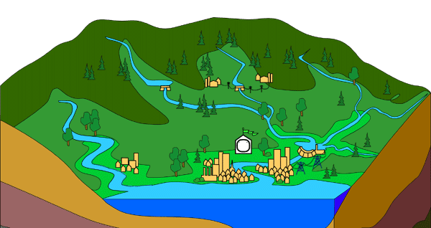

There are Pre-Activity and Post-Activity questions to do here. EACH member of the group will be completing this package and submitting it individually.
Part A: Pre–Activity Questions: Before you begin construction of your watershed model, answer the following questions.
- Watersheds are also called ‘drainage basins’ – why do you think this is so? (1 mark)
________________________________________________________________________________________________________________________________________________
- We use models to represent different phenomena in science. Describe another example of a model that you may have seen before in science. (2 marks)

________________________________________________________________________________________________________________________________________________________________________________________________________________________
- Name the three main watersheds in the Metro Vancouver area.(1.5 marks – ½ mark each)
a)__________________________________
b)__________________________________
c)__________________________________
- Where does West Vancouver get the majority of water from? (1 mark)
________________________________________________________________________________________________________________________________________________
- What are some ways you can think of in which humans can negatively impact watersheds. (1.5 marks marks – ½ mark each)

________________________________________________________________________________________________________________________________________________________________________________________________________________________
- What functions do wetlands play in an ecosystem? (2 marks)
________________________________________________________________________________________________________________________________________________________________________________________________________________________
Part B: Post-Activity Questions:
- Explain in paragraph form how people, buildings such as factories and agricultural areas and can impact watersheds ( /3)
______________________________________________________________________________________________________________________________________________________________________________________________________________________________________________________________________________________________________________________________________________________________
- Where might a good place for a farm or other agricultural area be? Why? (2 marks) ____________________________________________________________________________________________________________________________________________

- Is there any other type of pollutant you can think of that may impact a watershed and is not represented on your model? Explain how this pollutant could have an impact – be specific! (2 marks)
________________________________________________________________________________________________________________________________________________
- In our model, natural remediation was performed by the wetlands (sponges) as some pollutants were removed from the run-off. What else might be done to help with remediation of pollutants (natural or human designed remediation)? ( 2 marks)
________________________________________________________________________________________________________________________________________________________________________________________________________________________

Critical Thinking
- Explain how your model may have inaccuracies. What other ways could you alter your model to make it more accurately represent a watershed? ( 2 marks)
________________________________________________________________________________________________________________________________________________________________________________________________________________________________________________________________________________________________________________________________________________________________________________________________________________________________________________

