watershed model project: procedure Name:_________

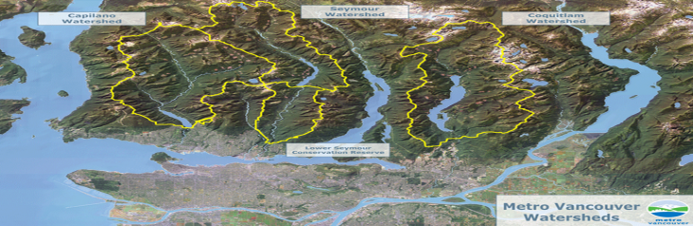
The purpose of this assignment is to learn about watersheds through constructing a model and observing how watersheds operate. You will be working in groups of 3 to build the watershed model, although each group member is responsible for completing the Questions Sheet.
Part A: (Basic Model Construction)
- Complete the Pre-Activity Questions in your Questions Booklet before beginning Model Construction
- Gather the required materials provided by your teacher (cloth wrap, aluminum tray, newspaper etc.)
- Using these materials, follow the instructions of your teacher to build your watershed model.
- Each groups’ model will be unique; however, they should all contain a ‘mountainous’ region as well as a ‘flatter’ region that gradually slopes into an ‘ocean’.

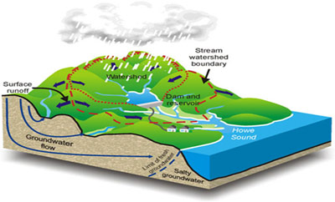
Part B: Precipiatation Part 1:
- Using the water bottles, test how the water ‘runs-off’ down to the ocean. Note any streams or larger rivers that may form.
Part C: (Add Elements)
- Add elements to your watershed model (you need to decide what a good spot for each would be)
- Put in land-use areas by placing homes, barns, factories, and animals around the watershed, from the hills to the ocean (you can use cut-outs to place these on your project or use toys etc.) You may need craft glue to hold these in place.:
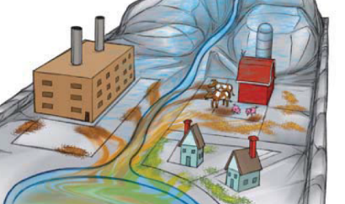
Your landscape must contain the following areas:
- Agriculture/Farms
- Factories
Urban Development/Residential consturction (You can add additional elements such as roads etc. if you choose) Here is an example

Part D: Pollute
- Sprinkle hot chocolate mix near animals to show manure and/or near construction sites to show exposed dirt.
- Sprinkle lime gelatin mix near houses to represent lawn-care fertilizers.
- Sprinkle orange gelatin mix on farm fields and factories to represent agricultural chemicals (pesticides, fertilizers etc.) and industrial waste (chemical solvents, toxic waste etc.)

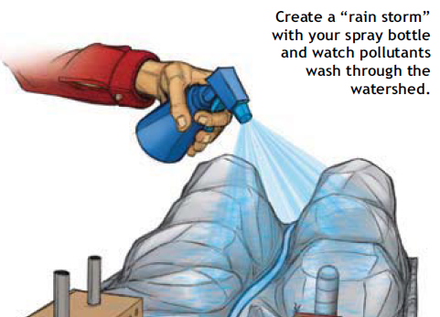
Part E: Precipiation Part 2
- Use the spray bottle or watering can to start a rain shower in the mountains.
- Note how the run-off has changed in appearance!

Part F: Remediate
- Dump the water into a bucket and rinse off any residue. Sprinkle the chocolate, lime, and orange mixes in the same spots, taking additional steps to prevent water pollution before the next rainfall.
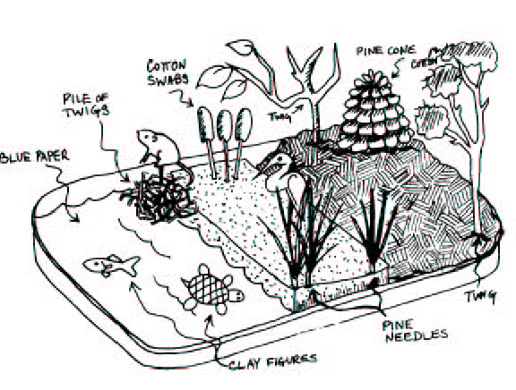
- Cut small pieces of sponge to place near pollution areas and in low spots where water may gather. These serve as wetlands, which filter runoff by trapping and breaking down pollutants.

- Cut small pieces of felt to place along the banks of the river to represent a buffer of stream-side trees and shrubs to slow runoff and trap pollutants.
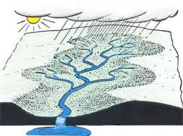
Part G: Rain Again

- Use the spray bottle or watering can to create a second rainfall.
- Note any further changes to the water reaching the ocean and have a look at the ‘wetlands’ and ‘trees’ and ‘shrubs’

You are finished the procedure! – make sure to answer the Post-Activity Questions on your Watershed Model Question Sheet

