Name: Date:

**Earth Science 11: The Universe**

**Text:** Chapter 16 *This is RECOMMENDED reading

**Part A: What is the Universe?**



What are some questions about the universe that we want answers to?

_________________________________________________________

_________________________________________________________

_________________________________________________________

Let’s have a quick look at the creation of the universe before we investigate its components in more depth...

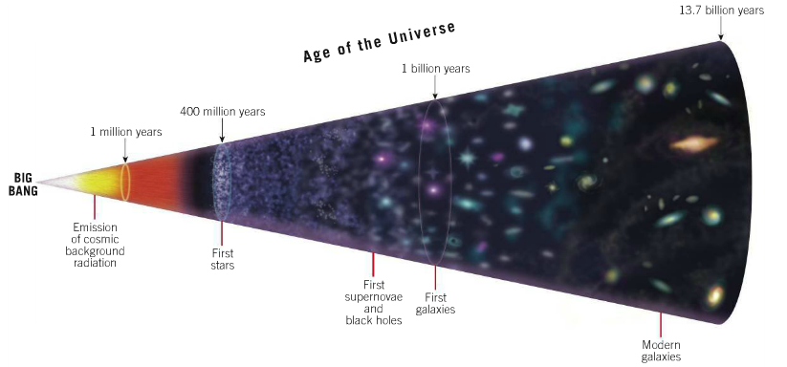**Big Bang Theory**

* The Big Bang Theory is the model that most accurately described the creation and current state of the universe.
* The Universe existed in a hot, dense state and around **13.7 billion years ago** began to expand, cool and evolve into its current state.

*Read Chapter 1 of *A Short History of Nearly Everything* by Bill Bryson for a vivid description of what the Big Bang was like

**Part B: Light and Electromagnetic Spectrum**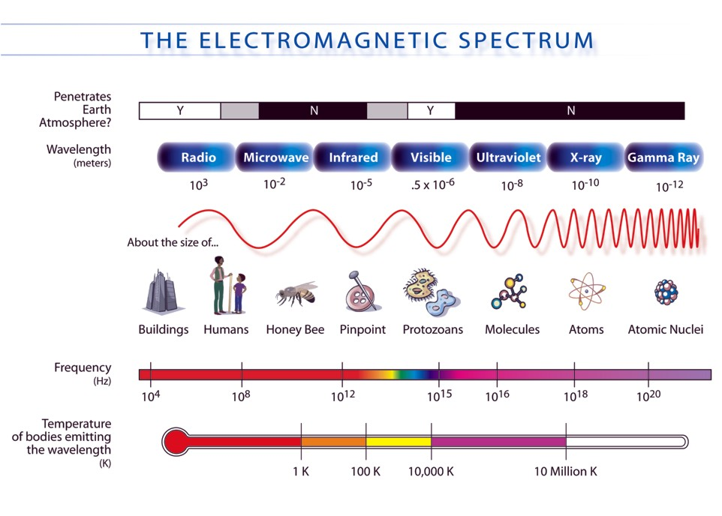

* The light produced by stars reveals a vast amount of information about them and their place in the universe.

**1. What is Light?**

Light is a form of **electromagnetic radiation**. This means that it:

a) **Travels in waves (at the speed of light: 300,000 km/s)**

b) **Does not need a medium for travel = can move through space**

Electromagnetic waves emitted by an object tell us about the **elements** present in the object and the object’s **motion**.

**2. Spectroscope and Types of Visible Spectra**

**Spectroscope:** an instrument used by astronomers to learn about the **composition** and **motion** of stars.

* contains a diffraction grating that separates visible light into a **spectrum** of colours (each colour represents a **different** **wavelength** in the electromagnetic spectrum).

**There are three types of spectrums that can be produced through this process:**

|  |  |
| --- | --- |
| Spectrum | Description |
| http://www.scienceinschool.org/repository/images/issue4spectrometer11_large.jpg | **hot compressed gasses inside stars** |
| http://www.scienceinschool.org/repository/images/issue4spectrometer11_large.jpg | **Specific wavelengths are emitted by hot gas**  **Each element has it’s own spectra** |
| http://www.scienceinschool.org/repository/images/issue4spectrometer11_large.jpg | **Cold gases in the outer atmosphere absorb the same wavelengths it would emit when heated** |

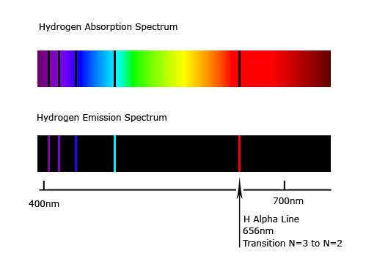Absorption spectra can also be useful in determining the **chemical composition** of gas clouds and planets’ atmospheres.

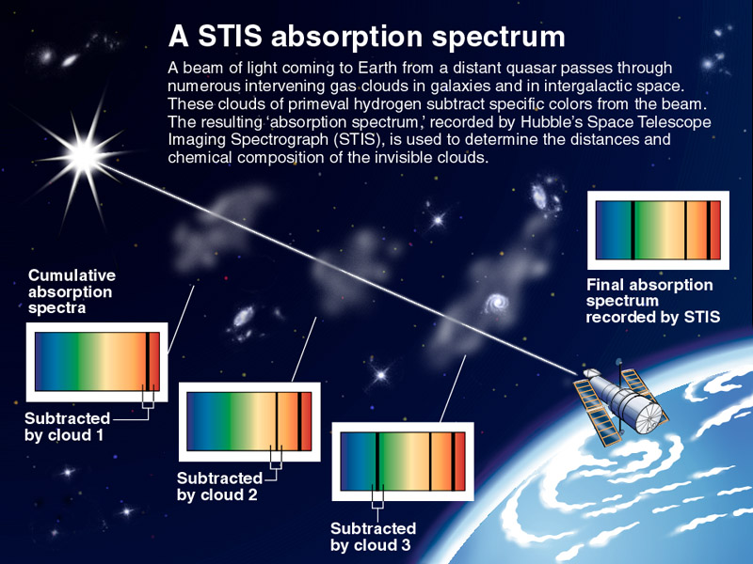

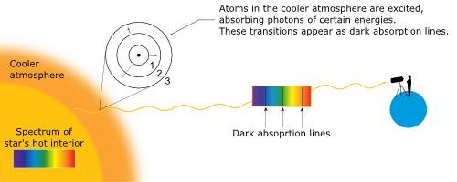

**3. Stellar Distances**

There are two ways that astronomers determine the distance of stars from an observer:

**a) Doppler Effect**

* 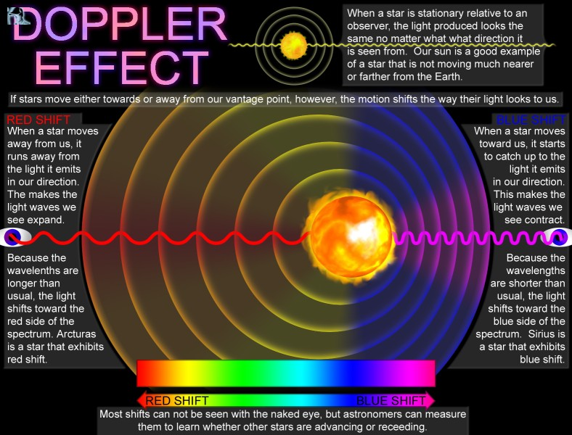The Absorption Spectrum produced by a star or planet changes depending on whether the star is moving towards or away from the observer.

Watch this video: <http://www.esa.int/spaceinvideos/Videos/2014/07/Doppler_effect_-_classroom_demonstration_video_VP05> for a demo of the Doppler effect

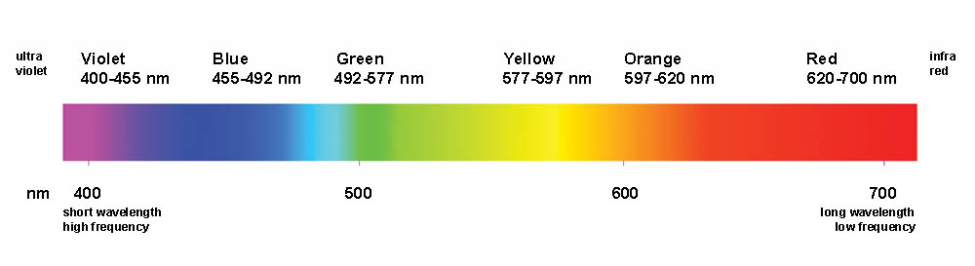On the continuous spectrum below, draw the absorption spectrum for a star. Next, indicate what direction the spectral lines would move if the star was moving towards Earth.

* If you understand this video ([The Big Bang Theory – The Doppler Effect](http://www.youtube.com/watch?v=Y5KaeCZ_AaY)), then you’ve got the concept!

**b) Stellar Parallax:**

* the **apparent movement** of an object due to the movement of the observer.

**Try it:** Close one eye and align your index figure with an object in the distance. Without moving your finger, view the object with the other eye and notice that its position appears to have changed.

* Astronomers use this principle to determine the **distance of stars from Earth**, with the closest stars having larger parallax angles.

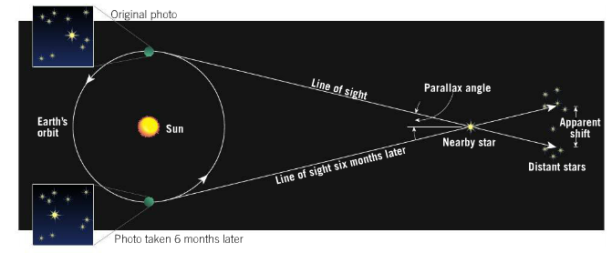

Watch this video on stellar parallax: <https://www.khanacademy.org/science/cosmology-and-astronomy/stellar-life-topic/stellar-parallax-tutorial/v/stellar-parallax>

**4. Star Brightness**

Stars are categorized by their brightness in **two** ways:

|  |  |
| --- | --- |
| **Apparent Magnitude** | **Absolute Magnitude** |
| How bright stars **appear from** **Earth**.  Difference of 2.5x brightness between magnitudes  The more **negative** the apparent magnitude of a star, the **brighter** it is. | The brightness stars would have if they were **all 32.6 light-years from Earth**.  The more **negative** the absolute magnitude of a star, the **brighter** it is. |

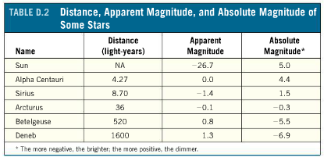

Explain how and why the brightness of Earth’s Sun changes under these two systems.

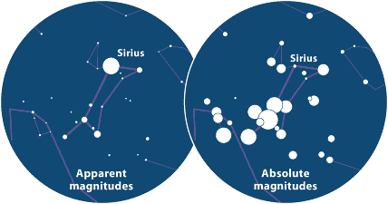

**5. Star Colour and Temperature**

* Stellar temperature can be determined by the **colour of the light** emitted.

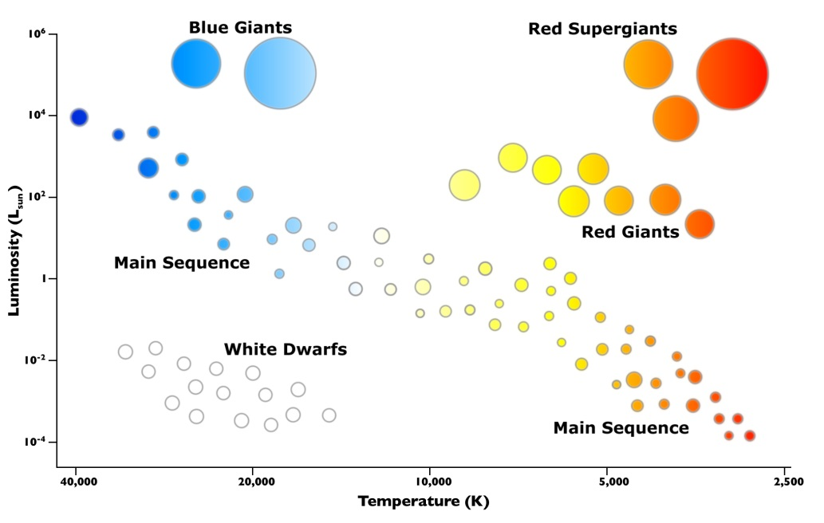

|  |  |  |
| --- | --- | --- |
| **HOT** |  | **COOL** |
| Emit Short wavelength of light  Appear **BLUE** | Appear **YELLOW** | Emit long wavelength  Appear **RED** |

**Luminosity:** total amount of **energy** emitted per unit of **time**

* Product of **temperature and mass**

**Part C: Star Categorization**

* The first stars formed **400 million years ago**
* Star’s live for billions of years and can be categorized into one of several different stages
* The Hertzsprung-Russel Diagram depicts the stages of stellar evolution using **luminosity** (energy emitted per unit time) and **temperature**.

**Hertzprung Russell Diagram**

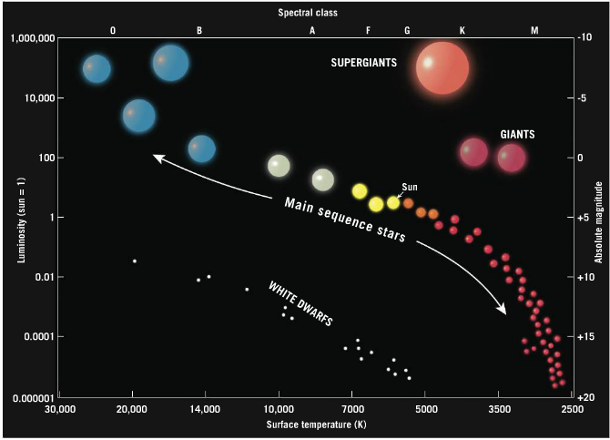

|  |  |  |  |
| --- | --- | --- | --- |
| Main Sequence | Red/Blue Giant | Red/Blue Supergiants | White Dwarfs |
| * 90% of all stars * Fuse hydrogen into helium * Vary in temp, size, luminosity | * 10 – 100x the sun’s diameter * Size let’s them be very luminous despite temperature | * 100x the sun’s diameter * Luminous regardless of temp due to size | * Stars at the end of their lives * Outer atmosphere is lost and only glowing core remains |

Watch this Hertzprung Russel Animation: <https://www.spacetelescope.org/videos/heic1017b/>

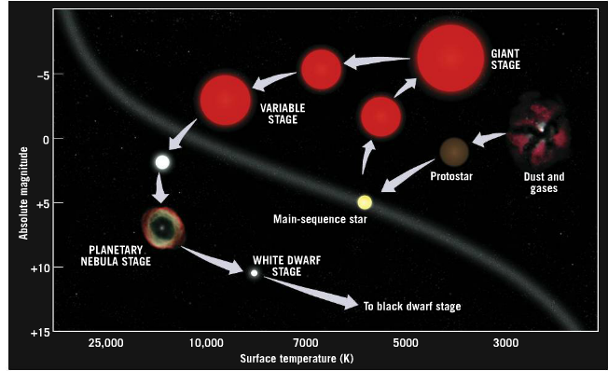**Part D: Star Evolution**

***Important: A star’s life is ruled by gravity!***

**1. Stellar Nebulae**

* 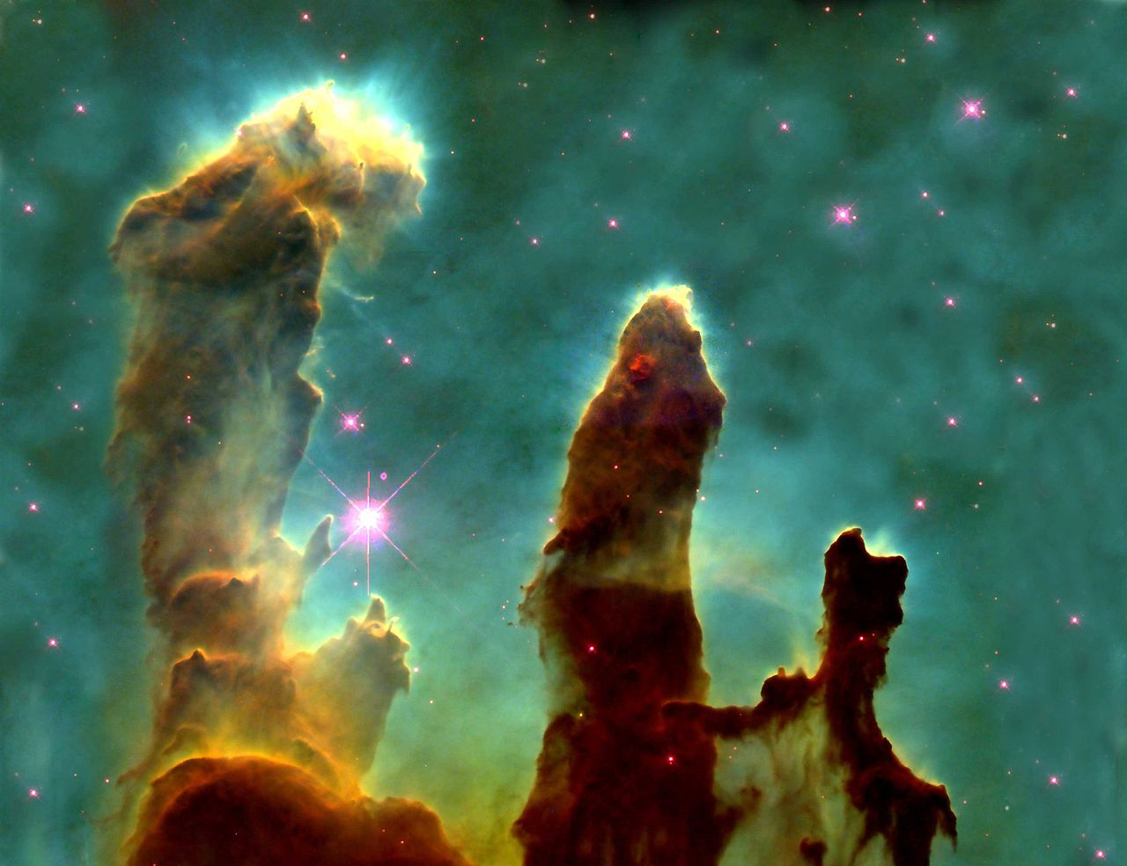The Universe cooled enough for gravity to be able to pull gas (**H and He**) and dust (heavier elements) together into massive clouds called **nebulae**.
* Gravity causes nebula to **contract**
  + causes an increase in the gases’ temperature (gravitational energy is converted into thermal energy).

**2. Protostar Stage**

* created when gas is heated to a high enough temperature to radiate **long-wavelength red light.**

Why are protostars not considered “real” stars?

**They don’t undergo nuclear fusion of four hydrogen into one helium**

Star producing Eagle Nebula

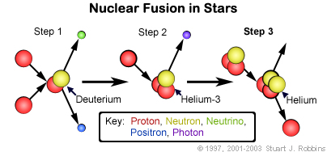**3. Main-Sequence Stage (Hydrogen fusion)**

**Nuclear fusion** releases an immense amount of **heat:**

**a) What effect would this have on the gas inside of the star?**

**Volume would increase**

**b) Is this effect a good, bad or neutral?**

**Good, as the outward pressure exactly balances the inward pull of gravity**

**As long as this balance is maintained, the star is stable**

* Stars remain in the main-sequence for **90%** of their life and rapidly evolve/die when they run out of **hydrogen** to fuse.

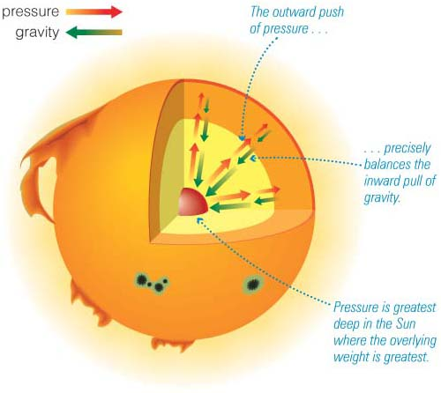**4. Red Giant Stage**

Without any hydrogen to fuse, what would happen to the volume of a star’s core?

**Decrease, as gravity is no longer balanced by the outward pressure of H fusion**

What effect would this have on the temperature of the star’s core?

**Increase, gravitational energy is converted into thermal energy (Increase molecule collision in a smaller volume)**

* The additional energy is directed outwards and causes an increase in the hydrogen fusion rate outside of the core.
  + - * + this generates more heat and causes the gaseous outer shell to expand and cool.
        + The **balance** between **gravity and gas pressure** is eventually re-established

the increase in temperature in the star’s core allows it to fuse He into C

massive stars will eventually fuse all elements up to iron on the periodic table

**5. Burnout and Death**

* Stars eventually **run out of nuclear fuel** and eventually **collapse** due to the force of gravity. However, stars have different deaths depending on their mass.

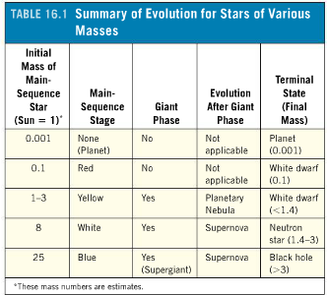**6. Stellar Remnants**

*Take your own notes from text 16.4 (pg. 492) on stellar remnants.

White Dwarf

* **Gaseous core that remains after outer layers of low mass stars is ejected into space**
* **Gravity collapses the core into a small hot star**
* **Without internal source of energy they slowly cool and become black dwarfs**

Black Holes

* **If core remaining after supernova explosion is more than 3 solar masses**
* **More dense than neutron star**
* **Surface gravity is so great even light cannot escape**

Neutron Star

* **Core of massive stars**
* **Generated during explosive supernova event**

*Video: Life and Death of Stars. Complete the note sheet provided.

**Part E: Stellar Investigations**

* Stars are one of the most obvious components of the Universe and through studies of their characteristics have revealed a great deal about it.

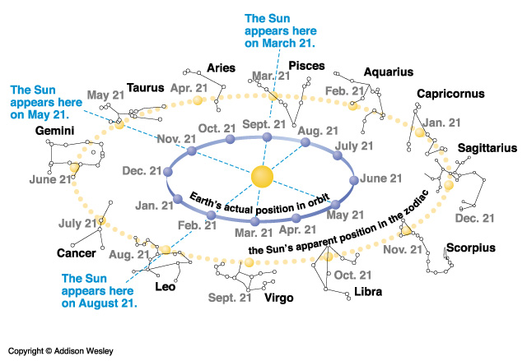**Constellations**

* Constellations are human’s way of making sense of the stars that fill our sky and their movements.

What are some of the important purposes constellations have had for humanity?

**Navigation, seasonal patterns (agriculture, migration), cultural myths**

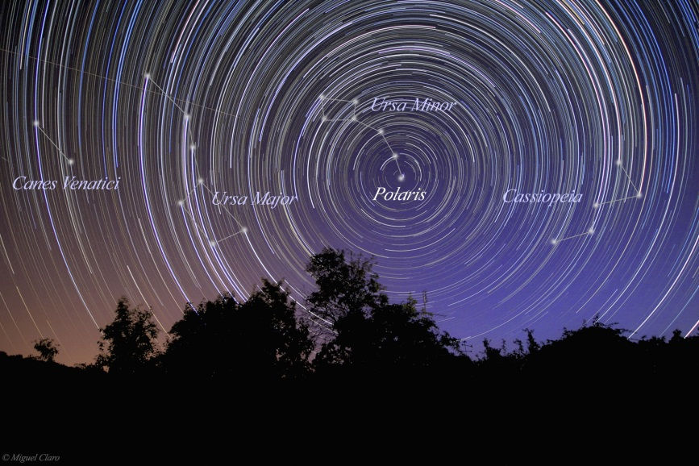______________

* Earth’s motions cause the apparent motion of the constellations:

a) Earth **rotation** is from west to east. This causes the stars to “move” from east to west.

b) Earth’s **revolution** causes the seasonal movement of the stars.

Why do some stars, like Polaris (North Star), never seem to change their position in the sky?

**Directly above Earth’s axis (poles) and as such in the centre of Earth’s rotation**

**Part F: Galaxies**

* Galaxies are collections of dust and gas clouds, stars, stellar remnants and planets held together by gravity

|  |  |  |
| --- | --- | --- |
| **Galaxy Type** | **Shape** | **Characteristics** |
| **Spiral** |  | -Flat, disc-shaped with arms extending from nucleus.  -Older stars (yellow colour) are found in the centre and younger ones (blue colour) in the arms. |
| **Elliptical** |  | -Elliptical shape, lack arms.  -Include the largest and smallest galaxies.  -Large elliptical galaxies contain older, low-mass stars and little dust and gas clouds = low star formation rates. This makes them look yellow to red in colour. |
| **Irregular** | http://abyss.uoregon.edu/~js/images/heic0615a.jpg | -Product of spiral and elliptical galaxies being distorted by a larger neighbour to create a galaxy with no symmetry.  -Stars are smaller, fainter and irregularly placed. |

**Part G: Big Bang Theory**

* 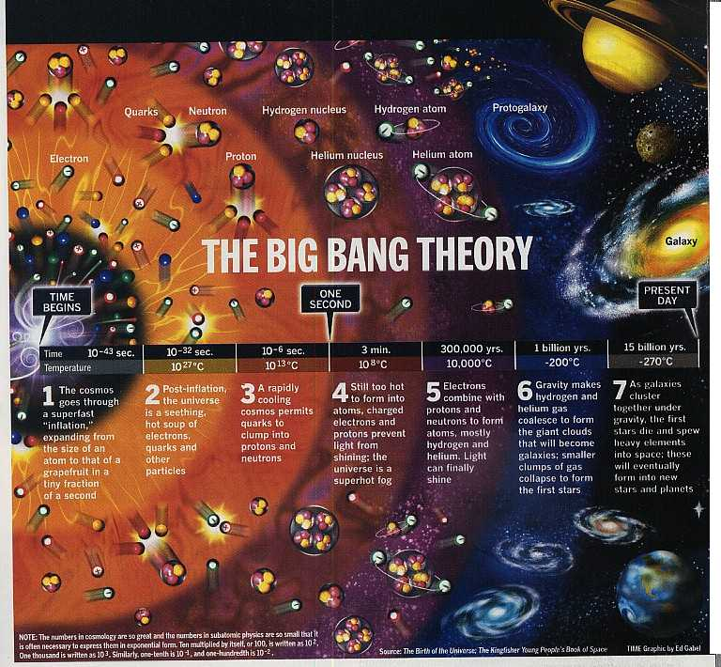The Big Bang Theory states that all matter existed in a hot, dense state and expanded outwards around 13.7 billion years ago.

What evidence do we have to support the Big Bang Theory?

Where did elements heavier than H and He come from to form our planets?

**Death of stars; Matter fused into heavier states by nuclear fusion and expelled into space by supernova explosions**

Use your text and <http://www.bbc.co.uk/science/0/20932483> as resources

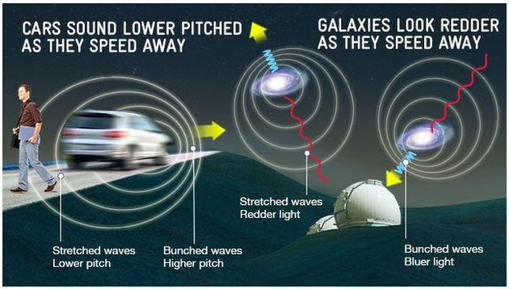**1. Doppler Effect**

Explain how the Doppler Effect supports the Big Bang Theory.

**All galaxies are red shifting away from Earth**

**Those farthest away are red shifting at a faster rate**

**2. Cosmic Background Radiation**

Explain how Cosmic Background Radiation supports the Big Bang Theory.

**Universe was extremely hot when created and this produced electromagnetic radiation that was high energy and short wavelengths**

**Waves stretched by expansion of universe to long wavelength radio waves**

**Detected and found to fill the entire universe**

