Science 9 Name:
Block:

1.3: How do living things sexually reproduce?

Concept 1: Male and female reproductive cells combine to produce a zygote

Sexual reproduction requires ____________ parents, each contributing a __________ cell called a

__________. The male contributes __________cells while the female contributes an __________cell

(also known as an ____________). When the male and female gametes combine, ______________

occurs.

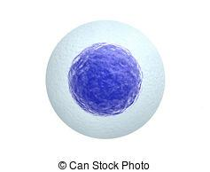
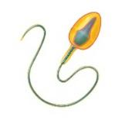

Fertilization

Concept 2: Reproductive cells are formed by a cell-dividing process called meiosis

Although human cells have _________ chromosomes, each chromosome is not unique. In fact, each

chromosome has a pair that carries almost identical information, called an _______________ pair. One

chromosome from each pair comes from the __________ while the other comes from the __________.

Human cells have ________ homologous pairs.
Homologous pair
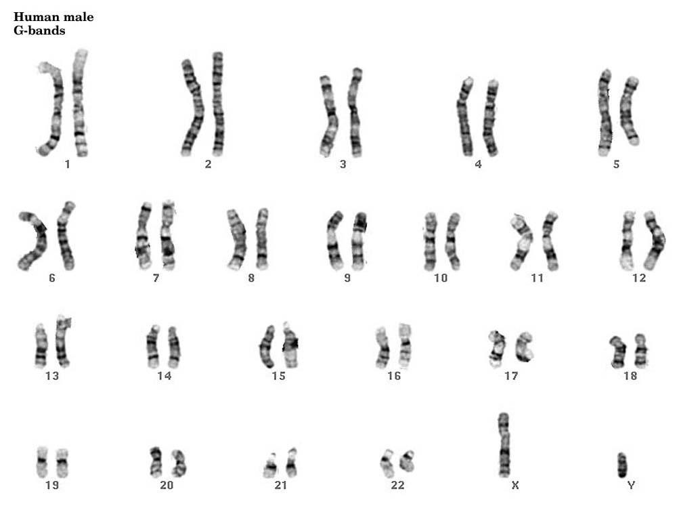

Chromosomes are numbered 1-22 and X/Y, and organized into homologous pairs. Notice that the homologous pairs have similar patterns of banding and are the same length. One of each pair comes from the mother and the other from the father.
 | Type of cell: | Number of chromosomes (in a human cell) | Number of copies of each chromosome | Formed through:
Diploid
Haploid
What is the goal of meiosis?

Meiosis

Meiosis is composed of two phase: ___________ and ___________. During meiosis I _____ haploid

cells are formed from _______ diploid parent cell. During meiosis II _________ haploid daughter cells

are formed from _________ haploid parent cells.

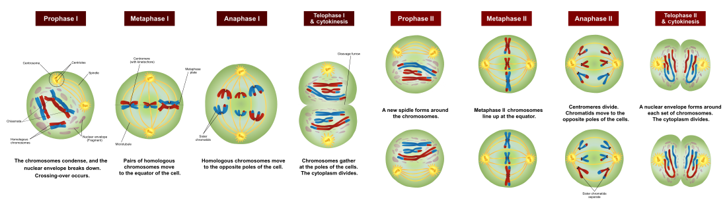

Watch meiosis video: https://www.youtube.com/watch?v=toWK0fIyFlY&t=1s

Interphase | - _______ is replicated  - Organelles are replicated  - Cell grows
Prophase I | - ______________ disappears  - DNA condenses into _______________  - ____________ chromosomes pair up
Metaphase I | - ________ __________ attach to chromosomes  - Chromosomes line up along the middle of the cell
Anaphase I | - Homologous chromosomes separate and move to each end of the cell
Telophase I | - Two __________ form and each nucleus contains a complete copy of the cell’s DNA  - The cell is ready to divide
Cytokinesis | - Cell divides into ________ cells
Prophase II | - Nuclear ____________ disappear
Metaphase II | - Chromosomes line up _________ ________ along the middle of the cell
Anaphase II | - _____________ chromosomes are pulled apart and one copy moves to each end of the cell
Telophase II | - _________nuclei form  - Cell prepares to divide
Cytokinesis | - Two cells divide into four cells

Variation and Diversity
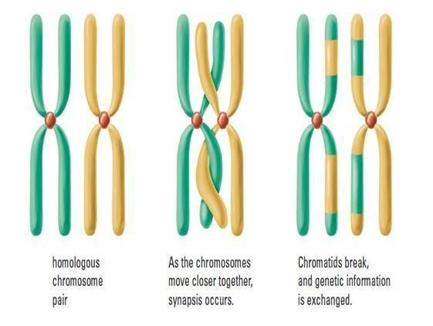
Sexual reproduction introduces diversity during meiosis in two main

ways:

- Crossing over: during __________________ the legs of two

homologous chromosomes cross over and exchange

________________ material.

- Independent assortment: during ____________ the homologous pairs line up randomly,

resulting in a random combination of chromosomes in each _______________cell.

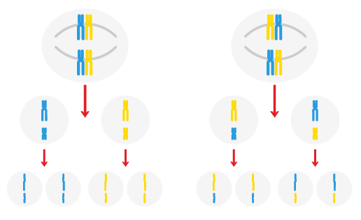
Two unique ways that two homologous pairs can line up, and the unique gametes that would be produced

