TOPIC 1.2: WHAT ARE DIFFERENT WAYS THAT LIVING THINGS REPRODUCE ASEXUALLY

Example | Type of Cell  (Eukaryotic or Prokaryotic) | Type of Asexual Reproduction
Bacteria | Prokaryotic | Binary Fission
Yeast | Eukaryotic | Budding
Mould | Eukaryotic | Spores
Plants | Eukaryotic | Vegetative Propagation
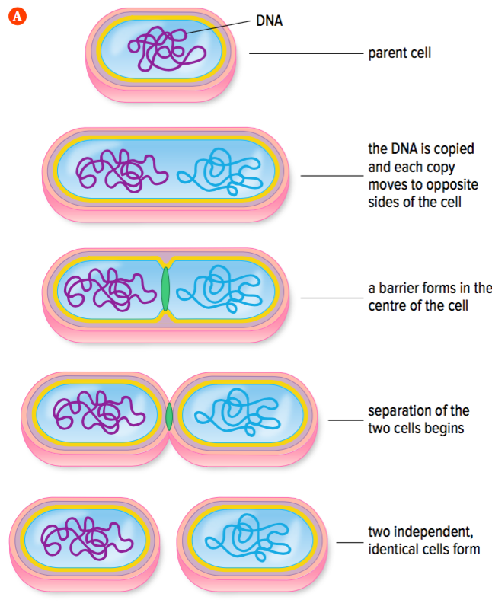
Concept 1: Bacteria reproduce by binary fission

- A parent cell splits into two individual,
___________________ cells (daughter cells)

- Daughter cells have identical genetic information (__________________)

Concept 2: All Eukaryotic cells reproduce by the cell cycle
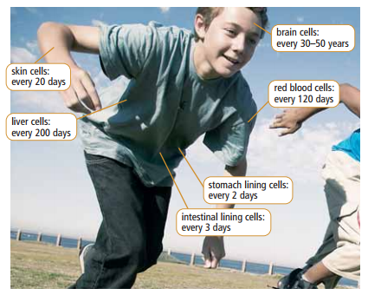
Functions of eukaryotic cell division:
- Replace older cells
- Replace __________________ cells
- Produce new ______________ in single-celled organisms (amoebas)

Reproduction and the Cell Cycle
- Eukaryotic cells reproduce by a series of events called the _________________
- The cell cycle has two stages with different events:
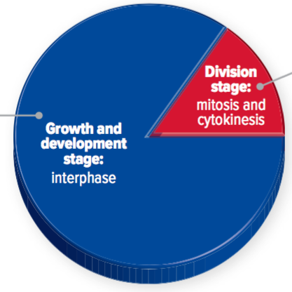
  - Growth and development
    - Interphase
  - Cell division
    - Mitosis
    - Cytokinesis
Interphase
- Cell grows and number of organelles increases
- DNA in the nucleus is _____________
Mitosis
- Division of the nucleus
- Has 4 stages: Prophase, Metaphase, Anaphase, Telophase

Prophase |  | Nuclear membrane ____________________  DNA condenses into chromosomes (each chromosome contains two copies of the same DNA)
Metaphase |  | Spindle fibers form  Chromosomes line up at the _______________
Anaphase |  | Chromosomes are separated and go to each end of the cell
Telophase |  | Nuclear membrane reappears  __________ nuclei form
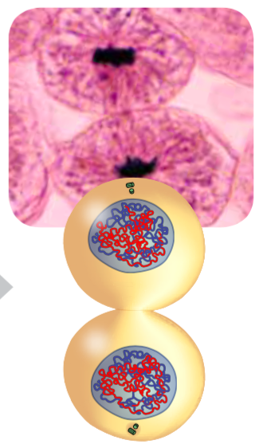
Cytokinesis
- Cytoplasm and organelles are divided
- Two separate cells form
* Watch this video to review the phases of the cell cycle https://goo.gl/xI0jGS

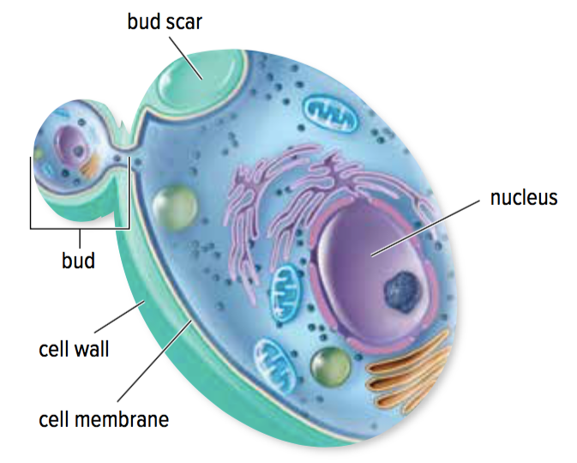
Concept 3: Yeast reproduce by budding
- Yeasts are _______________, eukayotic, micro organisms

Budding
- Yeast cell grows a bud that pinches off to become a separate _____________
- New cell is smaller than original cell at first
  - Eventually grows to the ___________ size as other yeast cells

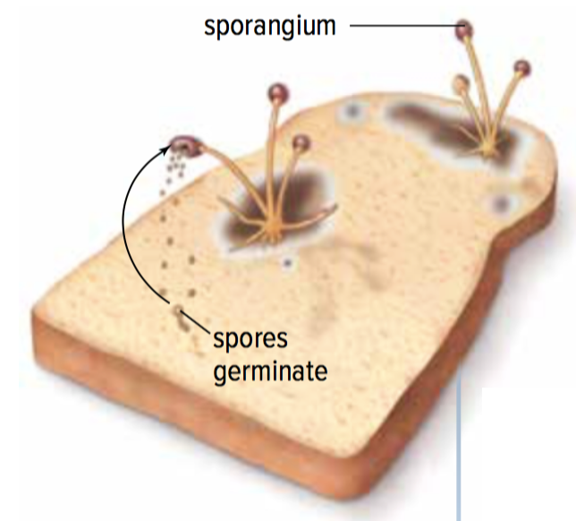
Concept 4: Molds reproduce using spores
- Moulds are composed of _________ eukaryotic cells
- Moulds form spores that are genetically ____________ to the mould cells they come from
  - Spores are released into the air from a structure called a sporangium
  - When a spore lands in a favourable environment (warm, moist), it grows and divides by ____________ and __________________
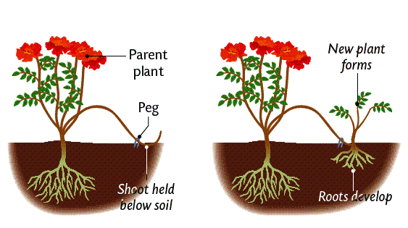
Concept 5: Plants have many ways to reproduce asexually.
- Plants reproduce sexually and asexually
- Asexual reproduction: vegetative propagation
  - New plants grow from a portion of the roots, stems, or leaves from an existing plant
  - New plants are _____________ (copies) of the parent plant

Which of the methods of asexual reproduction use mitosis?
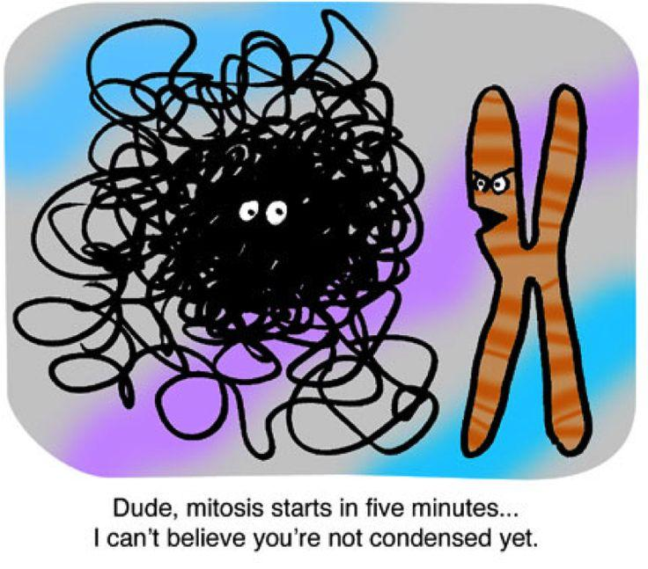

Explain this cartoon on the right. Who is talking to who? What are they talking about and why?

