CONCEPT 1: REPRODUCTION ENSURES THAT LIFE EXISTS BEYOND ITS PRESENT GENERATION.
 | Sustainability:
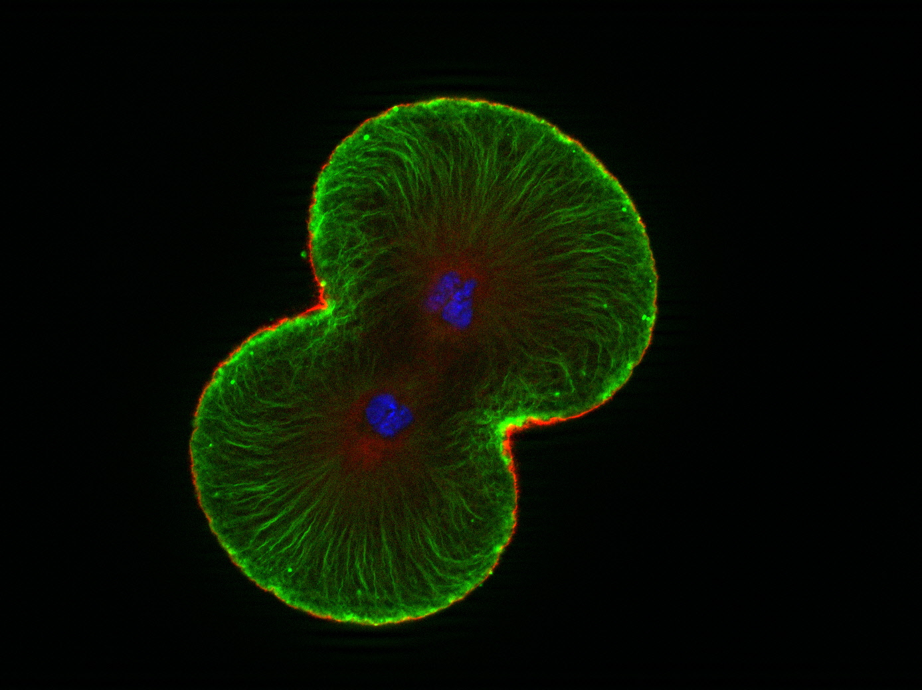 | Reproduction:
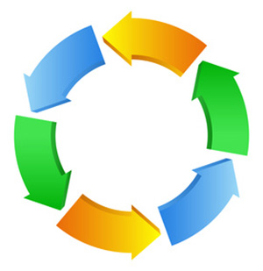 | Continuity

Explain how these three terms are related to each other.

__________________________________________________________________________________________________________________________________________________________________________________________________________________________________________________________________________________________________________________________________________________________________________________________________________________________________________

CONCEPT 2: REPRODUCTION TRANSFERS GENETIC INFORMATION FROM PARENTS TO OFFSPRING.

Every species has its own strategies for reproduction. See the examples below:

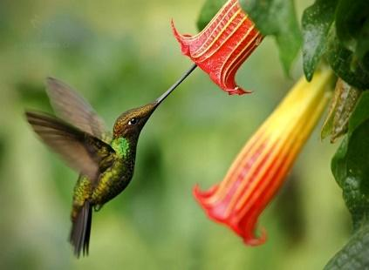 | 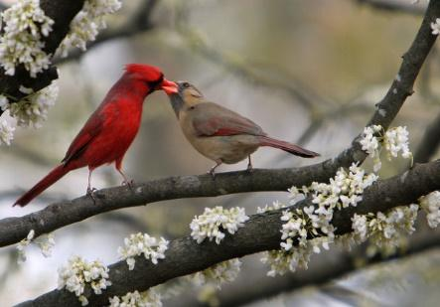 | 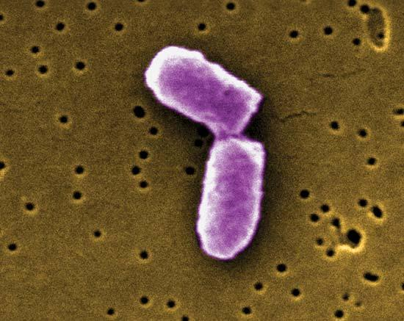
Plants have colours and scents that attract animals that can pick up and transfer pollen to other flowers | Many animals have courtship rituals. | Bacteria reproduce on their own splitting in two.

Despite these differences, there are just two basic ways that living things reproduce:

_________________________ reproduction: offspring come from a ___________ parent. Each offspring receives a copy of the parent’s genetic material. Offspring are genetically ______________________ to their parent and each other.

_________________________ reproduction: offspring come from _______ parents who each contribute half of the offspring’s genetic material. Offspring are genetically ______________________ than their parent and each other (unless they’re identical twins!).

In both asexual and sexual reproduction, the genetic material/information is passed on to offspring through a molecule called _____________.

DNA carries the master set of instructions for cell function
- Stores the _____________ _______________________ of an organism
- Genetic information determines how an organism ________, ______________, and _______________.
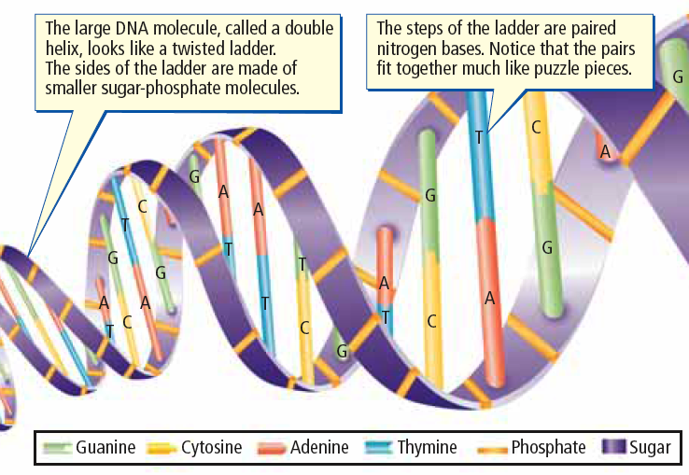

DNA: Structure
- Two long strands shaped like a _______________ _______________________
- Consists of many copies of four different chemical building blocks called ____________________: adenine (A), thymine (T), cytosine (C), guanine (G)
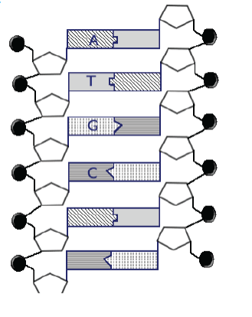
- DNA sequence: The specific order of ___________________; the “code” that holds the genetic information.

Use the image at the right to complete the follow:
Circle a nucleotide.
Label the sugar and phosphate.
Label the bases that are not already labeled

DNA: Function
- Stores the ___________ ___________________ of an organism
- An organism’s DNA is stored in each of its _____________.
- DNA molecules coil and compact into a condensed form called _______________ to fit into the cells
- Just before reproduction: DNA condenses further into structures called _______________________
- During reproduction: Copies of chromosomes (and therefore DNA) are transferred the
________________________.
https://www.youtube.com/watch?v=xUrlreMaUrs
Label the diagram below using the terms: chromosome, DNA and chromatin
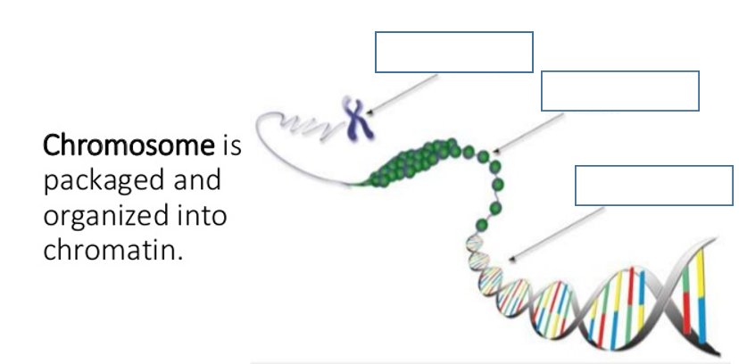
HYPERLINK "https://www.youtube.com/watch?v=xUrlreMaUrs"

