Explaining the Early Universe – Evidence for the Big Bang
(Refer to pp. 342 - 355 of BC Science 9)
Who is Edwin Hubble?
    - First astronomer to identify other ______________ besides the Milky Way.
    - By 1929 he estimated the distance to 46 galaxies.
    - Determined all galaxies are moving _________ from each other.
- The speed of their movement was ______________________ to their distance.
  - Ex. Galaxies farther from the Milky Way were moving away from each other ______________ than galaxies that are closer.

- What conclusion did Hubble make when he observed that distant galaxies appeared to be moving away from each other? (see Hubble’s Proposal on page 347)
____________________________________________________________________________________________________________________________________________________________________________________________________
This leads astronomers to think about tracing the paths of the movement backward. Today, the most widely supported theory is that approximately 13.7 billion years ago an unimaginably tiny volume of space suddenly and rapidly expanded to immense size.

***Complete Activity #1 (answer the following q’s here)
1. Imagine you were located in any of the galaxies (represented by the dots). How would the other galaxies appear to be moving in relation to you?

2. From the Milky Way galaxy, which galaxy appears to be moving away the fastest? Which appears to be moving away the slowest?

3. How is what you observed similar to what Edwin Hubble observed when he was investigating the motion of galaxies?

what is red shift analysis?
  - Hubble figured out that galaxies were moving away from Earth at a speed proportional to their distance by using a tool known as ______ ________ ____________.

BEFORE WE CAN UNDERSTAND WHAT THIS MEANS WE NEED TO REFRESH OUR UNDERSTANDING OF ELECTROMAGNETIC RADIATION
Electromagnetic Waves
- What is electromagnetic radiation? ____________________________________________________________________________________
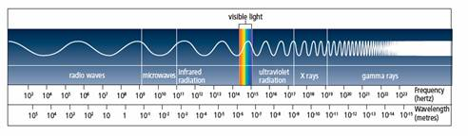

- Types of electromagnetic radiation from the longest to shortest wavelengths include:
___________________, _________________, ____________________________, ___________________, __________________________________, ____________, and _____________________.
- Stars and galaxies radiate ______________________, __________________ and __________.
Spectral Patterns
- Remember that visible light is only a __________ part of the electromagnetic spectrum
- White light separates into the colours of the rainbow when it passes through a ____________.
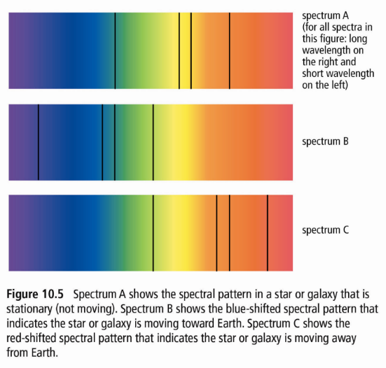
  - A ________________________ is an optical instrument that separates light into the spectrum.
      - It displays the unique spectrum of a star, which astronomers can analyze to discover the ___________________ and amount the light has shifted.
      - Can view the ____________ ________ produced by the light source and measure the wavelengths.
Red Shift explained: https://www.youtube.com/watch?v=Vz7XGqqpX74

***COMPLETE ACTIVITY #2 TO HELP UNDERSTAND RED/BLUE SHIFT
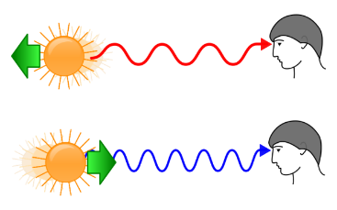
Cosmological Red Shift
- By examining the light from distant stars, astronomers can estimate the speed and directions the star is traveling.
- red shift: ______________________________________________________________________________________________________________________________________________________________________
        - “red-shifting”: the wavelength is getting ____________, and the star is moving _________ from us.
        - “blue-shifting”: is the opposite; the wavelengths are getting _____________, the star is getting ____________.
- cosmological red shift: __________________________________________________________________________________________________________________________________________________________________________
- the main evidence for a theory that explained the early universe.
WHAT IS THE BIG BANG?
Watch: https://www.youtube.com/watch?v=LeUcjqqhNxM – “Big Bang simulation”
- The Big Bang theory suggests that everything in the universe came from a ________ starting point, approximately _______________________ years ago, when a tiny volume of space suddenly exploded and rapidly expanded to immense size.
  - first described by a Belgian priest and physicist _______________ ________________ (1927).
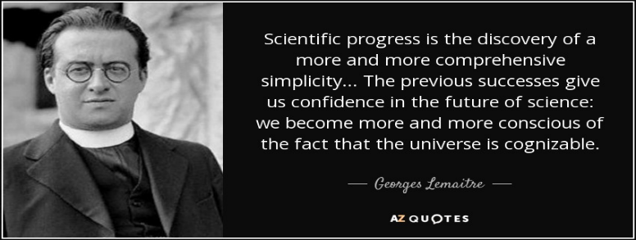
Fun Fact: At the start, his idea was ridiculed by other scientists. British astronomer Fred Hoyle sarcastically nicknamed Lemaître’s theory “the Big Bang.” Since then, both the theory and the nickname have endured.

Evidence Supporting the Big Bang Theory
  - Although there are other theories about the beginning of the universe, much scientific evidence supports the Big Bang theory. Use the textbook and your notes to fill in the comic strip below.
  - Also this video may help with COSMIC BACKGROUND RADIATION (3RD SLIDE): https://www.youtube.com/watch?v=1kqWWLpyMpY
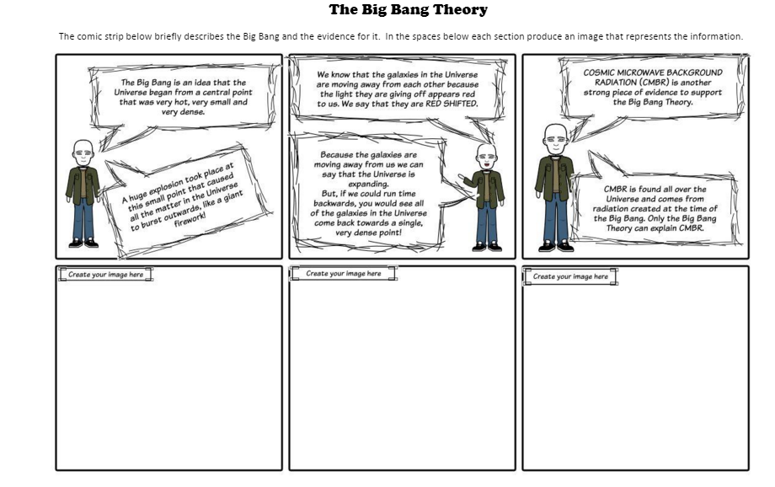

**Complete all of 10.1 in your workbook.

