How Big is Our Universe? (Measuring Distance in Space) Name:
Date:
Block:

After completion of the scale models of the planets, answer the following questions:
- Solar system objects are typically described as inner and outer. Based on your scale models, describe what you notice about the:
(a) size of the inner planets compared with the outer planets ________________________________
___________________________________________________________________________________
(b) distances to the outer planets compared with the inner planets ____________________________
___________________________________________________________________________________
- How do the distances between the inner planets compare with the distances between the outer planets?_______________________________________________________________________________________________________________________________________________________________

- It is difficult to understand the immense size and scale of the universe. Watch this video to give yourself a better understanding of just how immense the universe is.
https://www.youtube.com/watch?v=1Eh5BpSnBBw
- Check out the scale below: ex. If the size of a human is 1, then the observable universe is about 10²⁶. This video and simulation gives you an idea of how this works. https://www.youtube.com/watch?v=bhofN1xX6u0
- Check out some of the very large and very small object in our universe shown in the simulation! http://htwins.net/scale2/

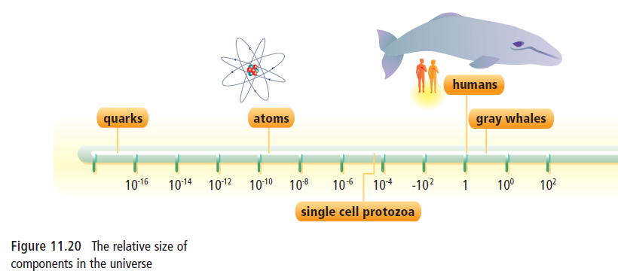

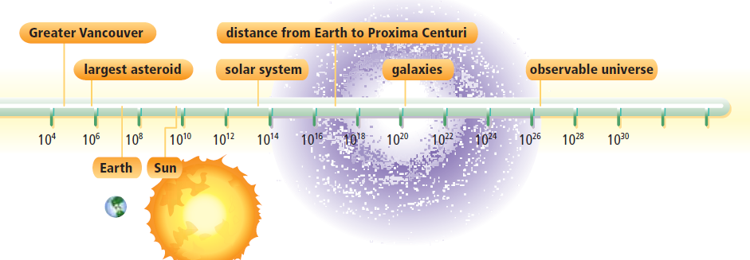

(Refer to pp. 396- 404 in BC Science 9).

Just as you wouldn’t use millimeters to measure the distance from Vancouver to New York, measuring distances in space in kilometers can be meaningless. We therefore need to use other units of measurement: Astronomical Units (AU’s) and Light Years

Check out this video on how distances are measured in space – the questions below are based on this video https://www.youtube.com/watch?v=Op3AYaJc0Xw
- About how far can light travel in one year? ____________________________________________
- The moon is only 1 light second from earth. What does that mean? ________________________________________________________________________________
- Trigonometric Parallax is used to measure the distance of objects no more than a thousand light years away. What is the method called for measuring objects even farther away? ________________________________________________________________________________
- How long will light from the sun take to reach us? _______________________________________
- “The further we can look back, the __________________ the universe we are probing.

UNITS FOR MEASURING DISTANCE:
      - Within our solar system: ________________________
      - Outside our solar system: _______________________
ASTRONOMICAL UNIT
- 1 AU = __________________________________________
- Ex. Jupiter is 5.27 AU’s from the Earth so therefore is 790.5 million kilometers (5.27 AU x 150 million km/AU)

LIGHT-YEARS
- _______________________________________________
      - 1 ly = ________ ________________ km.
      - Ex. The Andromeda galaxy is 2.5 million light-years from Earth.

Answer the following questions.
- An astronomical unit (AU) is the average distance between Earth and the Sun. Explain why the distances between bodies in the solar system are measured using AUs.

- The moon is at an average of 384,400 km from Earth. How many AU’s is this?

- Andromeda (the nearest galaxy to the Milky Way) is said to be 2.5 million light years away. How many kilometers is that?

