Earth Science 11: Earth Materials, Sedimentary Rocks
Chapter 1, pages 56 to 66
2.4: Sedimentary Rocks
Sedimentary Rock Formation
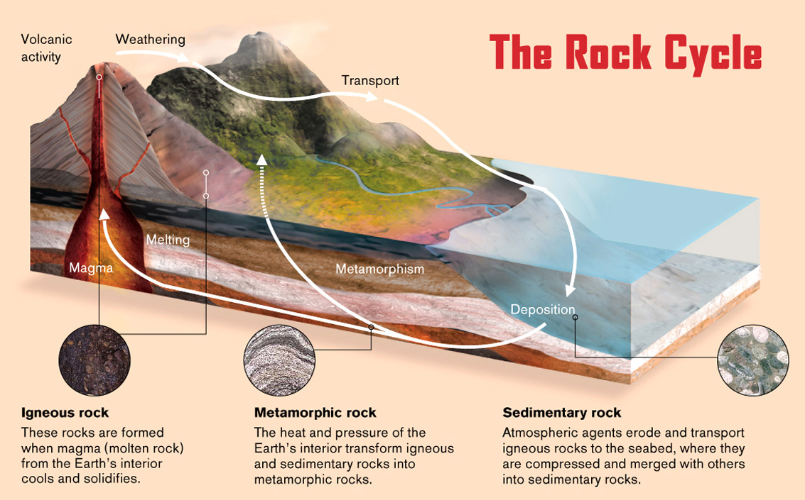
- All sedimentary rocks form through compaction and cementation of layers of sediment.

There are three different formation processes that produce different types of sedimentary rocks:
1) Clastic (or Detrital) Sedimentary Rocks
- Clastic sedimentary rocks are formed from the breakdown of other rocks that can range in size from boulders to microscopic clay.

There are 5 steps in the formation of clastic rocks:
Weathering | All the processes that break down rocks in the environments near earth’s surface  Mechanical Weathering – processes that tear rocks apart by breaking them  Chemical Weathering – processes that break down rocks atom by atom through chemical reactions.
Transportation | Clay, sand and ions are carried away from their sources ie. landslides, glaciers, rivers etc. sand grains become more round the further they travel
Deposition | Sediment is dropped in a depositional environments such as a beach, lake or salt flat.  Areas with stronger currents will collect sand and wash away finer sediment
Burial | Gradual sinking of the environment and more deposition on top leads to burial of the sand. With time burial can reach 10 or more km
Lithification (Cementation) | Sediment is compacted as it is buried. Secondary minerals grow in the pores between grains to lithify it (cement it). This helps hold the sediment together

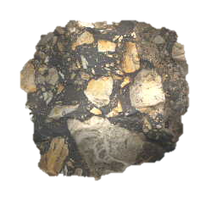
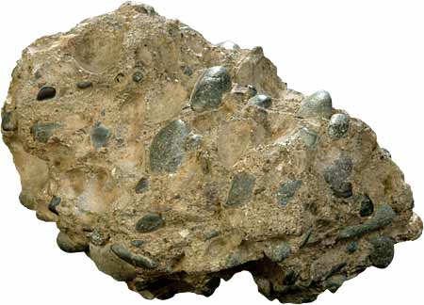
Which of the rocks below was transported the farthest from its source? How do you know?
The first rock because it has smaller sediments which are carried further from their source due to their size

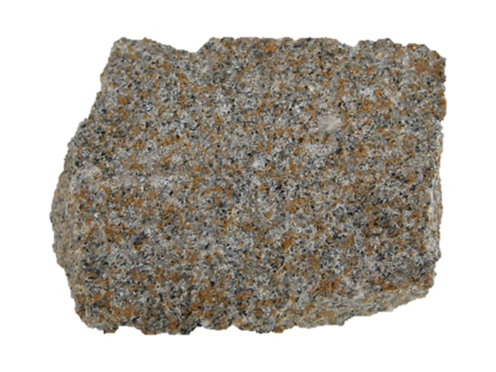
Which of the rocks below was deposited deeper in an ocean or lake? How do you know?
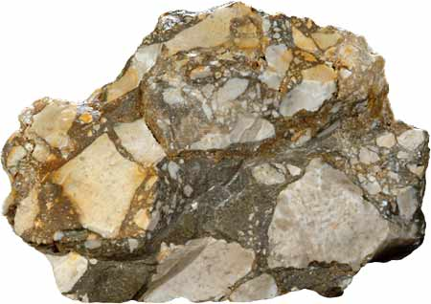
The first because only smaller sediments can be transported that far from the coastline

2) Chemical Sedimentary Rocks
- These rocks form when minerals dissolved in water precipitate out of solution.
Precipitation can occur in two ways:
i) evaporation of water leaving behind the mineral ie. Rock Salt
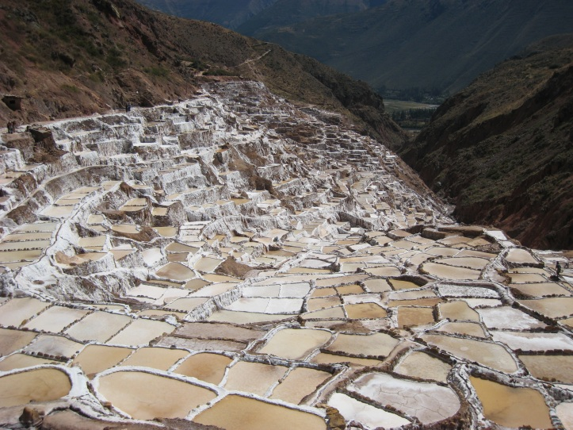
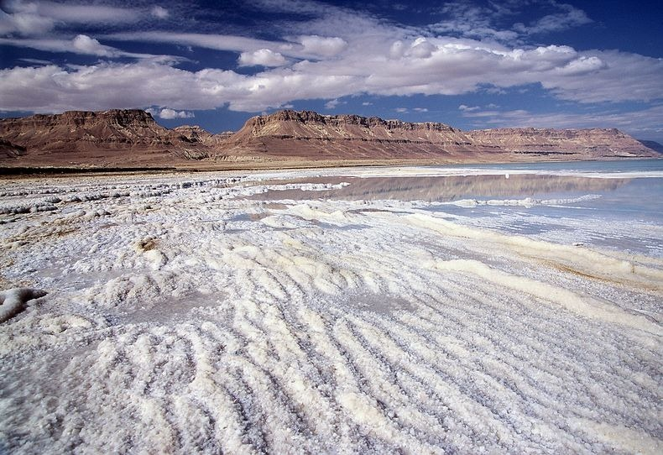
ii) organisms extract dissolved material to form shells and after the organisms die their skeletons accumulate on the floor
-These processes produce: Rock salt (Halite), Rock Gypsum and some Limestones.

3) Organic Sedimentary Rocks
- Forms from sediments consisting of plant and animal remains.
Two types of organic sedimentary rocks you may be familiar with are:
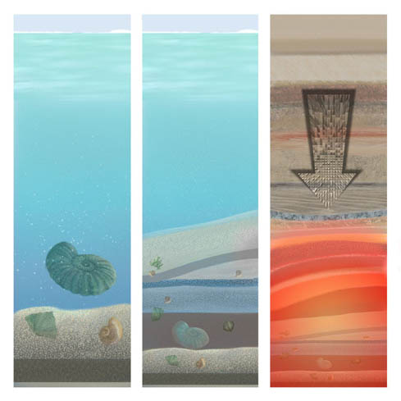
a) Limestone
- Seashells are rich in calcite, a key component of limestone.
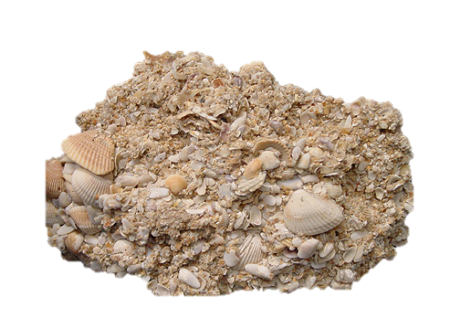
- When shelled marine organisms die their calcite-rich remains collect on the ocean floor, are buried and undergo cementation to become limestone.
-

b) Coal
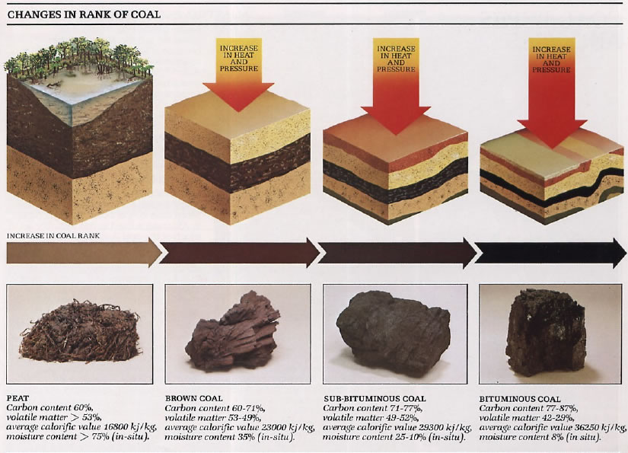
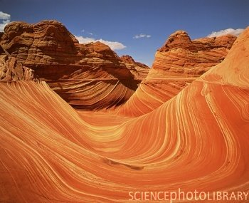
Sedimentary Rock Features
Stratification
- A result of a change in the type of sediment being deposited in one area. This creates distinct layers (called strata) piled on top of one another.
- The line between layers can reveal important information about the environment that existed between strata depositions.

Fossils
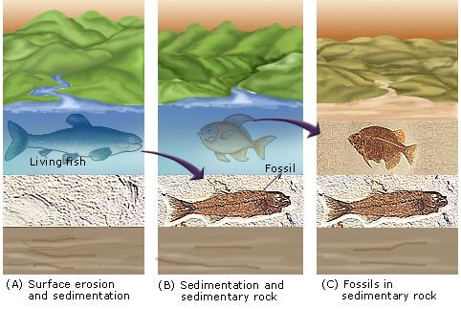
- Fossils are the remains, impression or any other evidence of life preserved in rock.
- Fossils can be useful in determining what life and environmental conditions existed at particular times in the past.
Why do fossils only form in sedimentary rocks?
made layer by layer so the fossil is preserved
The other two types of rock involve high heat or pressure which would destroy the fossil.

Ripple Marks and Mud Cracks
- Like fossils, impressions of past environmental conditions can be preserved in sedimentary rocks.
- Ripple marks are sand patterns formed by the action of water and wind.
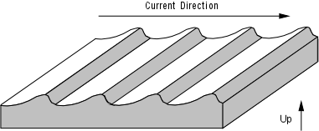
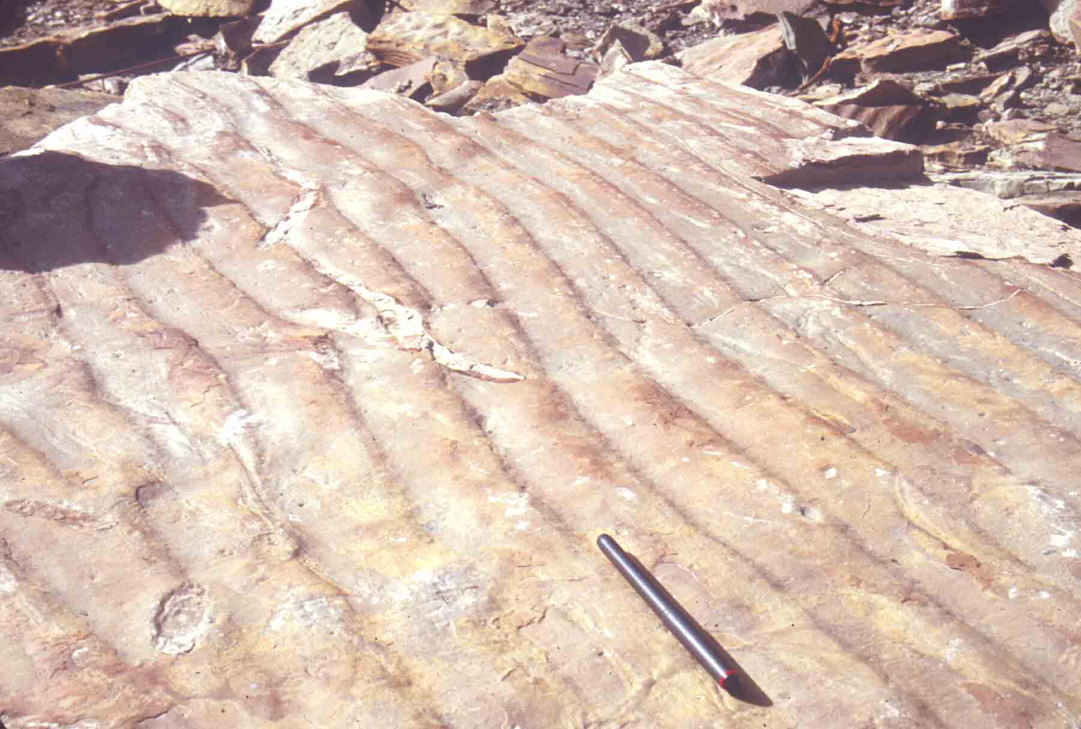
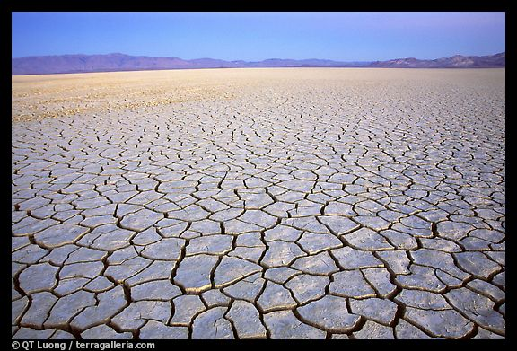
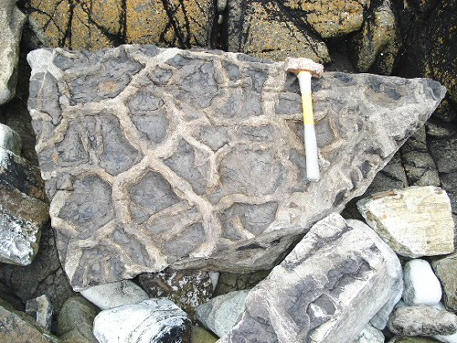
- Mud Cracks are formed when water evaporates from an area and the clay sediments dry and contract.

Nodules, Concretation and Geodes
*Take your own notes on this section.
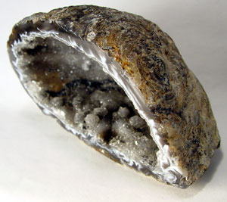
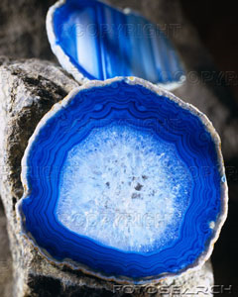
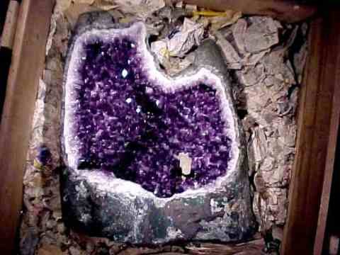

Nodules – small irregularly, rounded knot, mass or lump of a mineral or mineral aggregate that typically has a contrasting composition such as a pyrite nodule in coal
Concretation – a hard compact mass of matter formed by the precipitation of mineral cememnt within spaces between particles. Oviod or sperical in shape usually
Geodes – secondary structures which occur in certain sedimentary rocks. Formed by chemical precipitation. Hollow vaguely spheroid masses of minneral matter
- Form by filling of vesicles (gas bubbles) in volcanic rocks by mineral depositied from hydrothermal fluids
- dissolution of sedimentary nodules or concretions partial filling by the same or other minerals precipitated by hydrothermal fluids or grounds water
* Complete Activity 2.5 and 2.6 pg. 35 – 38 in your workbook

