Earth Science 11: Earth Materials, Sedimentary Rocks
Chapter 1, pages 56 to 66
2.4: Sedimentary Rocks
Sedimentary Rock Formation
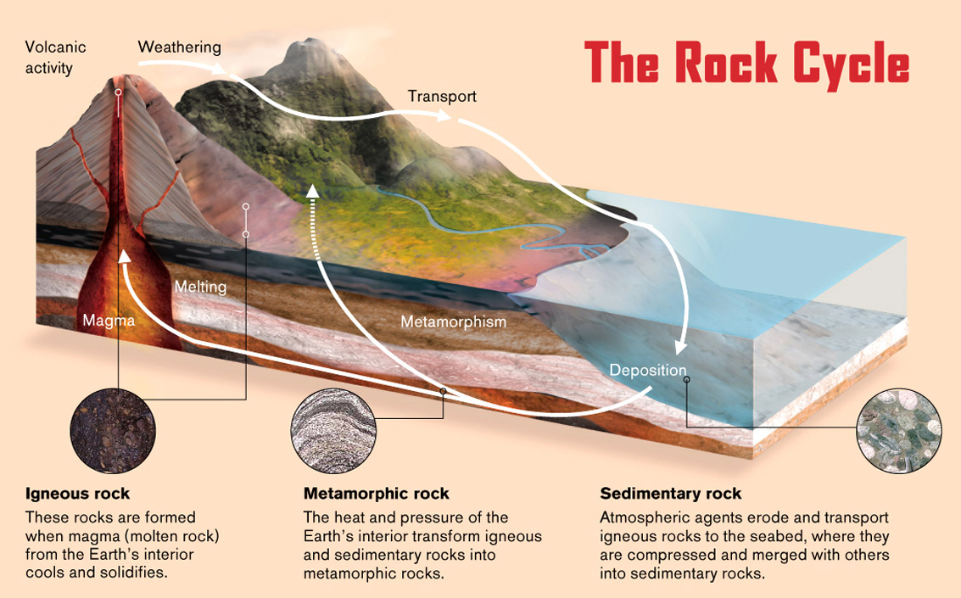
- All sedimentary rocks form through ________________________ and ____________________ of layers of sediment.

There are three different formation processes that produce different types of sedimentary rocks:
1) Clastic (or Detrital) Sedimentary Rocks
- Clastic sedimentary rocks are formed from the ___________________ of other rocks that can range in size from _______________________ to microscopic __________________.

There are 5 steps in the formation of clastic rocks:
Weathering
Transportation
Deposition
Burial
Lithification (Cementation)

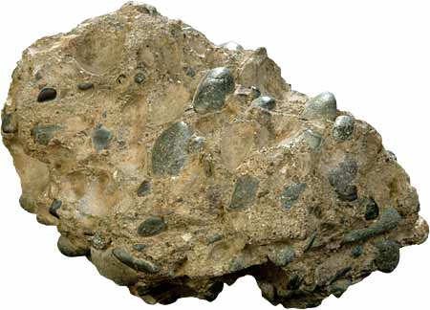
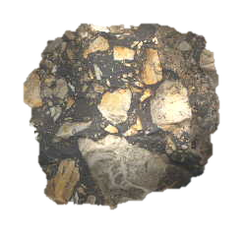
Which of the rocks below was transported the farthest from its source? How do you know?

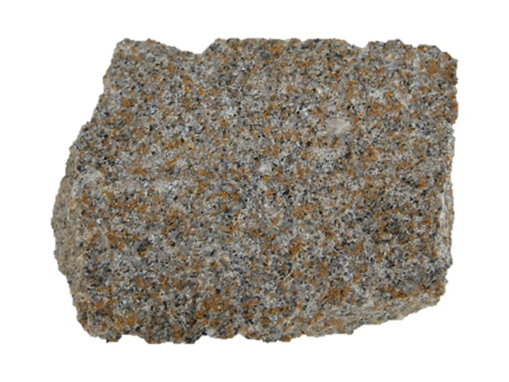
Which of the rocks below was deposited deeper in an ocean or lake? How do you know?
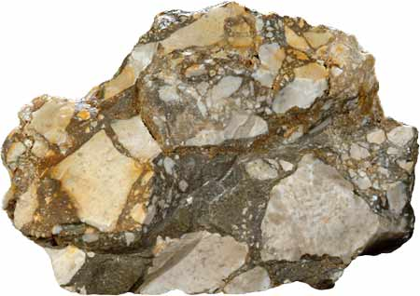

2) Chemical Sedimentary Rocks
- These rocks form when minerals dissolved in water precipitate out of solution.
Precipitation can occur in two ways:
i)
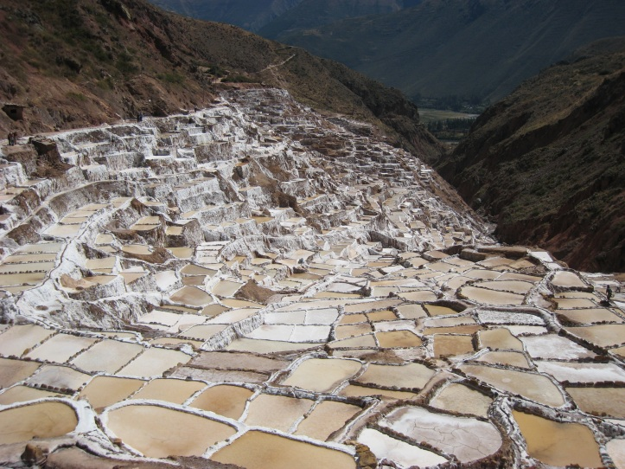
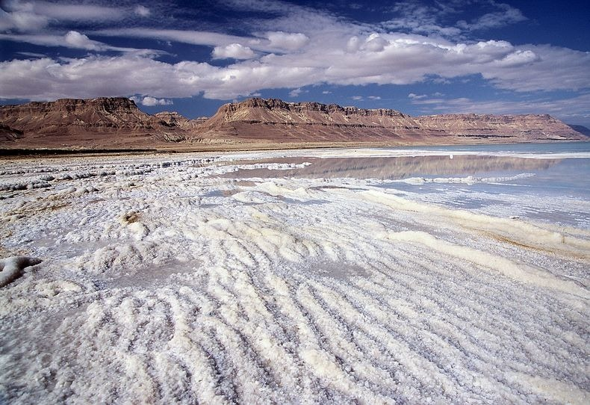
ii)

-These processes produce: Rock salt (Halite), Rock Gypsum and some Limestones.
3) Organic Sedimentary Rocks
- Forms from sediments consisting of____________________ and __________________ remains.
Two types of organic sedimentary rocks you may be familiar with are:
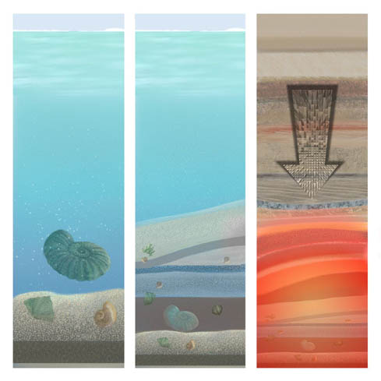
a) Limestone
- Seashells are rich in ________________, a key component of limestone.
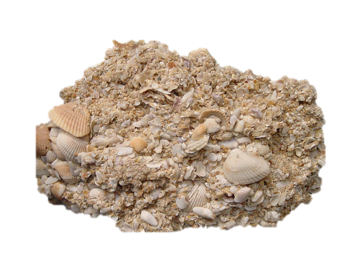
- When shelled marine organisms die their calcite-rich remains collect on the ocean floor, are buried and undergo cementation to become limestone.
-

b) Coal
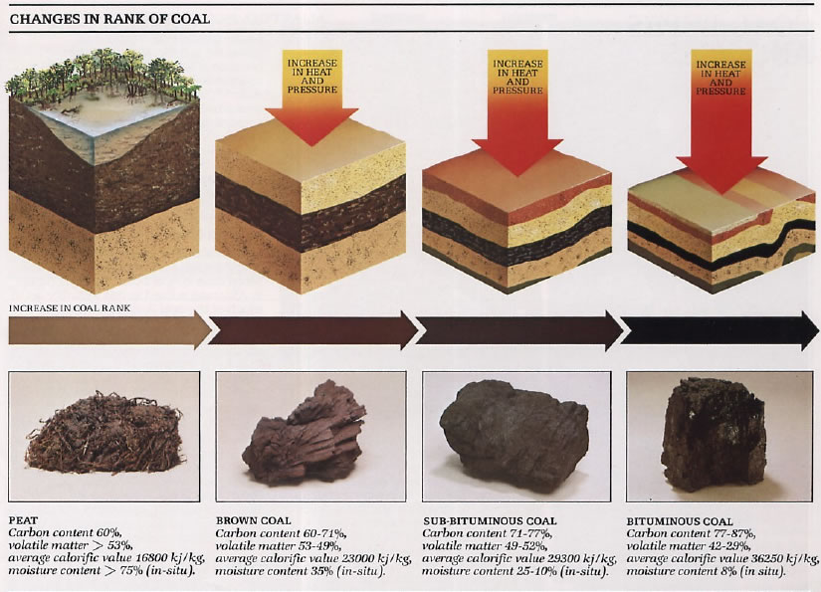
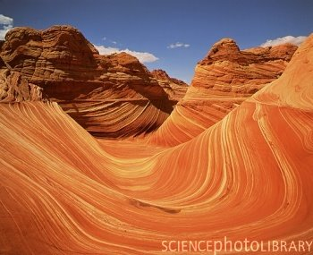
Sedimentary Rock Features
Stratification
- A result of a change in the type of sediment being deposited in one area. This creates distinct layers (called strata) piled on top of one another.
- The line between layers can reveal important information about the environment that existed between strata depositions.

Fossils
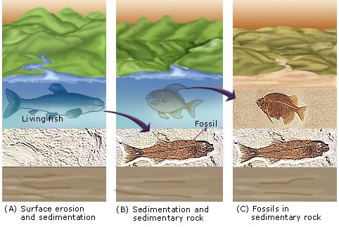
- Fossils are the remains, impression or any other evidence of life preserved in rock.
- Fossils can be useful in determining what life and environmental conditions existed at particular times in the past.
Why do fossils only form in sedimentary rocks?

Ripple Marks and Mud Cracks
- Like fossils, impressions of past environmental conditions can be preserved in sedimentary rocks.
- Ripple marks are sand patterns formed by the action of water and wind.
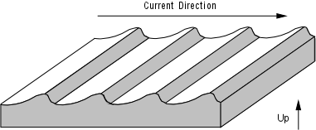
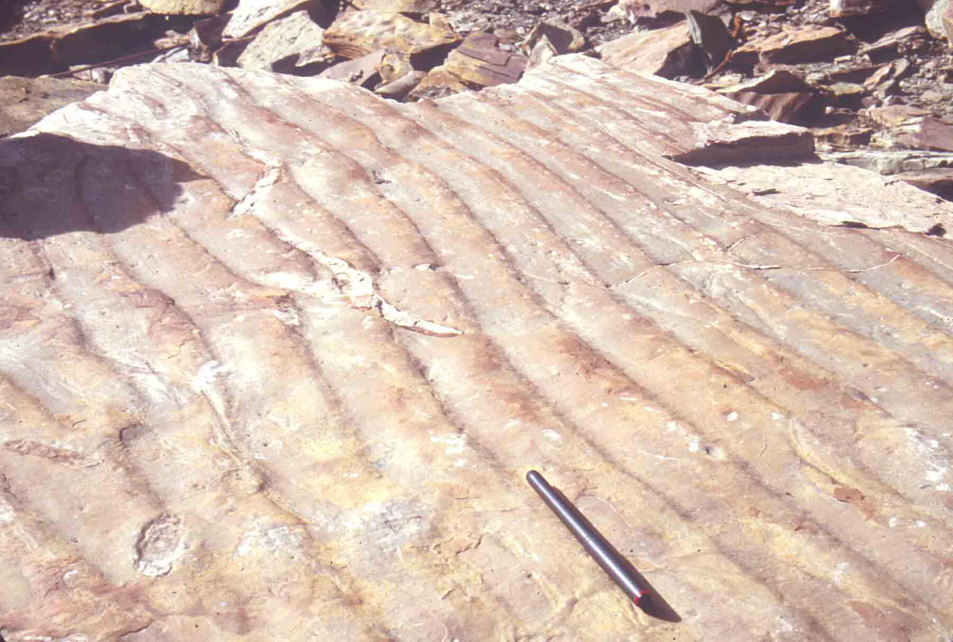
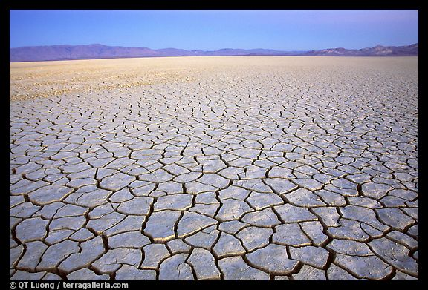
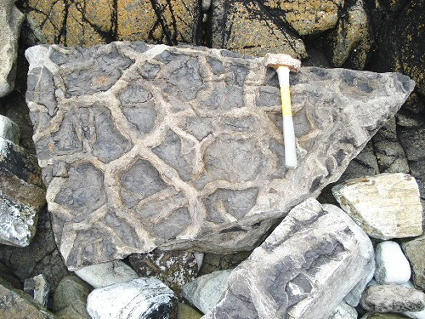
- Mud Cracks are formed when water evaporates from an area and the clay sediments dry and contract.

Nodules, Concretation and Geodes
*Take your own notes on this section.
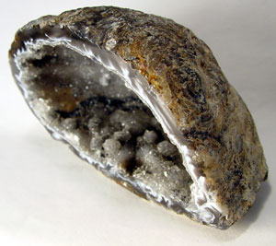
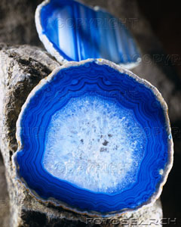
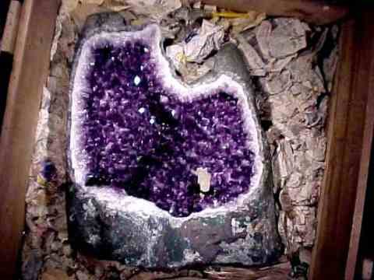

___________________________________________________________________________________________________________________________________________________________________________________________________________________________________________________________________________________________________________________________________________________________________________________________________________________________________________________________________________________________________________________________________________________________________________________________________________________

* Complete Activity 2.5 and 2.6 pg. 35 – 38 in your workbook

