Sculpting Earth’s Surface: Water
Chapter 3
Page 78 –

3.1: Earth’s External Processes

There are 3 external processes that effect the shape of Earth’s surface:
Weathering | The physical breakdown and chemical alteration of rock at or near Earth’s surface  - Physical: rock is broken down into smaller and smaller pieces  - Chemical: alters the internal structure of minerals
Mass Wasting | The transfer of rock and soil downslope, under the influence of gravity
Erosion | The physical removal of material by a mobile agent such as flowing water, waves, wind or glacial ice

3.2: Mass Wasting: The Work of Gravity

Types of Mass Wasting
Slump | Downward sliding of a mass of rock along a curved surface | 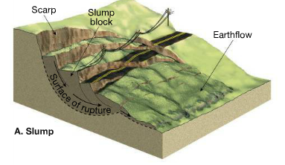
Rockslide | Block of bedrock break loose and slide very rapidly downslope | 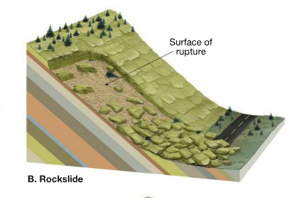
Debris Flow | A flow of weathered debris containing a large amont of water. Sometimes called a mudflow | 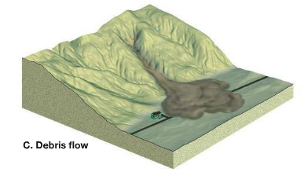
Earth Flow | The tongue-like flow of water saturated clay rich soil on a hillside that breaks away and moves downslope | 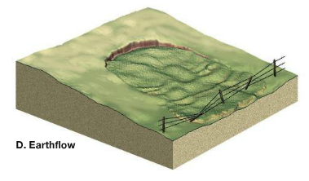

Triggers of Mass Wasting
Water | Water reduces the cohesion among particles allowing them to slide past each other more easily  Water also adds weight making it likelier to flow downslope
Over-steepened Slopes | A slope that is steeper that its stable angle  Humans can create over steepened slopes
Removal of Vegetation | Plants provide stability to the slope because of their root system
Earthquakes | Can trigger mass wasting events that have large impacts on humans

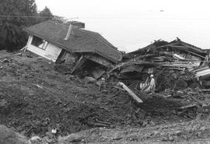
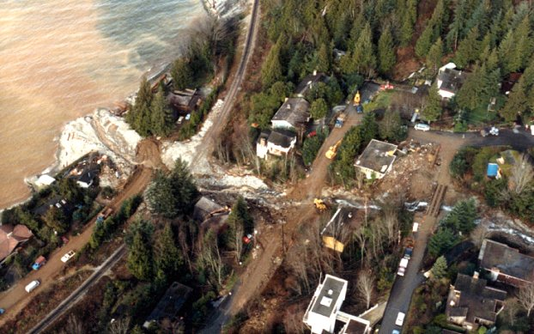
Do you know if any recent, large mass wasting events near us?
Harvey Creek, Alberta Creek in Lions Bay

https://www.youtube.com/watch?v=sNpjnJJiAZA
How are we preventing future mass wasting events?
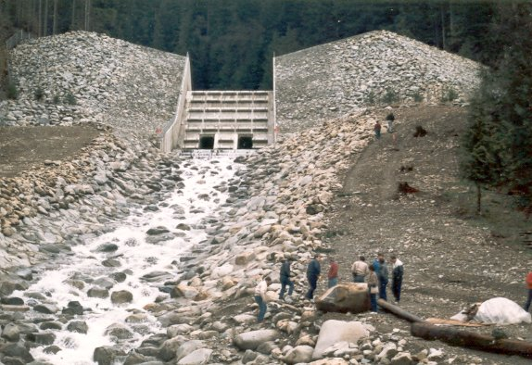
- dam-like structures that prevent debris from travelling
- Slits to let water through
- Reinforced sides of the valley ie. Cement
- Drainage pipes in rock to let water flow out

3.4: Running Water

- Combined effects of mass wasting events and running water produces stream valleys
Most of the water that falls on land enters the soil (infiltration) or remains at the surface, moving downslope as runoff.
The amount of water that runs off rather than soaking into the ground depends on:
- Intensity and duration of rainfall
Why might urban areas have higher amounts of runoff?
Large areas covered by impermeable buildings, roads and parking lots
- Amount of water already in soil
- Nature of the surface material
- Slope of the land
- Extent and type of vegetation
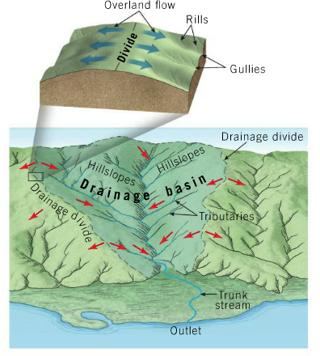
Drainage Basins (Watershed)
- the land area that contributes water to a river system.
- Drainage basin of one steram is sperated from another by a divide
  - Divides range from a ridge to continenetal divides, which split continents
River systems
- Involves a network of stream channels and their entire drainage basin
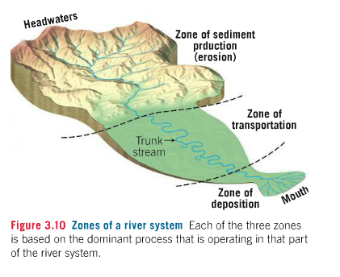
They are divided into three zones:
- Zone of Sediment Production
  - Located in the headwaters
  - Where most of the water and sediment is produced
    - Bedrock is broken down by weathering and transported by overland flow or mass wasting

- Zone of Sediment Transport
  - Sediment is transported through trunk streams
  - When they are balanced, the amount of sediment eroded is equal to the amount deposited
  - Trunk streams rework their channels overtime but are not a source of sediment

- Zone of Sediment Deposition
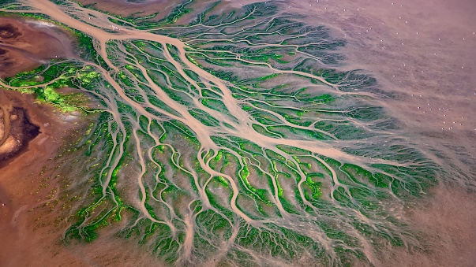
  - Where sediment come to rest, when the river reaches ocean or another large body of water the energy of transport is greatly reduced
    - most sediment accumulates at the mouth of a river and form a delta
    - They are then reconfigured by wave action to form other coastal features or moved far offshore by ocean current
3.5: Streamflow Characteristics

Water flows in 2 ways:
- Laminar flow
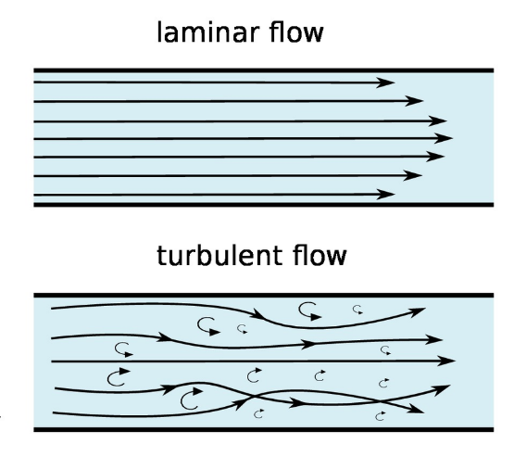
  - Moves in straight line paths parallel to the channel
  - Slow moving streams

- Turbulent Flow
  - Moves in an erratic fashion, such as swirling motions
  - Whirlpools, rapids, eddies,
  - Smooth streams can have turbulent flow on the sides or bottom of the channel
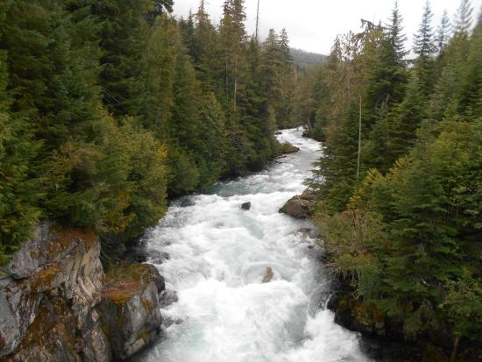
  - Erodes channel by lifting sediment from the streambed
Flow Velocity
- An important factor that effect stream turbulence is the flow velocity
- As the velocity increases, the flow becomes more turbulent
- Strength of the current increases as you move to deeper parts since there is less friction
Factors that affect flow velocity
Gradient | Slope of a stream channel (vertical drop of the stream over a specified distance)  Steeper the gradient, the more energy available for streamflow
Channel Shape, Size and Roughness | Affect the amount of friction  Larger, smooth channels have faster flow
Discharge | Volume of water flowing past a certain point in a given unit of time  Cross sectional area multiplied by its velocity  This can change with seasons, rainfall, snow melt,

3.7: Stream Channels
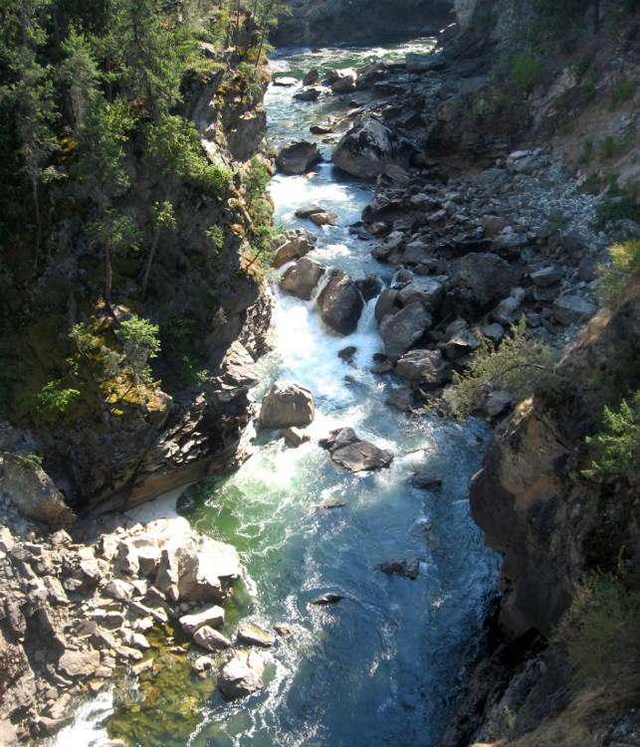
We can divide stream channels into two types:
- Bedrock Channel
  - In the headwaters because most of the rock is bed rock and there are steep gradients
  - Transport coarse particles
  - Potholes are visible evidence
  - Winding irregular pattern

- Alluvial Channel
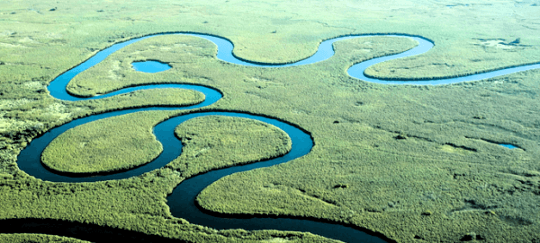
  - Loosely compacted sediment
  - Significant changes in shape because sediments are constantly being eroded
  - Meandering channels: sweeping bends with smooth, deep channels
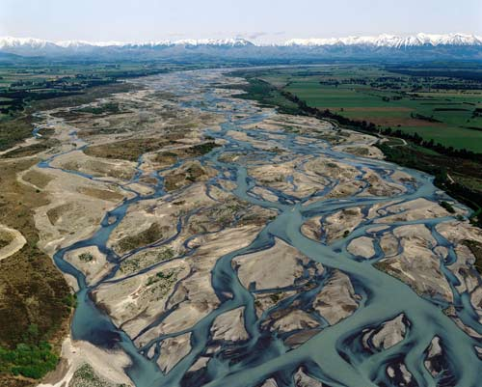
  - Braiding channels: interwoven channels

3.8: Shaping Stream Valleys

Stream Valley: the channel and the surrounding terrain that contributes water to the stream
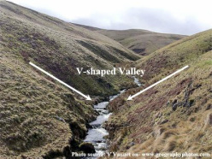
- Includes the flatter valley bottom and sloping valley sides
- Most stream valleys are broader at the top
Valleys can be divided into two types
- Narrow V-Shaped Valleys
- Wide Valleys with flat floors

