**Salmon Lesson #1: Types of Salmon Species and Life Cycle of Salmon**



Name the six species of Pacific Salmon:_



_____________________________________________



_____________________________________________



_____________________________________________



_____________________________________________



_____________________________________________



_____________________________________________



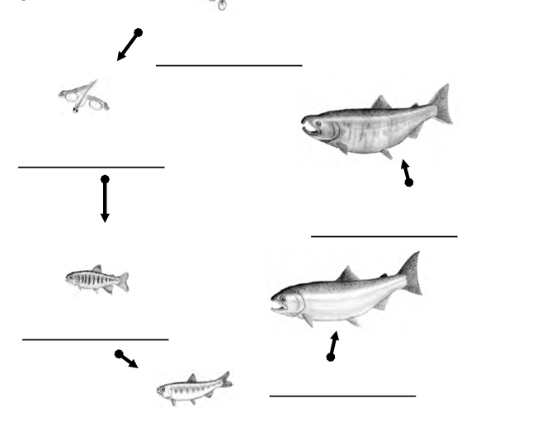List the stages of the salmon life cycle in order and include one fact about each stage of the cycle:



At what stage of their life do salmon go from fresh water (river) to ocean (saltwater)?



How long do salmon live out in the ocean before returning to the river to spawn?



It says on the Powerpoint that only _________________________ salmon survive to return to the river to spawn. List at least five threats salmon face on their journey that causes such a low survival rate.



Ex.

Pollution,

Commericial fishing,

alien species such as Atlantic salmon escaping from salmon farms taking resources,

sea lice,

predators (bears, killer whales, seals etc.)

extreme weather harming habitats like floods wiping out spawning grounds,

landslides blocking rivers,

habitat disruption from logging, agriculture etc.

not enough nutrients as young salmon etc.

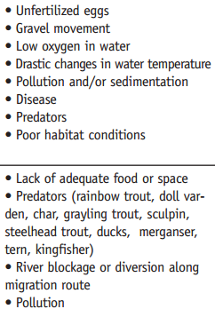



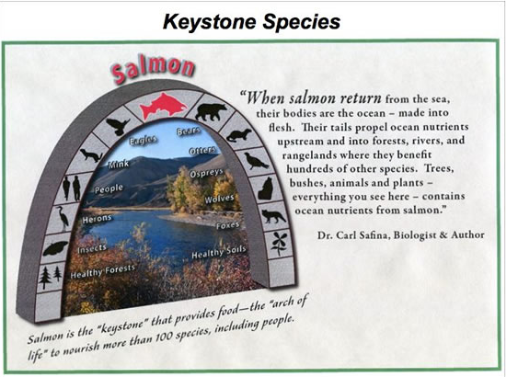

Explain why salmon are considered a keystone species.



In the table below, list the salmon species from biggest to smallest. Also include the nickname given to each species.



|  |  |  |
| --- | --- | --- |
|  | Species of Salmon | Nickname of Salmon |
| Biggest |  |  |
|  |  |  |
|  |  |  |
|  |  |  |
|  |  |  |
| Smallest |  |  |

