Salmon Lesson #1: Types of Salmon Species and Life Cycle of Salmon
Name the six species of Pacific Salmon:_
_____________________________________________
_____________________________________________
_____________________________________________
_____________________________________________
_____________________________________________
_____________________________________________
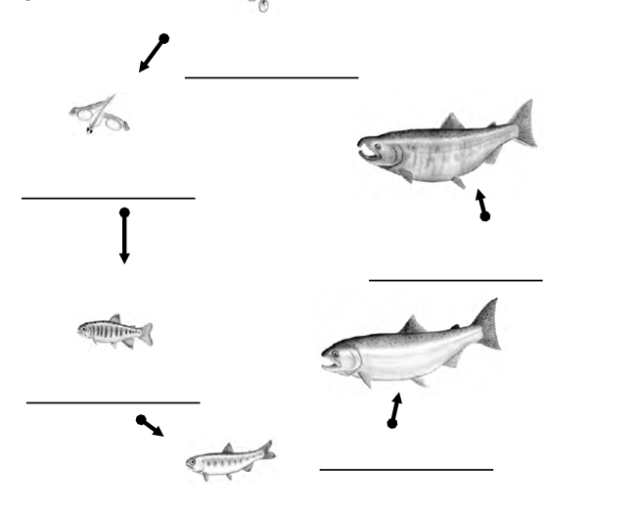
List the stages of the salmon life cycle in order and include one fact about each stage of the cycle:

At what stage of their life do salmon go from fresh water (river) to ocean (saltwater)?
How long do salmon live out in the ocean before returning to the river to spawn?

It says on the Powerpoint that only _________________________ salmon survive to return to the river to spawn. List at least five threats salmon face on their journey that causes such a low survival rate.

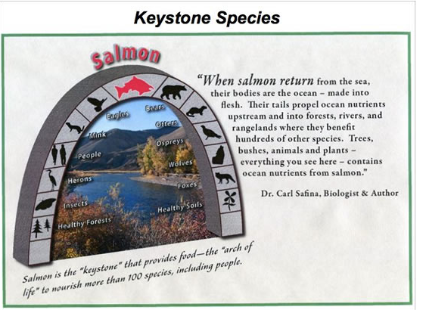
Explain why salmon are considered a keystone species.

In the table below, list the salmon species from biggest to smallest. Also include the nickname given to each species.
 | Species of Salmon | Nickname of Salmon
Biggest
Smallest

