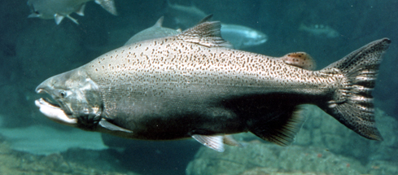

Salmon in the News
As we have learned, salmon are a keystone species here in BC as a vitally important part of our ecosystem. With that in mind, we want to increase our understanding of the issues that pertain to them.
WHAT DO I DO? You are going to be searching (online or in print) for a recent article that has to do with a current issue related to salmon (ex. Salmon farms, commercial fishing, low river levels etc.) The article can be from a newspaper, magazine or other credible online source. Remember, you are looking for a specific issue with salmon – not just general info.
With the article, you are to write a 200-300 word paragraph that includes the following:
- A summary of the issue in your own words
- Your personal thoughts on the issue
HOW DO I SUBMIT MY ARTICLE AND SUMMARY? You are going to use the Google Slideshow provided by your teacher. Each student in the class will have access to the slideshow. You will make your own slide which will include:
- The article that you chose or a link to the article
- Your summary of the article
DO I PRESENT THIS TO THE CLASS? Yes! Each student will be doing a really quick 1 minute presentation – a Salmon Slam! This presentation should explain what your article was about and your thoughts on it. (You won’t have time to read your entire paragraph)
Marking Rubric
Article Choice
Did you choose an interesting article? 1 2 3
Written Summary
Did you summarize the article in your own words in a well written paragraph? 1 2 3
Did you include your own thoughts on the issue? 1 2 3
Presentation
Is the presentation easy to follow and within the required time-frame? 1 2 3
Submitted correctly and on-time
Is your article and summary submitted on time/in the proper format? 1 2 3 Total mark /15

