**Earth Science 11: Earth Materials: Rock Cycle**

**Chapter 2, pages 44 to 46**

|  |
| --- |
| **2.1: Rock Cycle** |

**What is a Rock?**

* [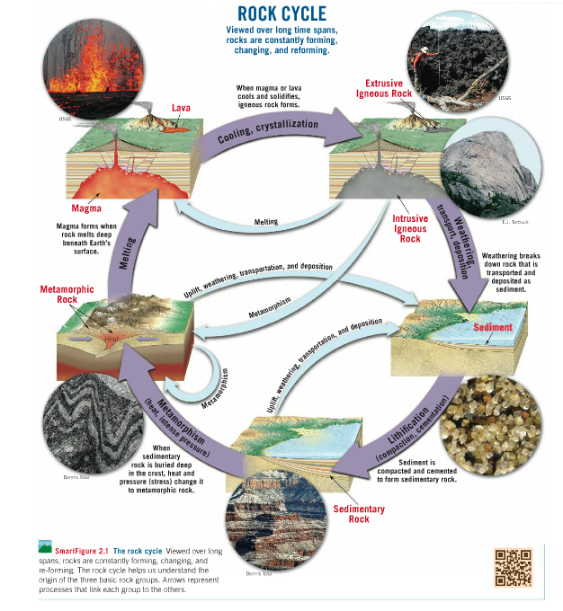](http://media.pearsoncmg.com/bc/bc_0media_geo/smartfigure/sf-RockCycle.html)A solid mass of mineral or mineral-like matter that occurs naturally as part of our planet

**Explain the statement “One rock is the raw material for another”**

*Go to the following link to learn more about the rock cycle: <https://goo.gl/q7qRd5>

Use the diagram above to describe the how the parent rock is transformed into the daughter rock. Make sure you talk about the processes involved.

|  |  |  |
| --- | --- | --- |
| **Parent Rock** | **Pathway** | **Daughter Rock** |
| *Extrusive Igneous* |  | *Sedimentary* |
| *Metamorphic* |  | *Igneous* |
| *Intrusive Igneous* |  | *Metamorphic* |

***\*Complete Activity 2.1 (pg. 28 – 29) in your workbook\****

**Earth Science 11: Earth Materials, Igneous Rocks**

**Chapter 1, pages 48 to 53**

|  |
| --- |
| **2.2: Igneous Rock Formation** |

Igneous rocks are formed by the following pathway:

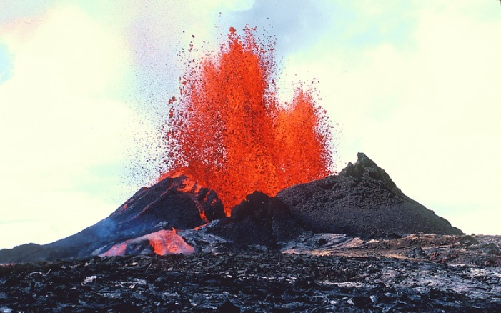

|  |  |
| --- | --- |
| **Extrusive Igneous Rock** | Molten rock solidifies at the surface |
| **Intrusive Igneous Rock** | Molten Rock solidifies below the surface |

**What two factors affect crystallization?**

**Cooling time and parent magma composition**

**What is the difference between magma and lava?**

**Magma – molten rock found in the mantle**

**Lava – molten rock found above the Earth’s surface**

**Texture**

* A rock’s texture is described using the **size, shape and arrangement** of its mineral grains.
* Texture is very useful in determining the environment in which rock’s formed.

[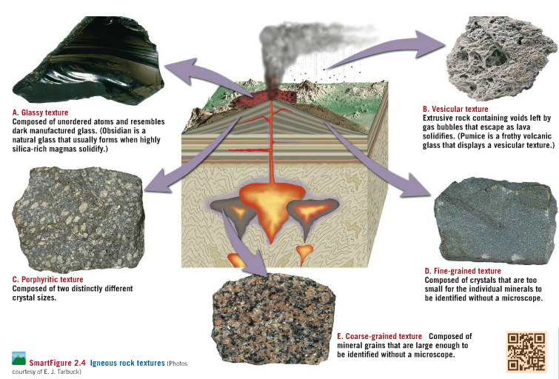](http://media.pearsoncmg.com/bc/bc_0media_geo/smartfigure/sf-IgneousTextures.html)*\*Examine the diagram below and watch the smartfigure on texture.*

**Which of the igneous textures above best describe a rock that:**

a) Cooled so quickly its atoms froze in place without forming mineral crystals? **Glassy texture**

b) Cooled slowly for millions of years below ground? **Coarse – grained texture**

c) Began cooling slowly underground but finished crystallizing quickly when it was ejected above Earth’s surface?

**Porphyritic texture**

d) Crystallized rapidly at Earth’s surface and contained a large amount of gas or water vapour? **Fine Grained and vesicular texture**

\**Complete Workbook Activity 2.2 (pg. 30 – 31)*

Use what you know about rock texture to determine the formation environment of the rocks below:

|  |  |  |
| --- | --- | --- |
|  | **Sample A** | **Sample B** |
| **Image** | http://0.tqn.com/d/geology/1/0/M/W/scoria500.jpg | **http://www.nps.gov/goga/forteachers/images/granite2-copy.jpg** |
| **Formation Environment**  *(Intrusive or Extrusive)* |  |  |
| **Evidence of Formation Environment** |  |  |

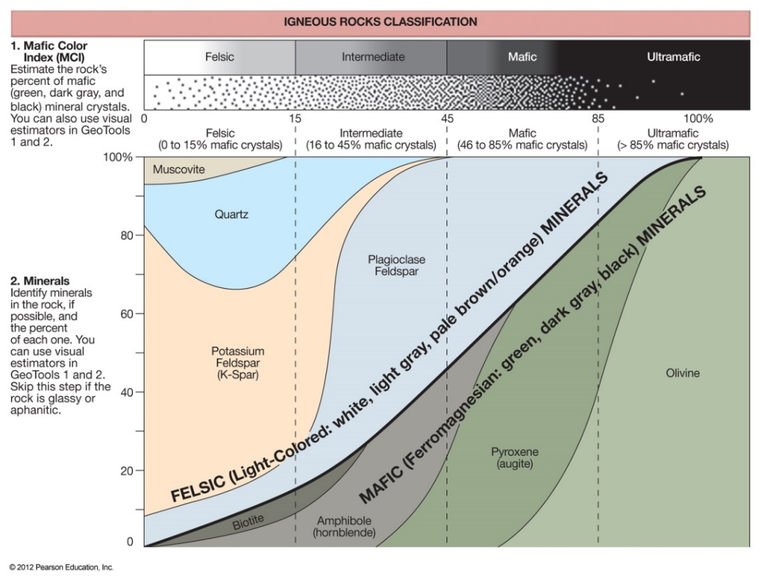

**Igneous Rock Families**

Igneous rocks are divided into four basic families based on their proportion of:

a) **Light silicate minerals**, which are silica, potassium and sodium rich.

b) **Dark silicate minerals**, which are iron, magnesium and calcium rich.

**Slica Content Increasing**

**Specific Gravity Increasing**

**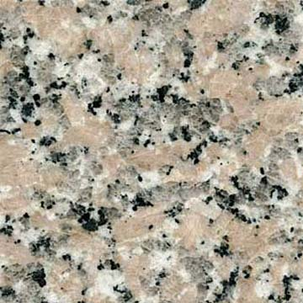*1) Felsic Igneous Rocks: Granitic***

* Felsic rocks form from magma containing a large amount (~70%) of the light silicate minerals **feldspar**, and **silica** and little (~10%) dark silicate minerals.

Most Felsic rocks are intrusive. Why do you think this could be?

* Parent magma has high silica content
* Resistant to flow since the silica bonds must be broken for this to happen
* Intense pressure can push felsic magma above ground creating violent volcanic eruption (mount st helens)

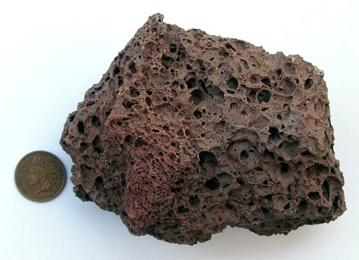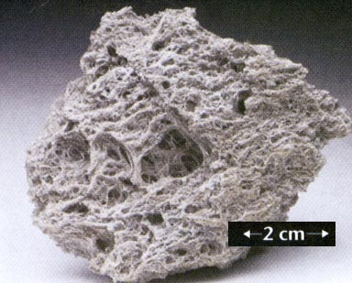

Scoria (Mafic)

Pumice (Felsic)

***2) Mafic Igneous Rocks: Basaltic***

* form from magma containing a large amount of the dark silicate minerals **Magnesium** and **Iron** and little light silicate minerals.

**Will Mafic rocks be lighter or darker than Felsic rocks? Why?**

* **Darker, as made up of dark coloured silicate minerals**

**Will Mafic rocks be heavier or denser than igneous rocks? Why?**

* **Denser, as their components are made of heavier elements**

***3) Intermediate Igneous Rocks: Andesitic***

* Contain a mixture of both light and dark coloured silicate minerals, they are commonly medium gray to green in colour.

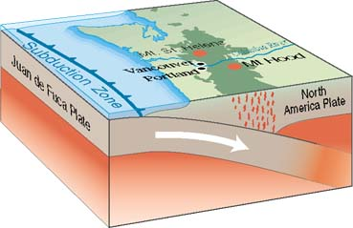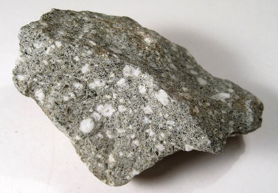

* Associated with volcanic activity at the edge of continents where mafic magma mixes with felsic continental crust to form an intermediate magma.

***4) Ultramafic Igneous Rocks***

* Peridotite is the only ultramafic rock and is largely composed of olivine and pyroxene with very little light coloured silicate minerals.
* Ultramafic rocks are rare, but important parts of the upper mantle.

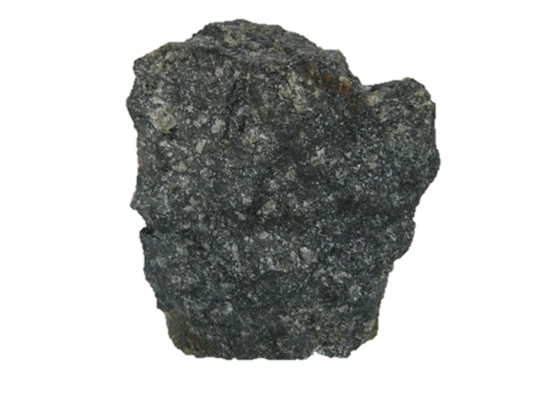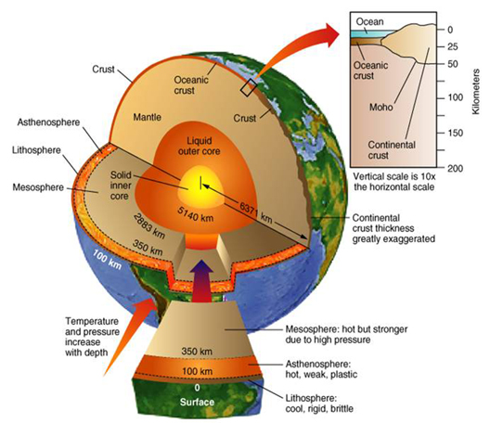

[](http://media.pearsoncmg.com/bc/bc_0media_geo/smartfigure/sf-IgneousClassification.html)**Classifying Igneous Rocks**

Igneous rocks are classified based on their textures and compositions.

*\*Watch the smartfigure to learn how igneous rocks are classified*

***\*Complete Activity 2.3 and 2.4 (pg. 31 – 34)***