The town of Pasquit is set to develop a dam, with construction starting in Spring 2016. Pasquit is a small town of 10 000 people. The Pasquit River passes 3km outside the town center and BC Hydro has completed initial studies that indicate Pasquit River has sufficient power that a large hydroelectric dam could be built to produce electricity for the town as well as the rest of the province.
The facilities planned for the Pasquit Hydro Dam include creating a reservoir upstream that leads to an intake area to deliver water to the turbine and generator that create the electricity. A powerline exits this powerhouse to deliver the electricity to the local area (see Figure 1, below). This project will provide 3500 jobs to the people of Pasquit.
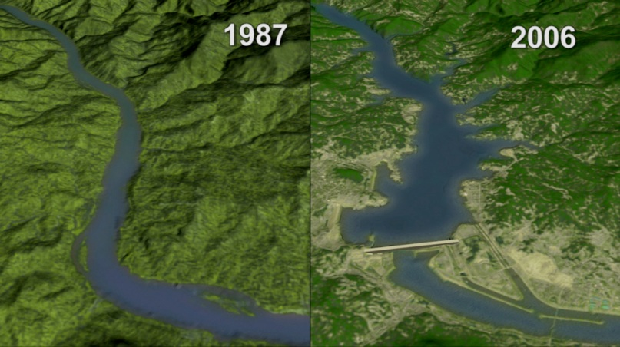
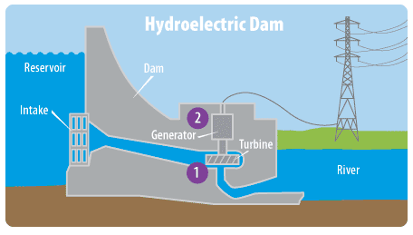
Currently, the widest section of the river is about 150m wide. Creating the reservoir would change the landscape as the water would be held in a reservoir (see Figure 2, below). The river is used by many fishermen as well as the local rafting company. The rapids the local rafting company use will no longer exist due to the development of the dam.
proposed
current

On November ___, 2015, there is going to be a televised town meeting in which each of the 10 000 citizens will vote on this important matter that faces their town…
In this town meeting there will be 7 parties represented:
The Salmon, BC Hydro, First Nations, GoGreen Enviro Group, Pasquit Labour Association, BC Government, Sport & Leisure Society.

The town meeting will consist of a formal debate where the 7 parties will do the following:
- Make a 60-90 second opening statement
  - Introduce your organization
  - Your position on whether the dam should be opened
  - Give a couple of introductory facts/reasons
- Open floor debate
  - When you speak, you stand
  - Your organization must direct an argument towards another organization (not an individual)
  - Must end in a question so that party is able to rebut
** This is repeated for much of the duration of the class **
  - The party will have a chance to answer the questions posed to them.
- Closing Statement *for each organization
  - 30 seconds maximum
  - Summarize your overall position and points made in the debate
  - “For these reasons, we, _____________ do/do not think the large hydro dam should be opened.”
To achieve a good mark on this debate, you must…
- Show good TEAMWORK throughout the planning process & the debating process
- Make sure everyone PARTICIPATES in the debate!
- Have CLEAR ARGUMENTS and REBUTTALS (be able to extract powerful facts at appropriate times throughout the debate from your research)
- Hand in your COLLECTED RESEARCH/debate notes
Research
- Your research can be accessed from our Collingwood Library resources and databases
- Collingwood website Library Sandbox Pathfinders Middle Years Science Science 8 - Debate
- These databases are an excellent resources for your information needed for the debate
- There will be two library sessions to help collect information and learn more about debating.

Pasquit Dam Debate: Marking Rubric
 | Below Expectations  (1-5) | Meets Expectations  (6-8) | Above Expectations  (9-10) | Score
Teamwork | - group is not sharing all roles  - only one or two students are speaking in the debate  - group needs encouragement to motivate each other | - most students are sharing all roles  - most students are speaking during debate  - most students are being positive and motivating to their peers | - Students are sharing all roles  - Students are helping all members of their group speak  - Students are being positive and motivating to their peers | /10
Participation & Planning | - students need reminders to stay on task during research and debate  - students do not respect debate rules  - not all students speak during debate | - students are usually engaged and on task during research and debate  - students usually respect the debate rules  - most students speak during debate | - Students are engaged and on task when researching and during debate  - students respect the debate rules  - Every student spoke during debate | / /10
Opening Statement | - opening statement was unclear and not well-written and/or spoken  - one-two arguments are supported with some or little evidence  - some sources may not be reputable | - opening statement is fairly clear and well-written and/or spoken  - two arguments with supported some evidence  - some sources may not be reputable | - opening statement is clear and well-written and spoken  - three arguments are supported with sufficient evidence from reputable sources are included | /10
Arguments &  Rebuttals | - arguments are not concise, directed at an individual and/or not based on fact  - arguments are not well put together and often do not end in a question  - rebuttals do not link to the question posed to their organization | - most arguments made are fairly clear, usually directed at an organization and often based on fact  - arguments are well put together and often ends in a question  - most rebuttals are clearly linked to the question | - Each argument made is clear, directed at another organization and based on fact  - Each argument is well-synthesized, effective & ends in a question  - Each rebuttal clearly relates to the question in the argument and based in fact | /10
Closing Statement | - closing statement is unclear and not well-spoken  - may not summarize points for position | - closing statement is fairly clear and well-spoken  - provides a basic summary of points supporting position | - closing statement is clear and well-spoken  - provides an excellent summary of points supporting position | /5
Debate Planning | - little notes or no notes are completed on google docs | - some notes are completed on google docs | - well-researched notes are completed on google docs | /5
TOTAL |  |  |  | /50

