Parts of the Eye

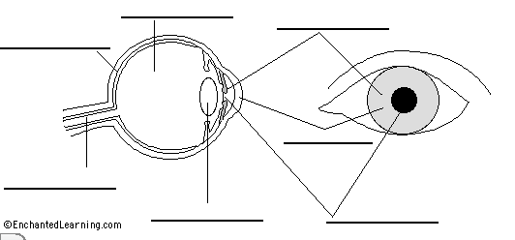

Use the following terms to label the eye diagram above. This website or the textbook are useful resources. http://www.childrensuniversity.manchester.ac.uk/interactives/science/brainandsenses/eye/
Iris Cornea Pupil Lens
Aqueous Humour Vitreous Humour Retina Choroid
Sclera Optic Nerve
Use the textbook (pg. 202 – 205 or Glossary) or website above to fill out the table with the function of each of the parts listed above
Part | Function
Cornea
Sclera
Choroid
Iris
Pupil
Aqueous Humour
Lens
Vitreous Humour
Retina
Optic Nerve

