What have I eaten in the last 24 hours? Name:__________
Purpose: You are going to be using the website https://www.eatracker.ca to track what you have eaten within the last 24 hours. You are then going to compare your diet to Canada’s Food Guide recommendations which are included on the website.
PART 1: In the table below, write in ALL of the food items who have eaten in the last 24 hours. Include everything (food, drink, junkfood etc.). Include quantities (for example: 2 pieces of pepperoni pizza)
Food eaten within the last 24 hours
Yesterday Lunch
Yesterday Dinner
Today Breakfast
Any other (snacks etc.)

PART 2:
Instructions:
- Go to website https://www.eatracker.ca and register – you will need to enter some information about yourself such as height, weight etc. Remember your password as you will be using this website to enter what you have been eating over the course of three days.

- You will be entering EVERYTHING that you have ingested (from your table above)

- In order to enter your information you need to log onto your eatracker account and click on “My Food”).

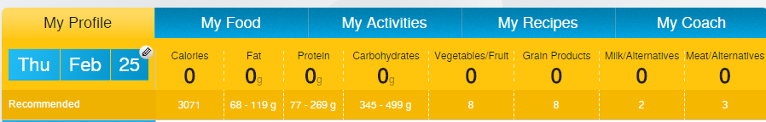

- You need to search for the food item and categorize it into the meal you had it at. For example if you had had 2 scrambled eggs for breakfast you would need to do the following:
- Type “eggs” into the search box
- Choose the type and quantity of eggs you had and select the meal that you had it for:
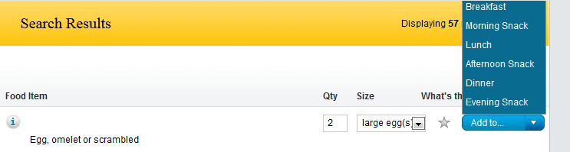

- If, for example, you had a smoothie, you will need to break that down into the ingredients that were in it (ex. Yogurt, blueberries etc.) Do your best to estimate the ‘Size’ and ‘Quantities’

- Use the information given by eatracker.ca to fill in the tables below. For Table three, you will need to go to “My eating feedback” and click on “Nutrients”.

Results /5:
Table 1: ____________________________________________________________
 | Recommended value | Your results
Total Calories
Fat
Protein
Carbohydrates

Table 2:____________________________________________________________
 | Recommended servings | Your results
Vegetables/Fruit
Grain Products
Milk/ Alternatives
Meat/Alternatives

Table 3: _____________________________________________________________
 | Recommended daily intake | Your Results
Vitamin A
Vitamin C
Calcium
Iron

Questions /10:
- Did all of your recorded values meet the recommended values? ___________________

ONLY ANSWER ONE COLUMN BASED ON YOUR ANSWER ABOVE
If you answered yes……. | If you answered no……….
List the food group recommendation you think you may have most trouble meeting on a daily basis. (1 mark)  Why would this be difficult? (1 marks) | List one of the values that did not meet (1 mark):  What do you think you could you change in your diet to meet this value? (1 mark)

- Choose one category from each table in the results sections and briefly explain the importance of it. (For example you may choose to explain the importance of: Fats, Grain Products and Vitamin C). (3 marks)

- Table 1 Nutrient chosen: _____________________________________

Why is this nutrient important for your health? :

- Table 2 Nutrient chosen: _____________________________________

Why is this nutrient important for your health? :

- Table 3 Nutrient chosen: _____________________________________

Why is this nutrient important for your health? :

- Name and describe one nutrient that is not listed in the tables above but also has an important role in your diet. (2 marks)
________________________________________________________________________________________________________________________________________________________________________________________________________________________________________________________________________________________________________________________________________________________________________
- Explain why it is important to provide your age, weight, height and level of daily activity. (1 mark)
________________________________________________________________________________________________________________________________________________________________________________________________________________________________________________________________________________________________________________________________________________________________________
- What challenges/obstacles do you face trying to meet your recommended nutritial nutritional intake? Be specific with what you do or might do to counter those challenges. (2 marks)
________________________________________________________________________________________________________________________________________________________________________________________________________________________________________________________________________________________________________________________________________________________________________________________________________________________________________________

