Atmosphere Unit
Moisture, Clouds and Precipitation
Chapter 12
12.1: Water’s Changes of State

Water is the only substance commonly found in 3 states of matter:
a) Solid, Temp 0° or below, Ice, snow, hail…
The movement of water through these states is called the hydrologic cycle.
b) Liquid, Temp 0 to 100 °C
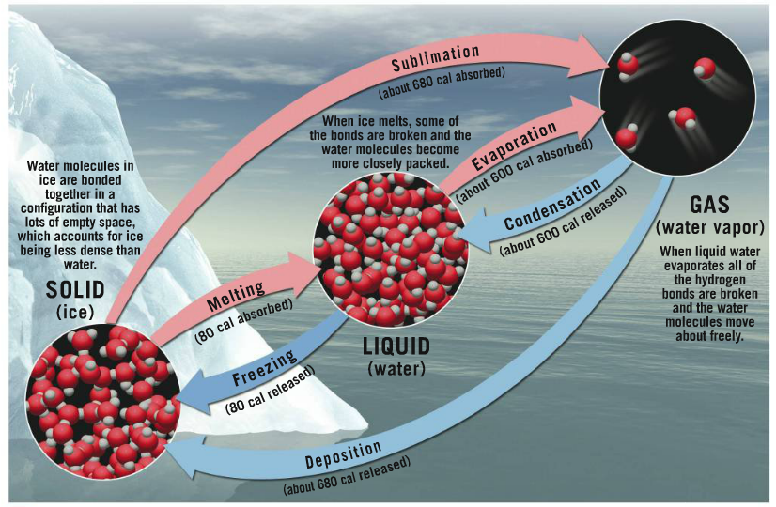
c) Gas, Temp 100°C +, water vapour
- When water changes states heat is exchanged with water and its surroundings. For example, when water evaporates heat is absorbed (this is why sweating cools us down).
What is latent heat?

Why does this occur?

_________________= the heat required to raise the temperature of 1 gram of water 1 degree.

12.2: Humidity

Humidity | the measure of how much water vapour there is in the air.
 | Saturated | Unsaturated
 | Air is holding the maximal amount of water | Air is not holding the maximal amount of water
Vapor Pressure =

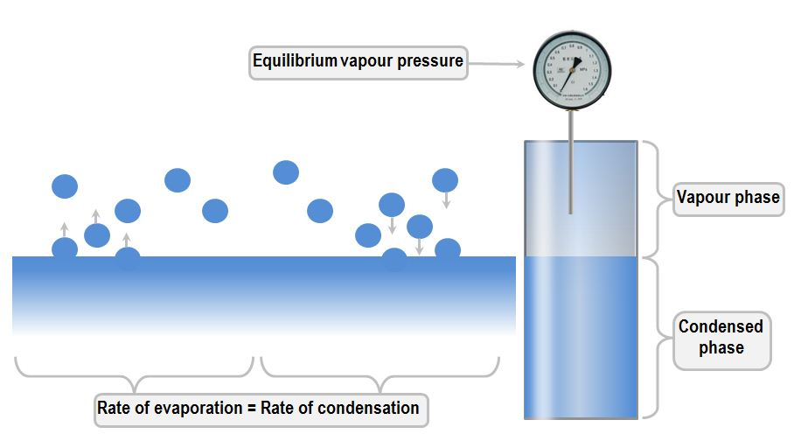

- Saturated air exists when the number of vapour molecules leaving the water’s surface is equal to those returning to it.

Where in the world would you find the most humid air? Why is this?

There are three ways to express the water-vapour content of air:
Mixing Ratio | Relative Humidity | Dew Point Temperature
Measure of the amount of water vapour in UNSATURATED air | RATIO of the air’s current water vapour content compared to the amount of water vapor required for saturation at a given TEMPERATURE and PRESSURE | The temperature the air needs to be cooled to in order to reach saturation

* Now we will go into each of these in more detail and learn how to calculate them*

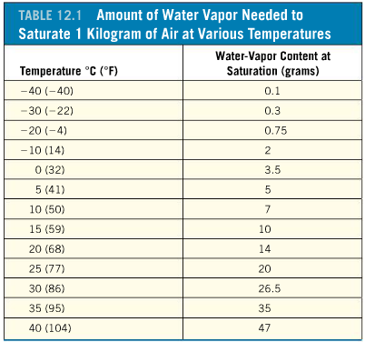
a) ___________________________________
- a way to measure the amount of water vapour in unsaturated air.
How the values in the chart are found:
Mixing Ratio = Mass of Water Vapour (grams)
Mass of Dry Air (kilograms)
- The chart to the right contains the mixing ratios for a variety of temperatures. You will not have to calculate mixing ratio but you will need to know how to use the chart.

b) _______________________________________________
- Ratio of the air’s water vapour content and the amount of water vapour required for saturation at the given temperature and pressure.
- Represents how close the air is to saturation, not the actual quantity of water vapour in the air
- Most commonly used measurement of humidity.
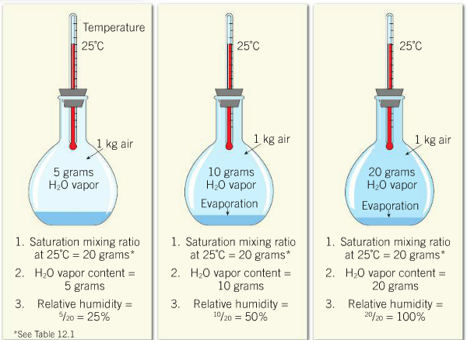
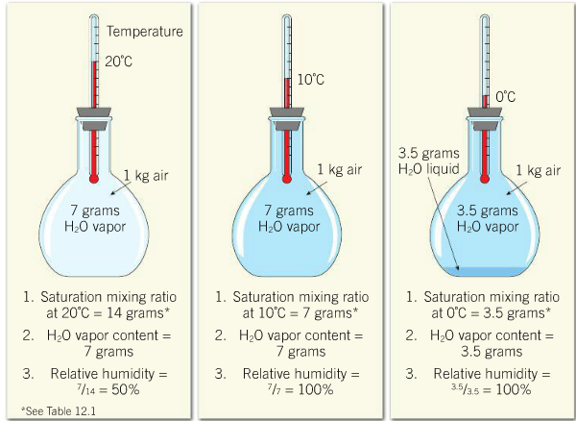
Examine the two diagrams below. What are two ways that the relative humidity of air can be changed?

*Complete Lab 14.3 (pg. *****) Add how to calculate relative humidity?

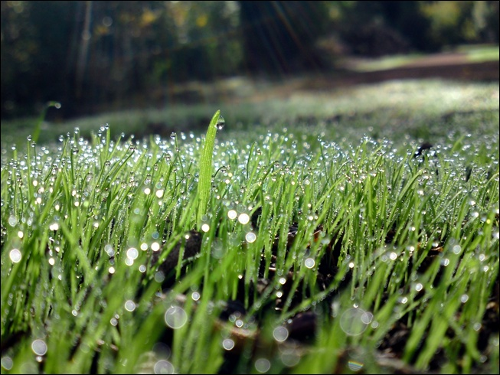
c) ___________________________________________
- the temperature air needs to be cooled to reach saturation.
*Watch Smartfigure 12.8
Why does dew form on grass over night?

*Complete Lab 14.4-14.7
12.3: Adiabatic Cooling and Cloud Formation

Adiabatic: process that occurs without the transfer of heat or matter between the system and their surroundings
Adiabatic temperature changes are caused by:
*Heat is not applied or removed in adiabatic cooling! Just changes in pressure!

a) Expansion of air causes it to cool (motion of gas molecules decrease)
b) Compression of air causes it to become warmer (motion of gas molecules increase)
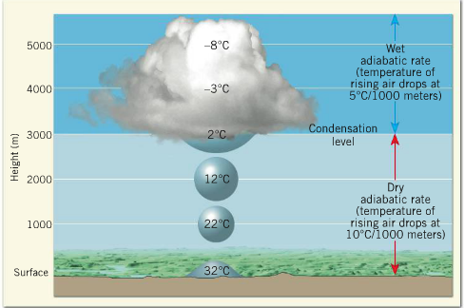

Dry Adiabatic Rate (Unsaturated) | Wet Adiabatic Rate (Saturated)
Atmospheric pressure decreases with elevation ie. air expands as it ascends and cools.  Atmospheric pressure increases with loss of elevation ie. air is compressed and warms.  10°C change in temperature per 1 km | Air is cooled past its dew point and condensation occurs.  Condensation releases energy ie. reduces the rate of cooling as air continues to rise.  5-9°C change in temperature per 1 km.

*Complete Activity 14.8
12.4: Process That Lift Air

Now that we know how clouds can be formed through adiabatic cooling and condensation at the dew point, we need to consider what mechanisms force air to rise in the first place.
 | Air is forced to rise over a mountainous barrier, causing adiabatic cooling to produce clouds and rain on the windward slopes.  Commonly occur with coastal mountain ranges | 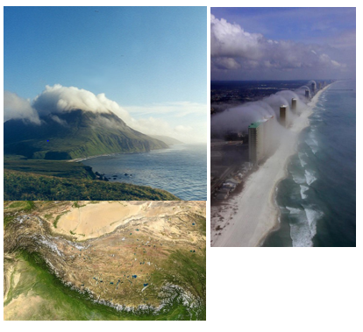
 | Air can be forced to rise in the absence of physical barriers by the meeting of warm and cold air masses (a front)  Warmer (less dense) air is forced over cooler (denser) air. | 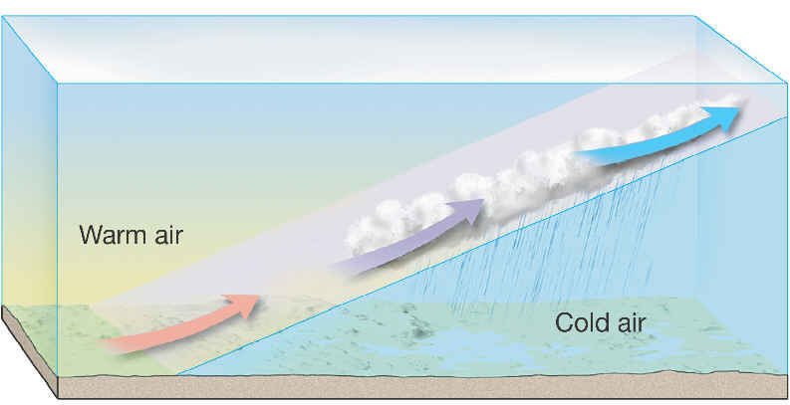
 | Collision of moving air in the lower atmosphere creates an upward movement of air  Can be caused by air becoming caught in the transition from water (smooth surface) to land (rough surface). Air piles up here and is forced upwards. | 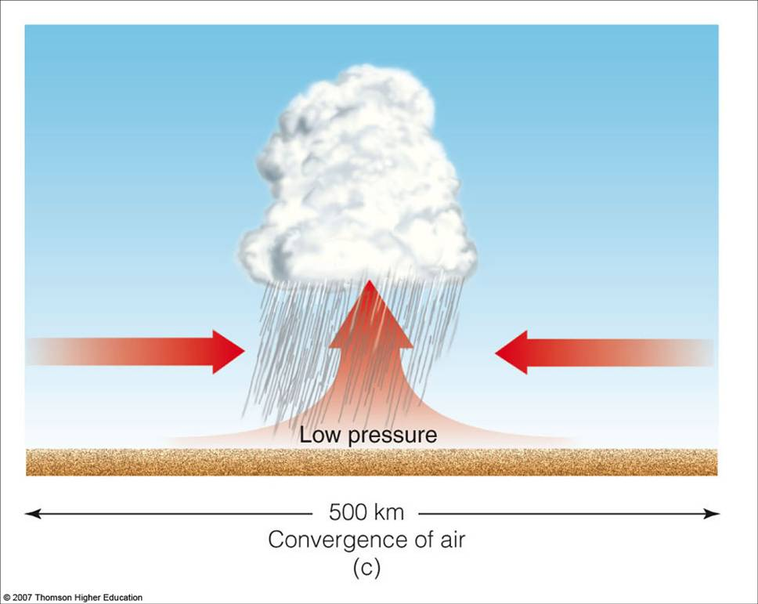
 | Unequal heating of Earth’s surface produces local pockets of warmer, less dense air, which rises.  Found over surfaces with a low albedo because they produce lots of infrared radiation that warms the air above them. | 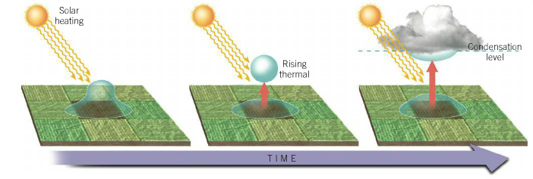
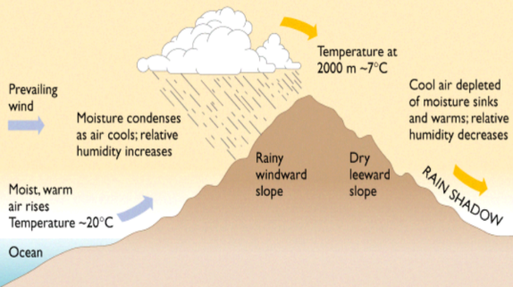
Explain why Vancouver experiences more rain than the Okanagan. You can use the diagram the right.

12.5: The Critical Weathermaker: Atmosphere Stability
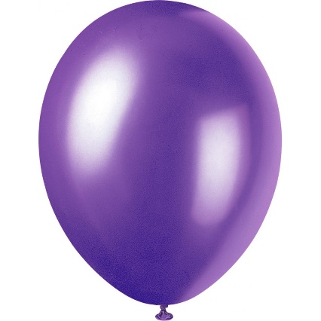
An air mass is like a balloon:
- It behaves as if it has a thin, flexible cover that allows it to expand and contract without mixing with the surrounding air.
- The stability of the balloon depends on the temperature difference between the air inside the balloon and the surrounding air.

Based on the temperature differences between the air mass and the surrounding air, it can be classified as:
Stable | Air mass resists vertical movement (same temperature/density as surrounding air)
Will clouds form in stable air?
Not by itself (as air would not rise), but other processes (rainshadow effect, etc) can cause an air mass to rise.

Resulting clouds will not have great vertical thickness and instead will be spread out horizontally with light to moderate rain (not a big temperature difference = not a lot of condensation/precipitation)

Unstable | Air mass that is a different temperature/density than the surrounding air = vertical displacement.
Will clouds form in unstable air?
Yes, unstable air produces towering clouds, thunderstorms and heavy rain.

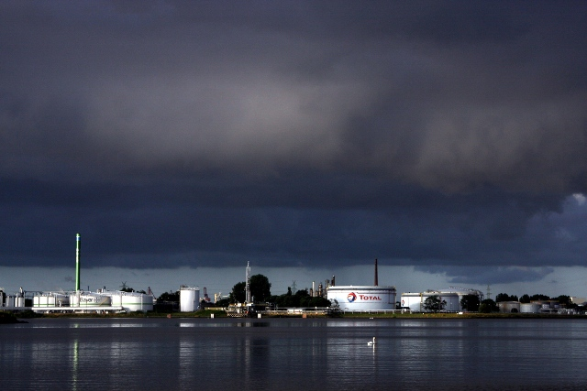
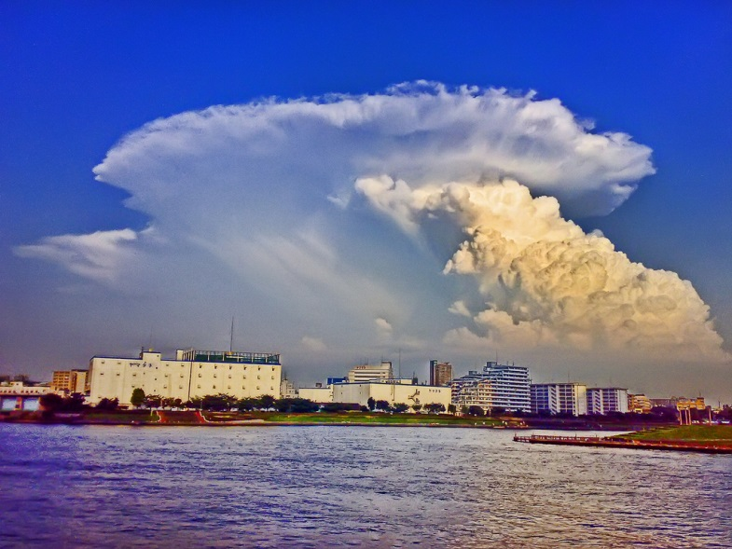
Under what conditions would the clouds below form?

12.6: Types of Clouds
What is a cloud?

Clouds are great indicators of atmospheric conditions and are classified by their:
Form | Cirrus | High ,white and thin (often feathery)
 | Cumulus | Cauliflower structure (flat base, globular masses, vertical depth)
 | Stratus | Horizontal sheets of layers that cover much of the sky
Height | High | Bases above 6,000m
 | Middle | 2000 – 6000m, called alto
 | Low | Below 200m

The Form and Height terms above can be mixed together to more accurately describe a cloud:
Altostratus: Horizontal cloud layer between 2000 and 6000 m.
When a cloud produces a lot of precipitation what do you add to the name?

Cirrocumulus:
Cirrostratus:

*Label the form of the cloud below*
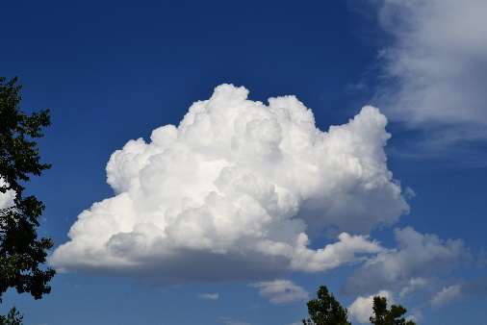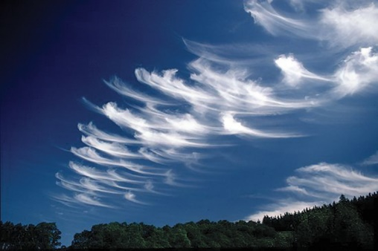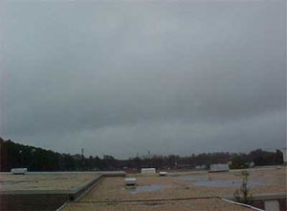

Would all the cloud types on the diagram above typically be found in one area?

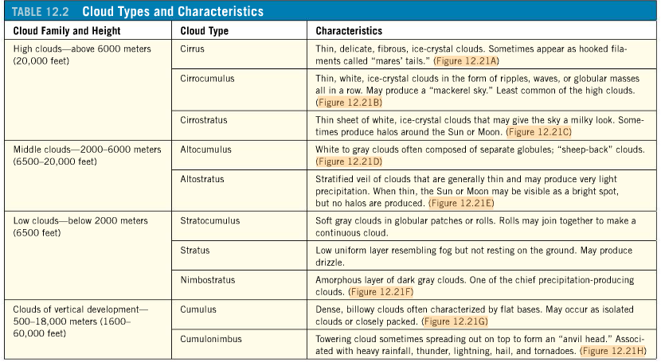
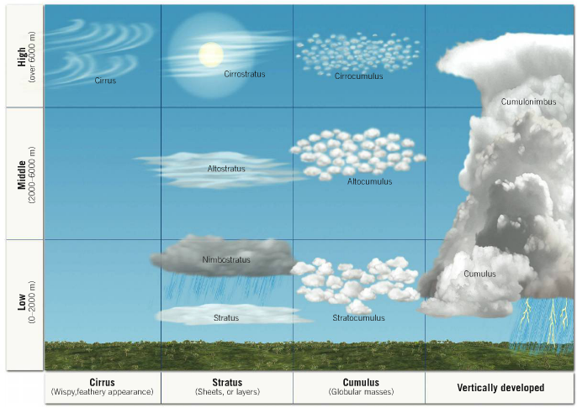
Formation of a Cumulus Cloud
The condensation point is the level in the atmosphere at which air is cooled past its dew point and condensation occurs.
Cumulus clouds grow vertically as long as:
a) There is a supply of moist, warm air.
b) The air inside the cloud is less dense (warmer) than the surrounding air.
Why does air cool as it rises?

*Remember: Air cools at different rates depending on whether it is saturated or unsaturated*
What is the dew point?

12.8: Precipitation
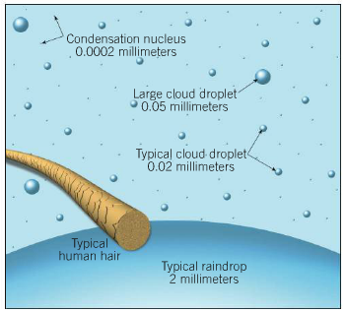
Why don’t all clouds produce precipitation?

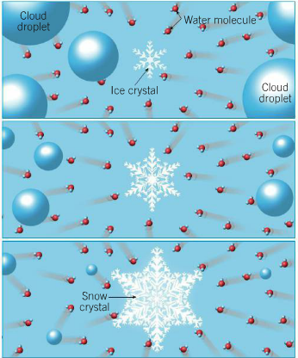
There are two hypotheses about how water droplets grow to a large enough size to produce precipitation:
a) Bergeron Process (Cold Clouds)
- Clouds high in the atmosphere are made of supercooled water (liquid water at -40°C) that crystallize into snowflakes when they come into contact with freezing nuclei.
- Snowflakes grow in size by collecting the surrounding water vapour and eventually become heavy enough to fall to Earth. The snowflake melts on its descent, producing rain.
*See the importance of nucleating agents to ice formation from 11:55 on.
b) Collision-Coalescence Process (Warm Clouds)
- Hygroscopic particles attract water to form giant water droplets. These droplets fall quickly and collide with smaller water drops, producing droplets large enough to fall to Earth’s surface without evaporating.
Forms of Precipitation
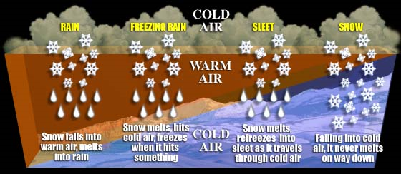
The type of precipitation an area experiences varies depending on the temperature layers that exist in the atmosphere.
*See the dramatic impact that freezing rain has had on Canadians from 11:57 onwards.
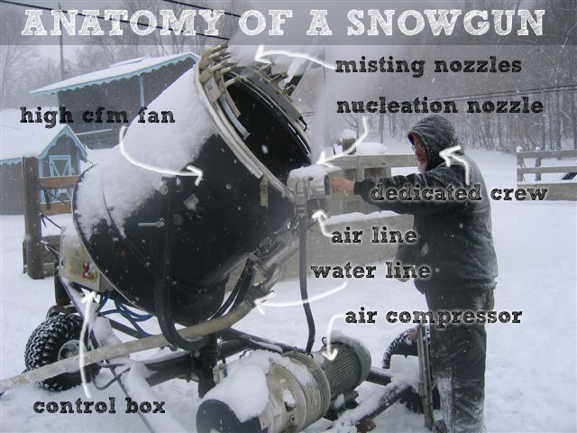
Using what you know about ice formation can you explain how snow guns create ice crystals?
1. A pressured mixture of air and water is blown into the air. The water is supercooled before-hand in a cooling tower.
2. Air-water mixture expands as it is no longer pressurized, cooling to a temperature several degrees cooler than the surrounding air.
3. Ice crystals form on nucleating agents.
4. The ice crystals that do not melt fall to the ground as snow.
Are there any problems with creating snow?
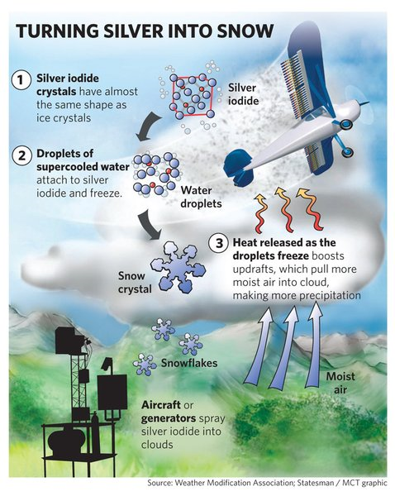
a) Water consumption: Need 2x the water to produce snow artificially. Requires water tanks to be built on mountain sides = landslide risks.
b) Pollution: Chemical nucleating agents are used to crystallize water at warm temperatures. These find their way into the water supply (Vancouver Olympics).
Weather modification works based on the same principles discussed above:
1. Frozen CO₂ (dry ice) is dropped into clouds to cool to a temperature at which ice crystals can form.
2. Silver iodide crystals are used as artificial freezing nuclei.
Why might weather modification be useful?
-Used to promote rainfall in dry areas or during droughts.
-China used it before the 2008 Olympics to clear away pollution and ensure no rain during the opening ceremonies.
-Crowd dispersal at Woodstock?
-However, its effectiveness is debatable. How do you prove the rain was not natural?

