Name: ________________________

**42**

Block: ______ Date: ___________________

**Lenses and Mirrors Lab**

Introduction

In this activity, you will observe what happens to light as they bounce off a plane mirror. Then, you will investigate how properties of concave and convex lenses and mirrors affect how they interact with light.

Pre-Activity questions

Define the following terms using the glossary of your Science 8 textbook (6 marks):

* Convex: _______________________________________________________________________
* Concave: ______________________________________________________________________
* Focal point: ____________________________________________________________________
* Focal length: ________________________________________________________________
* Converging: ____________________________________________________________________
* Diverging: ______________________________________________________________________
* Incident ray: ____________________________________________________________________
* Reflected ray: ___________________________________________________________________
* Refracted ray: __________________________________________________________________
* Angle of incidence: ______________________________________________________________
* Angle of reflection: ______________________________________________________________
* Angle of refraction: ______________________________________________________________

Materials:

In each station, you will need the following:

* lens or mirror
* Ray box
* Ruler
* Pencil

Activity

*Station 1 (8 marks)*



1. What type of mirror is this? **_________________** (1 mark)
2. In the diagram, draw your **results** of what the lines will look like after it hits the mirror using a ruler. (2 marks) Label the incident ray, angle of incidence, reflected ray, angle of reflection, normal and mirror (1/2 mark each, 3 marks total)
3. What can you conclude about the relationship between the angle of incidence and the angle of reflection? (2 marks)

_____________________________________________________________________________________

_____________________________________________________________________________________

_____________________________________________________________________________________

*Station 2 (5 marks)*

1. What type of mirror is this? **Convex or concave**? (circle the correct answer) (1 mark)
2. In the diagram below, **predict** how the lines will look like after it hits the lens using a ruler. (1 mark)

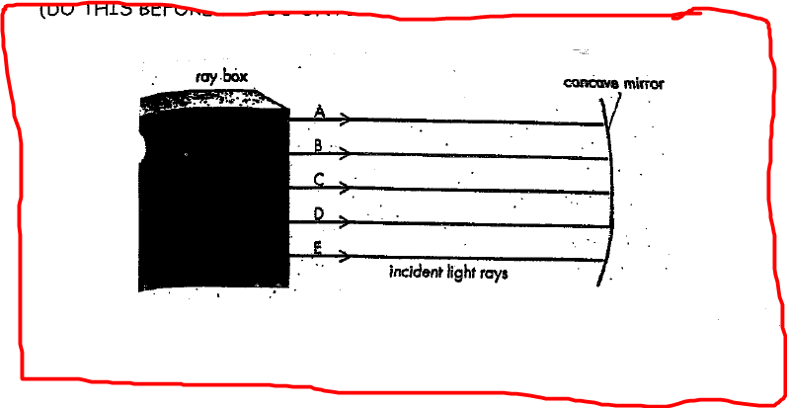

1. In the diagram, draw your **results** using a ruler. Label the **focal point**. (2 marks)



1. Is the light **diverging or converging**? (circle the correct answer) (1 mark)

*Station 3 (5 marks)*

1. What type of mirror is this? **Convex or concave**? (circle the correct answer) (1 mark)
2. In the diagram below, **predict** how the lines will look like after it hits the lens using a ruler. (1 mark)

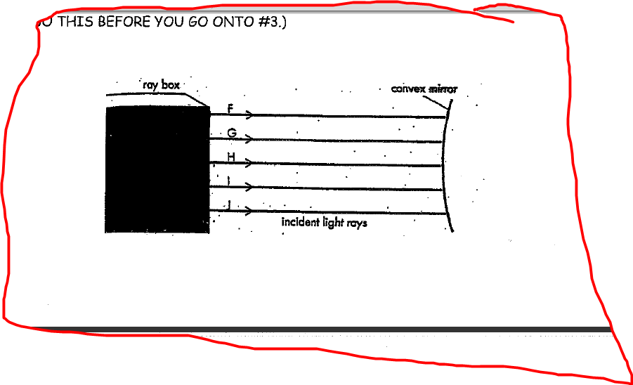

1. In the diagram, draw your **results** using a ruler. Label the **focal point**. (2 marks)



1. Is the light **diverging or converging**? (circle the correct answer) (1 mark)

*Station 4 (5 marks)*

1. What type of lens is this? **Convex or concave**? (circle the correct answer) (1 mark)
2. In the diagram below, **predict** how the lines will look like after it passes the lens using a ruler. (1 mark)

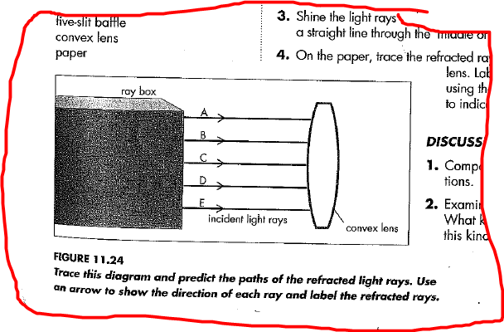

1. In the diagram, draw your **results** using a ruler. Label the **focal point**. (2 marks)



1. Is the light **diverging or converging**? (circle one answer) (1 mark)

*Station 5 (5 marks)*

1. What type of lens is this? **Convex or concave**? (circle the correct answer) ( /1)
2. In the diagram below, **predict** how the lines will look like after it passes the lens. Use a ruler ( /1)

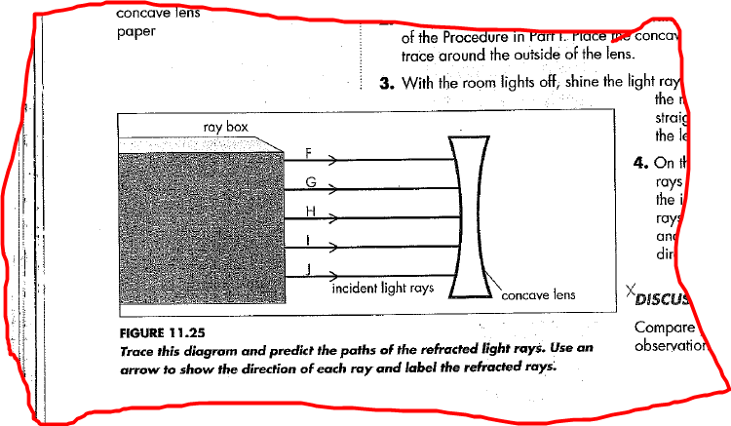

1. In the diagram, draw your **results** using a ruler. Label the **focal point**. (2 marks)



1. Is the light **diverging or converging**? (circle the correct answer) (1 mark)

Analysis Questions

1. Compare and contrast how images appear on a convex mirror versus a concave mirror. Page 185 (2 marks)

__________________________________________________________________________________

__________________________________________________________________________________

1. How might images appear differently through a convex lens versus a concave lens in relation to where the focal point is located. Pages 191 - 192. (2 marks)

__________________________________________________________________________________

__________________________________________________________________________________

1. Name two uses for a convex lens and two uses for a concave lens. (2 marks)

__________________________________________________________________________________

__________________________________________________________________________________

1. 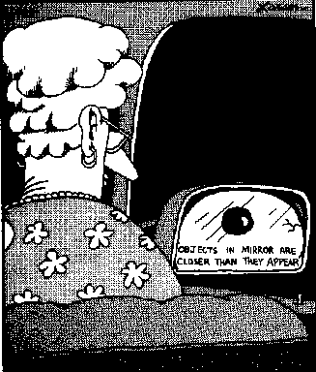Name two uses for a convex mirror and two uses for a concave mirror. (2 marks)

______________________________________________________

______________________________________________________

______________________________________________________