Earth Science 11: Earth Materials

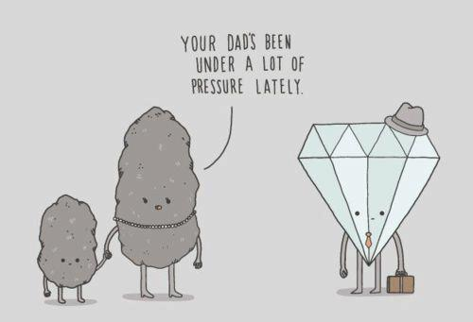

Name: _______________________________

Earth Science 11: Earth Materials: Minerals
Textbook: Chapter 1
1.1: Matter and Atoms

- Everything with mass and volume is called MATTER , which is made up of ELEMENTS.
- Elements are made up of particles called ATOMS.
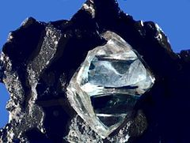

- the internal arrangement of atoms in a substance as this determines its properties.
GRAPHITE AND DIAMONDS ARE MADE UP OF CARBON, BUT THE BONDS BETWEEN THE CARBON ATOMS AER DIFFERENT – DETERMINES HOW HARD EACH MINERAL IS

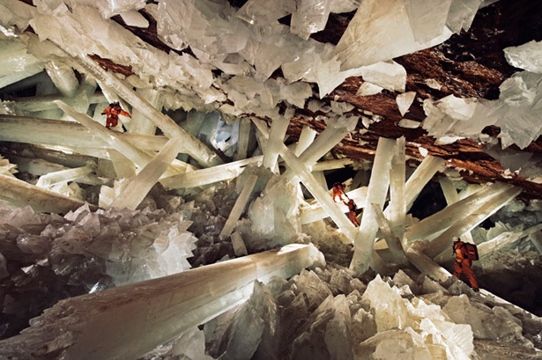
What is a Mineral?
Minerals have the following characteristics:
1. NATURALLY OCCURING
2. SOLID
3. DEFINITE CHEMICAL COMPOSITION
4. INORGANIC (WAS NEVER ALIVE)
5. ATOMS ARRANGED IN AN ORDERLY PATTERN Mexico’s Cueva de los Cristale
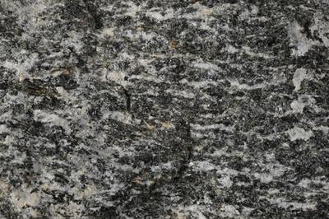
How do Minerals Form?

1.4: Properties of Minerals

*Use workbook activities 1.1 – 1.5 (pg. 2 – 8) to investigate the properties used in mineral identification.*

Structure of Minerals: Crystal Faces
- A crystal is a geometric solid with smooth surfaces called crystal faces.

- Ionic bonding between Na+ and Cl- ions results in a repeating pattern of each sodium ion being surrounded by six chlorine ions and each chlorine ion being surrounded by six sodium ions. Produces a cubic crystal (all Sodium Chloride crystals will have this shape!).
- Each mineral crystal has a unique shape that can be used to identify it.
Are crystal faces always present?
NO, ONLY IF THERE IS ENOUGH ROOM FOR THE CRYSTAL TO GROW WHEN FORMING
Structure of Minerals: Mineral Cleavage
- Cleavage: TENDENCY TO SPLIT ALONG PLANES OF WEAK BONDING

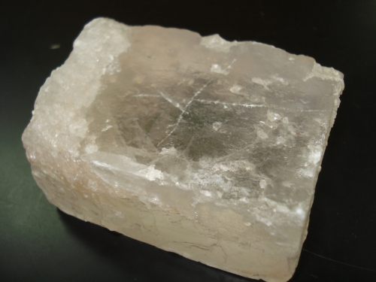
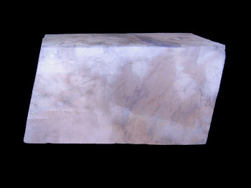
Halite (NaCl): Cubic cleavage Calcite (CaCO₃): Rhombohedral cleavage.

*Complete Activity 1.6 (pg. 10 – 11) in your workbook
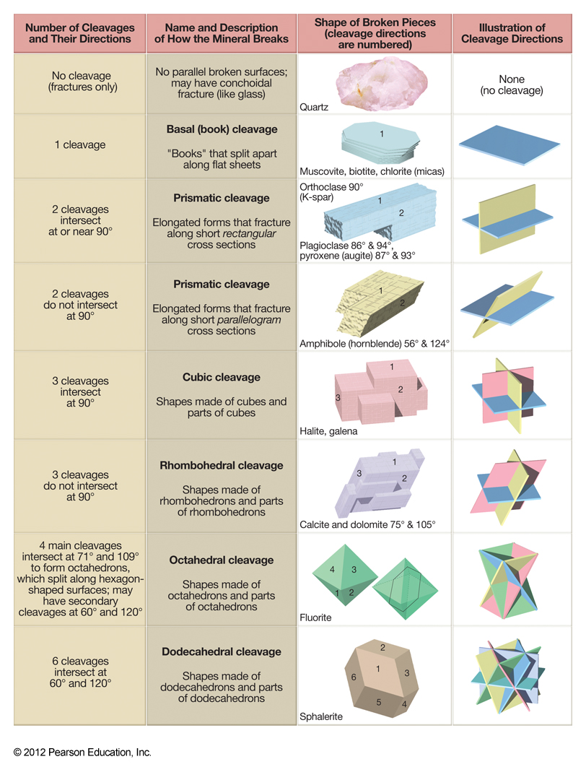
9 and 12 Mineral Structure: Silicates
1.5 Mineral Groups

- Minerals composed of OXYGEN and SILICA are called silicates.
  - More than 90 % of Earth’s crust are silicates
- Silica tetrahedrons are the BASIC BUILDING BLOCKS of silicates.

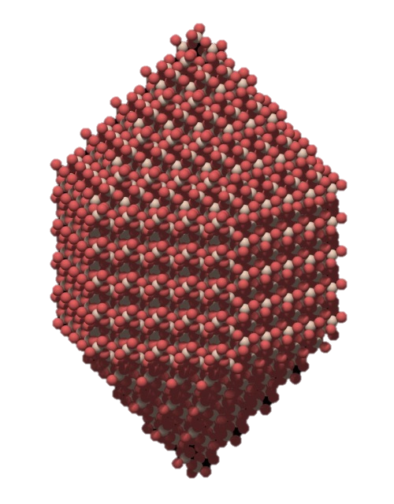
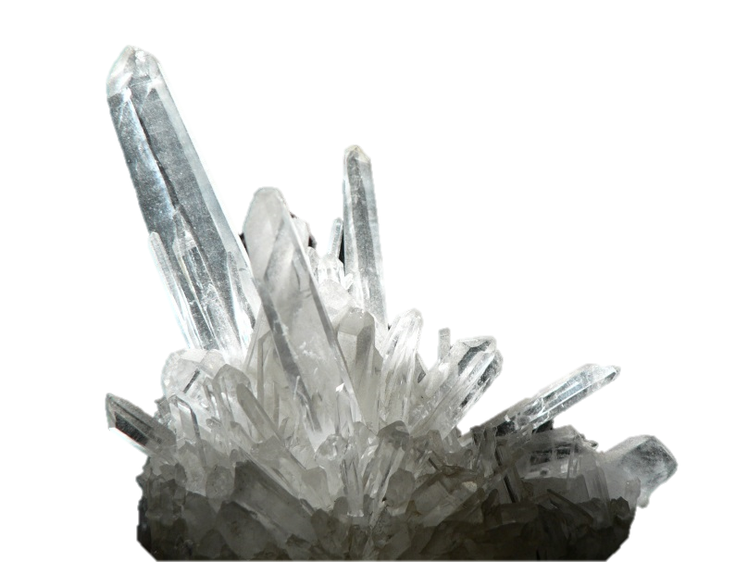

- Arrangement of silica tetrahedrons in a silicate determines many minerals characteristics such as melting point, cleavage, hardness and density.
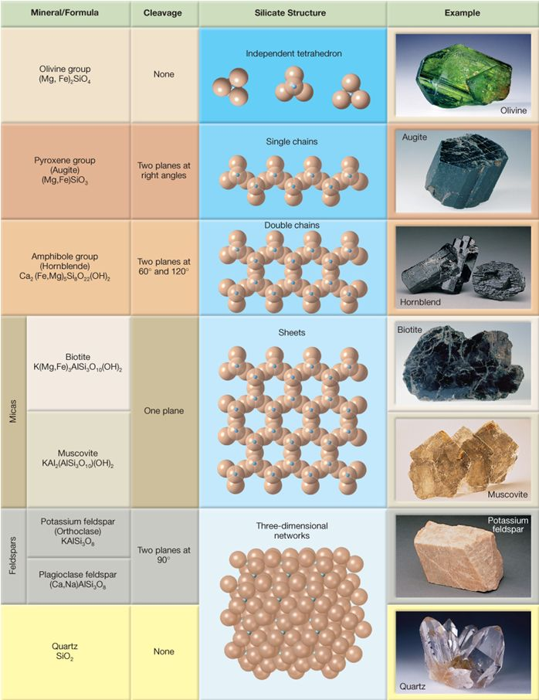
*Complete Mineral ID Lab (Activity 1.9 pg.13)

