Earth Science 11: Earth Materials

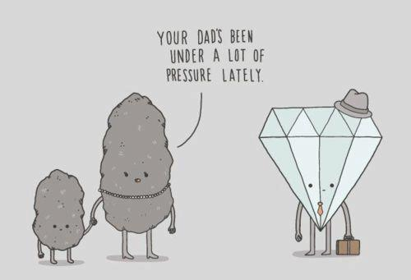

Name: _______________________________

Earth Science 11: Earth Materials: Minerals
Textbook: Chapter 1
1.1: Matter and Atoms

- Everything with mass and volume is called ____________________, which is made up of
____________________.
- Elements are made up of particles called ____________________.
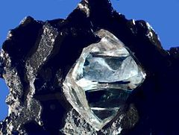

- the internal arrangement of atoms in a substance as this determines its properties.
____________________________________________________
____________________________________________________
____________________________________________________
____________________________________________________
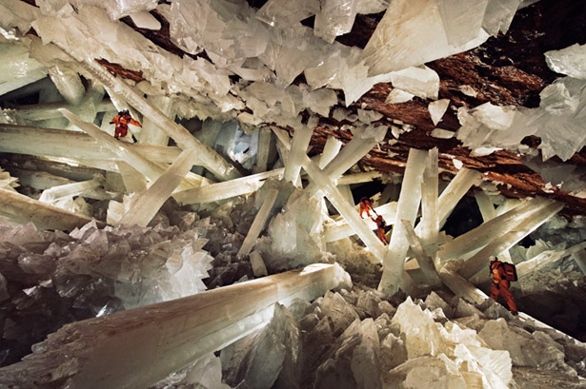
What is a Mineral?
Minerals have the following characteristics:
1. _____________________________________________
2. _____________________________________________
3. _____________________________________________
4. _____________________________________________
5. _____________________________________________ Mexico’s Cueva de los Cristale
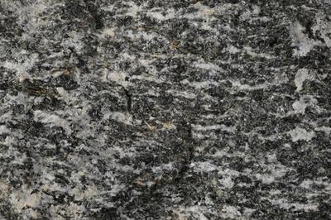
How do Minerals Form?

1.4: Properties of Minerals

*Use workbook activities 1.1 – 1.5 (pg. 2 – 8) to investigate the properties used in mineral identification.*

Structure of Minerals: Crystal Faces
- A crystal is a geometric solid with smooth surfaces called crystal faces.

- Ionic bonding between Na+ and Cl- ions results in a repeating pattern of each sodium ion being surrounded by six chlorine ions and each chlorine ion being surrounded by six sodium ions. Produces a cubic crystal (all Sodium Chloride crystals will have this shape!).
- Each mineral crystal has a unique shape that can be used to identify it.
Are crystal faces always present?
Structure of Minerals: Mineral Cleavage
- Cleavage: ____________________________________________
___________________________________________________________
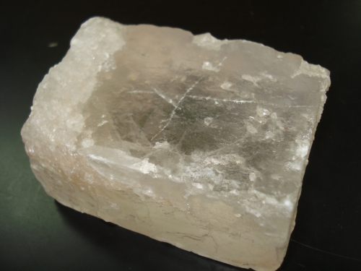
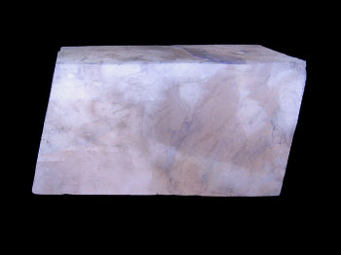
Halite (NaCl): Cubic cleavage Calcite (CaCO₃): Rhombohedral cleavage.

*Complete Activity 1.6 (pg. 10 – 11) in your workbook
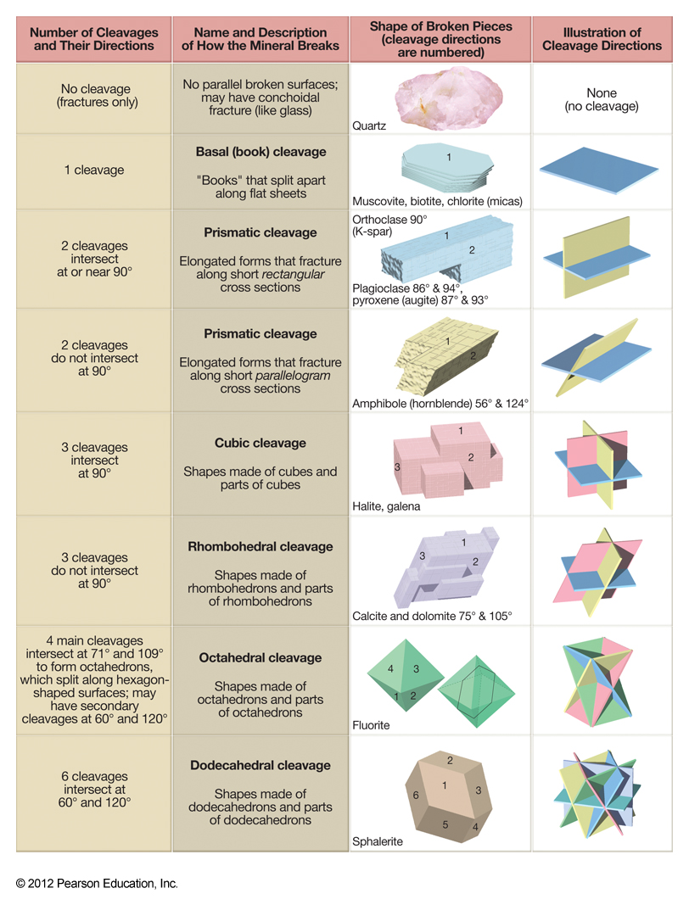
9 and 12 Mineral Structure: Silicates
1.5 Mineral Groups

- Minerals composed of _______________ and _______________ are called silicates.
  - More than _____% of Earth’s crust are silicates
- Silica tetrahedrons are the __________ ____________ ________ of silicates.

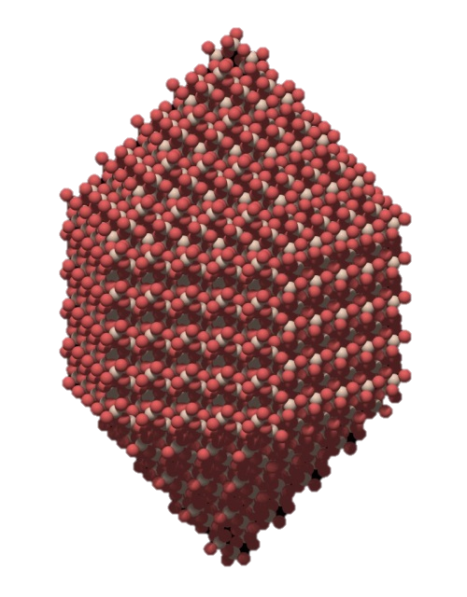
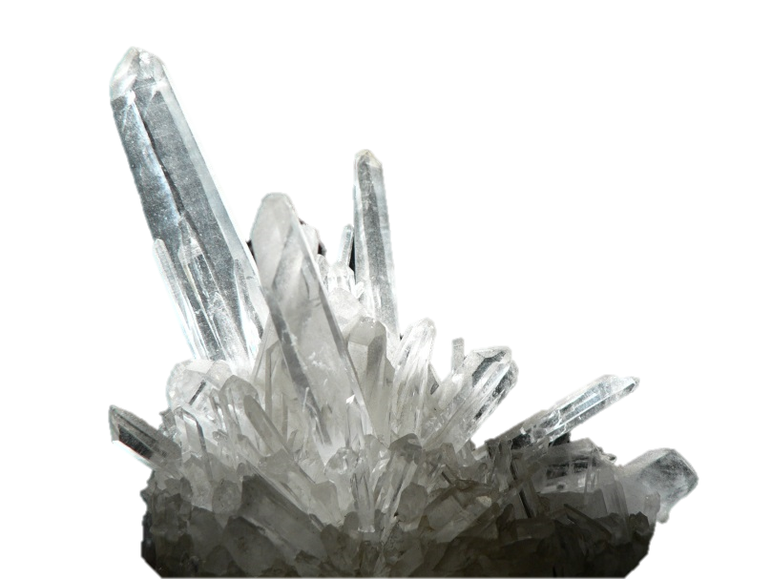

- Arrangement of silica tetrahedrons in a silicate determines many minerals characteristics such as melting point, cleavage, hardness and density.
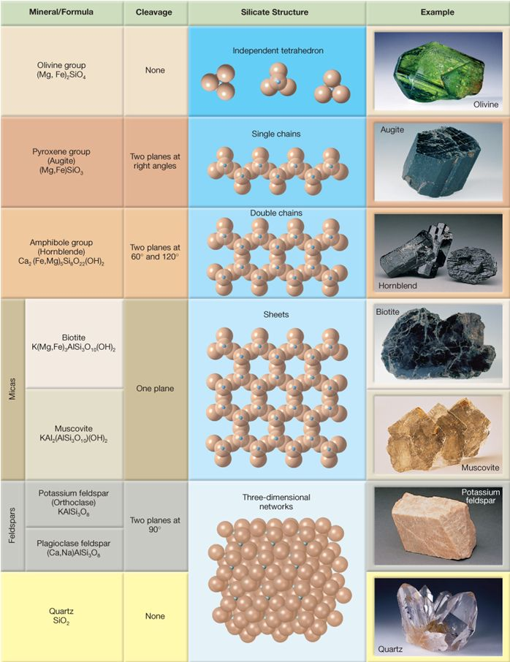
*Complete Mineral ID Lab (Activity 1.9 pg.13)

