Earth Science 11: Metamorphic Rocks
Textbook Pages: 66-71
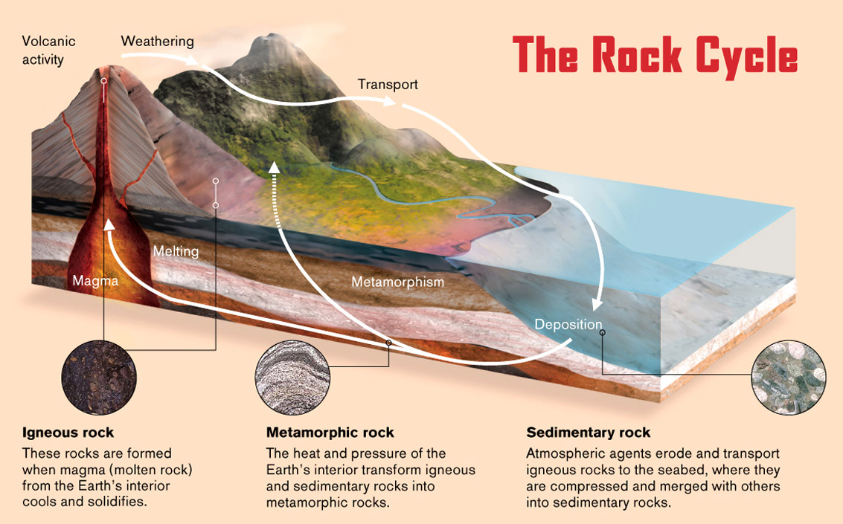
Metamorphism: when a rock encounters physical or chemical conditions significantly different from those it formed in.
- the rock changes state until an equilibrium with the new environment is reached.

Metamorphism causes changes in:
- rock texture (grain size)
- chemical composition (the minerals present)
- internal structure (density and porosity).

Causes of Metamorphism
Heat | Increase in temperature causes recrystallization (transformation of existing minerals into new minerals | What are two sources of heat inside earth?  Igneous intrusions and geothermal gradient (temp increases as you move towards the core)
Confining and Differential Pressure | Confining: pressure equal in all directions  Differential: pressure is not equal in all directions (minerals will be stretched perpendicular to the direction of greatest stretch – causes foliation) | 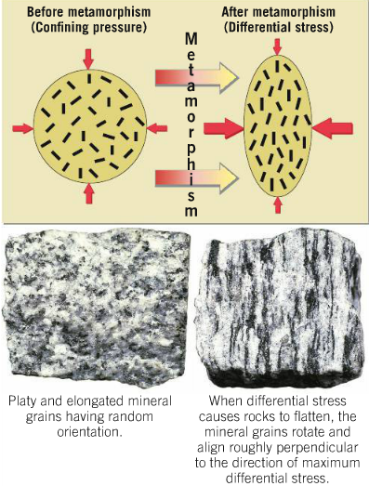
Chemically active fluids | Iron rich fluids

Types of Metamorphism
Contact | Regional
Covers a small area and is caused by an increase in heat, typically from an igneous intrusion. | Covers a large area and is caused by an increase in heat and pressure, typically from a convergent plate boundary.
 | 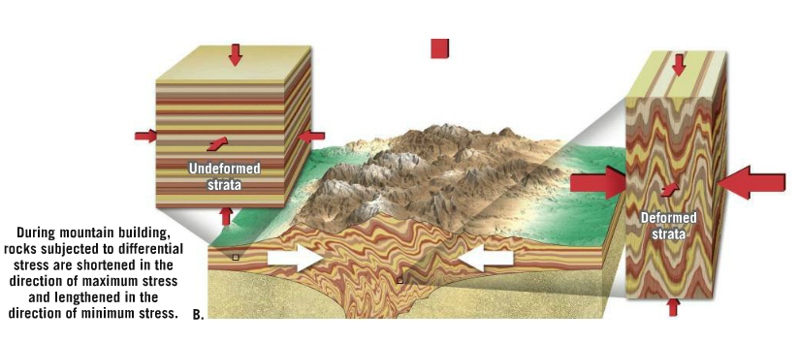

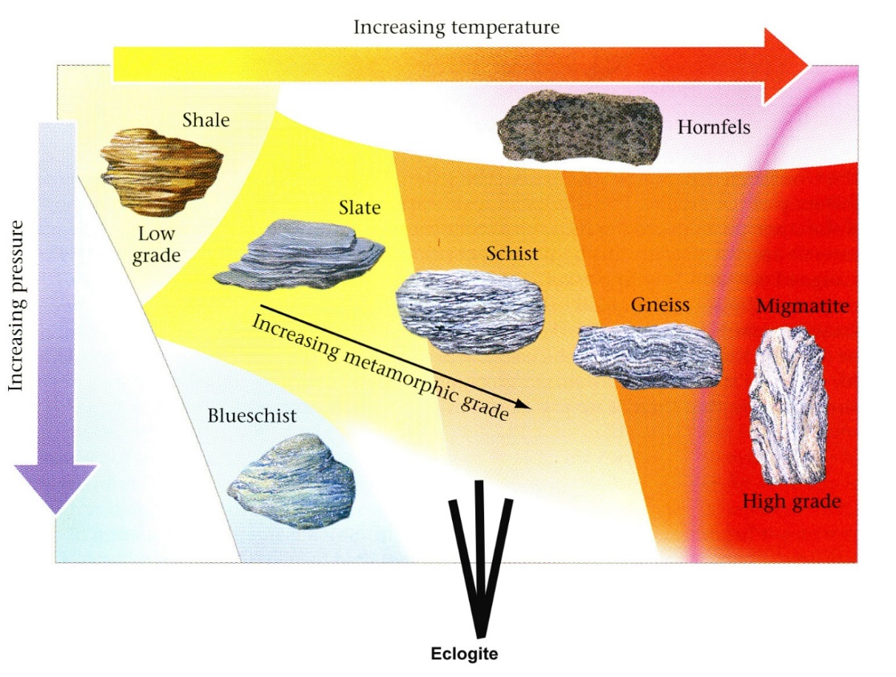
Metamorphic Grade
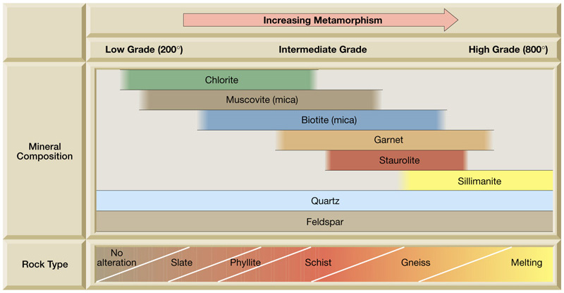
- describes the degree to which a rock has undergone metamorphism. This is indication by index minerals which only form under specific temperature and pressure ranges.
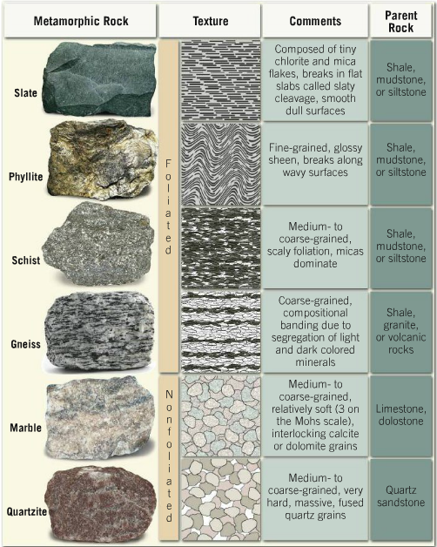
Metamorphic Rock Identification
- The Descriptions and identifications of metamorphic rocks are based on the parent rock, mineral content and texture (foliated or non-foliated).
*Complete Activity ** (pg. )in your workbook

