Name:_____________________

Lesson 9: Measuring Electrical Energy
p. 252-255
Electrical energy use is measured in two main ways:
Electrical Power:
- The rate at which electrical energy is used by a load
- Measured in watts (W) or kilowatts (kW)
- 1 kW = 1000 W
- Appliances are given power ratings
E.g. an appliance with a power rating of 100 W will consume energy 10 times faster than an appliance with a 1 kW rating
Kilowatt-Hours:
- The electrical energy used by an appliance over time
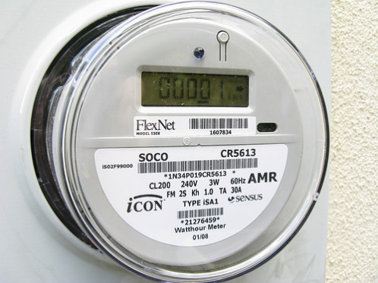
- Measured in kilowatt-hours (kWh) which combines units of power and time
- E.g. if you use an appliance rated 1000 W for one hour, you will have used 1 kWh of electrical energy
Reducing your energy usage:
Smart Meters:
- Track your energy usage through the day
- Information sent to utility company
EnerGuide and ENERGY STAR
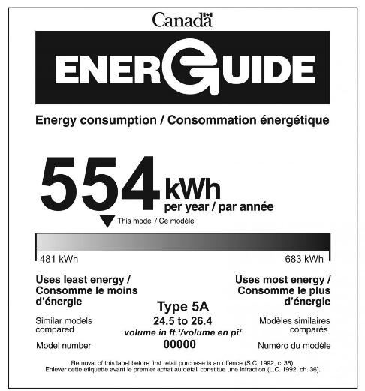
- The Government of Canada requires new
appliances be labelled to show how much energy they use
in a typical year
How much energy the appliance uses in a year

Phantom Loads:
Range of efficiency for yearly use
How the appliance compares with others
- The electrical energy a device uses when it is turned off
- Many electrical devices go into stand-by mode rather than switching off
- Phantom loads account for about 900 kWh of electrical energy use each year in the average home
- Examples of devices that have phantom loads: remote controlled devices, computers, power bars, microwaves

