Name:_____________________

Lesson 9: Measuring Electrical Energy
p. 252-255
Electrical energy use is measured in two main ways:
Electrical Power:
- The _________ at which electrical energy is used by a _________
- Measured in __________ (___) or ____________ (____)
- 1 kW = ___________ W
- Appliances are given ___________ ___________
E.g. an appliance with a power rating of 100 W will consume energy ______ times faster than an appliance with a 1 kW rating
Kilowatt-Hours:
- The electrical energy used by an appliance over _________
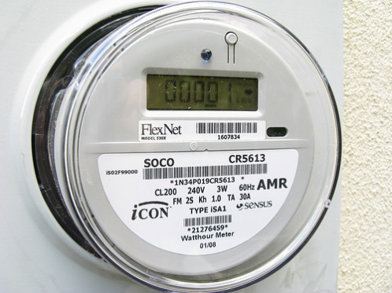
- Measured in ______________ (____) which combines units of _________ and _________
- E.g. if you use an appliance rated 1000 W for one hour, you will have used __________ of electrical energy
Reducing your energy usage:
Smart Meters:
- Track your energy usage through the day
- Information sent to _________ __________
EnerGuide and ENERGY STAR
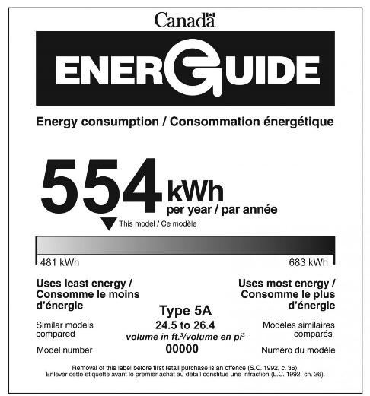
- The ____________ of _______________ requires new
appliances be labelled to show how much energy they use
in a typical ____________

Phantom Loads:

- The electrical energy a device uses when it is turned off
- Many electrical devices go into _________________ mode rather than switching off
- Phantom loads account for about ______________ of electrical energy use each year in the average home
- Examples of devices that have phantom loads: __________________________________________________
________________________________________________________________________________________

