Series and Parallel Circuits

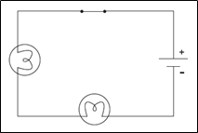
Series circuit: ________________________________
____________________________________________

With a series circuit, there is only _________ pathway through which current can flow. The current is _______ in _______ parts of the circuit.
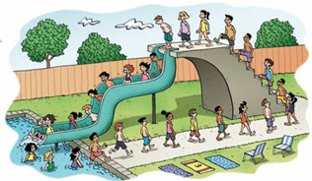
Example of a series circuit:
Some decorative lights are connected in such a way that if one bulb burns out the rest of the lights __________ work.

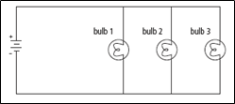

Parallel circuit: ___________________________
________________________________________
________________________________________

With a parallel circuit, the current ___________ into different paths. In each path, the current is _______________.
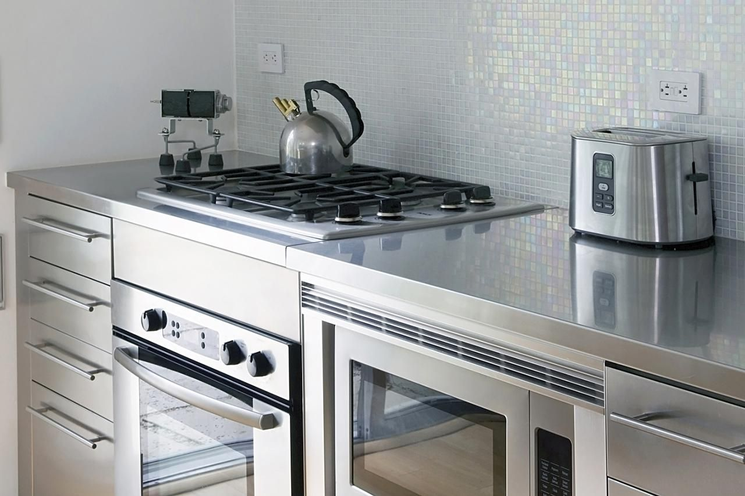
Example of a parallel circuit:

Appliances in your kitchen are connected so that if one appliance is turned off the rest ___________ work.

In parallel circuits each device is controlled by its own switch without shutting off the others. When all the devices are on, a large amount of ______________ is passing through the ______________ near the source. When large amounts of current flow through a wire, it can get _________________ and it becomes a safety hazard.

Would having only one parallel circuit in your house be convenient? Why or why not?

In buildings, such as your school and house, many ______________ parallel circuits are installed.

With this system large electrical cables carry _____________________from a ________________________ to the building. This is then connected to a___________________ (______________), which connects to each of the ___________________ inside the panel.
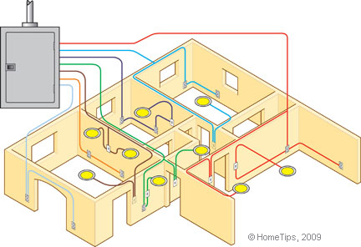
This separation of the parallel circuits helps to decrease the amount of _________________ flowing through the conductors, which decreases the chance of a possible fire being caused by extremely hot wires.

For a review of series and parallel circuits, watch this!
https://youtu.be/O8GgRIIB1Yc

