Series and Parallel Circuits
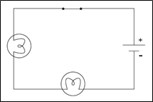

Series circuit: a circuit in which current can only flow along ONE path

With a series circuit, there is only one pathway through which current can flow. The current is equal in all parts of the circuit.
Example of a series circuit:
Some decorative lights are connected in such a way that if one bulb burns out the rest of the lights won’t work.

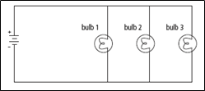

Parallel circuit: a circuit that has at least one branch point where the current splits into two or more pathways

With a parallel circuit, the current splits into different paths. In each path, the current is reduced.
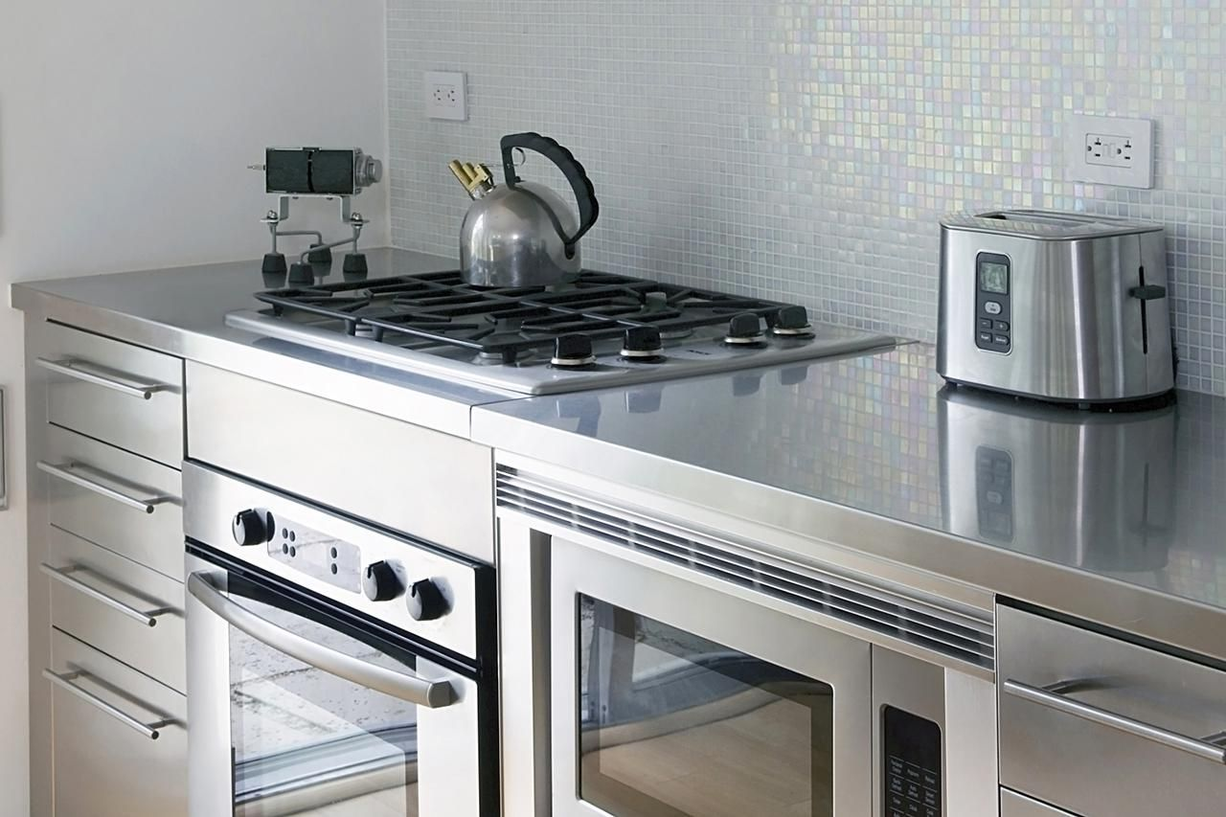
Example of a parallel circuit:

Appliances in your kitchen are connected so that if one appliance is turned off the rest will work.

In parallel circuits each device is controlled by its own switch without shutting off the others. When all the devices are on, a large amount of current is passing through the conductor near the source. When large amounts of current flow through a wire, it can get very hot and it becomes a safety hazard.

Would having only one parallel circuit in your house be convenient? Why or why not?

In buildings, such as your school and house, many separate parallel circuits are installed.

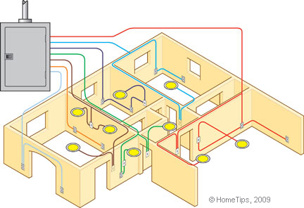
With this system large electrical cables carry electrical energy from a power source to the building. This is then connected to a circuit panel (fuse box), which connects to each of the parallel circuits inside the panel.

This separation of the parallel circuits helps to decrease the amount of current flowing through the conductors, which decreases the chance of a possible fire being caused by extremely hot wires.

For a review of series and parallel circuits, watch this!
https://youtu.be/O8GgRIIB1Yc

Perform Circuit Challenge Activity on pg. 238. In the boxes below draw your circuits using symbols to represent the: switch, light bulbs, wire, and battery.

Circuit #1:

Circuit #2:

Circuit #3:

