Renewable Energy Sources

List some examples and qualities of a renewable and nonrenewable energy resource

Renewable
Nonrenewable
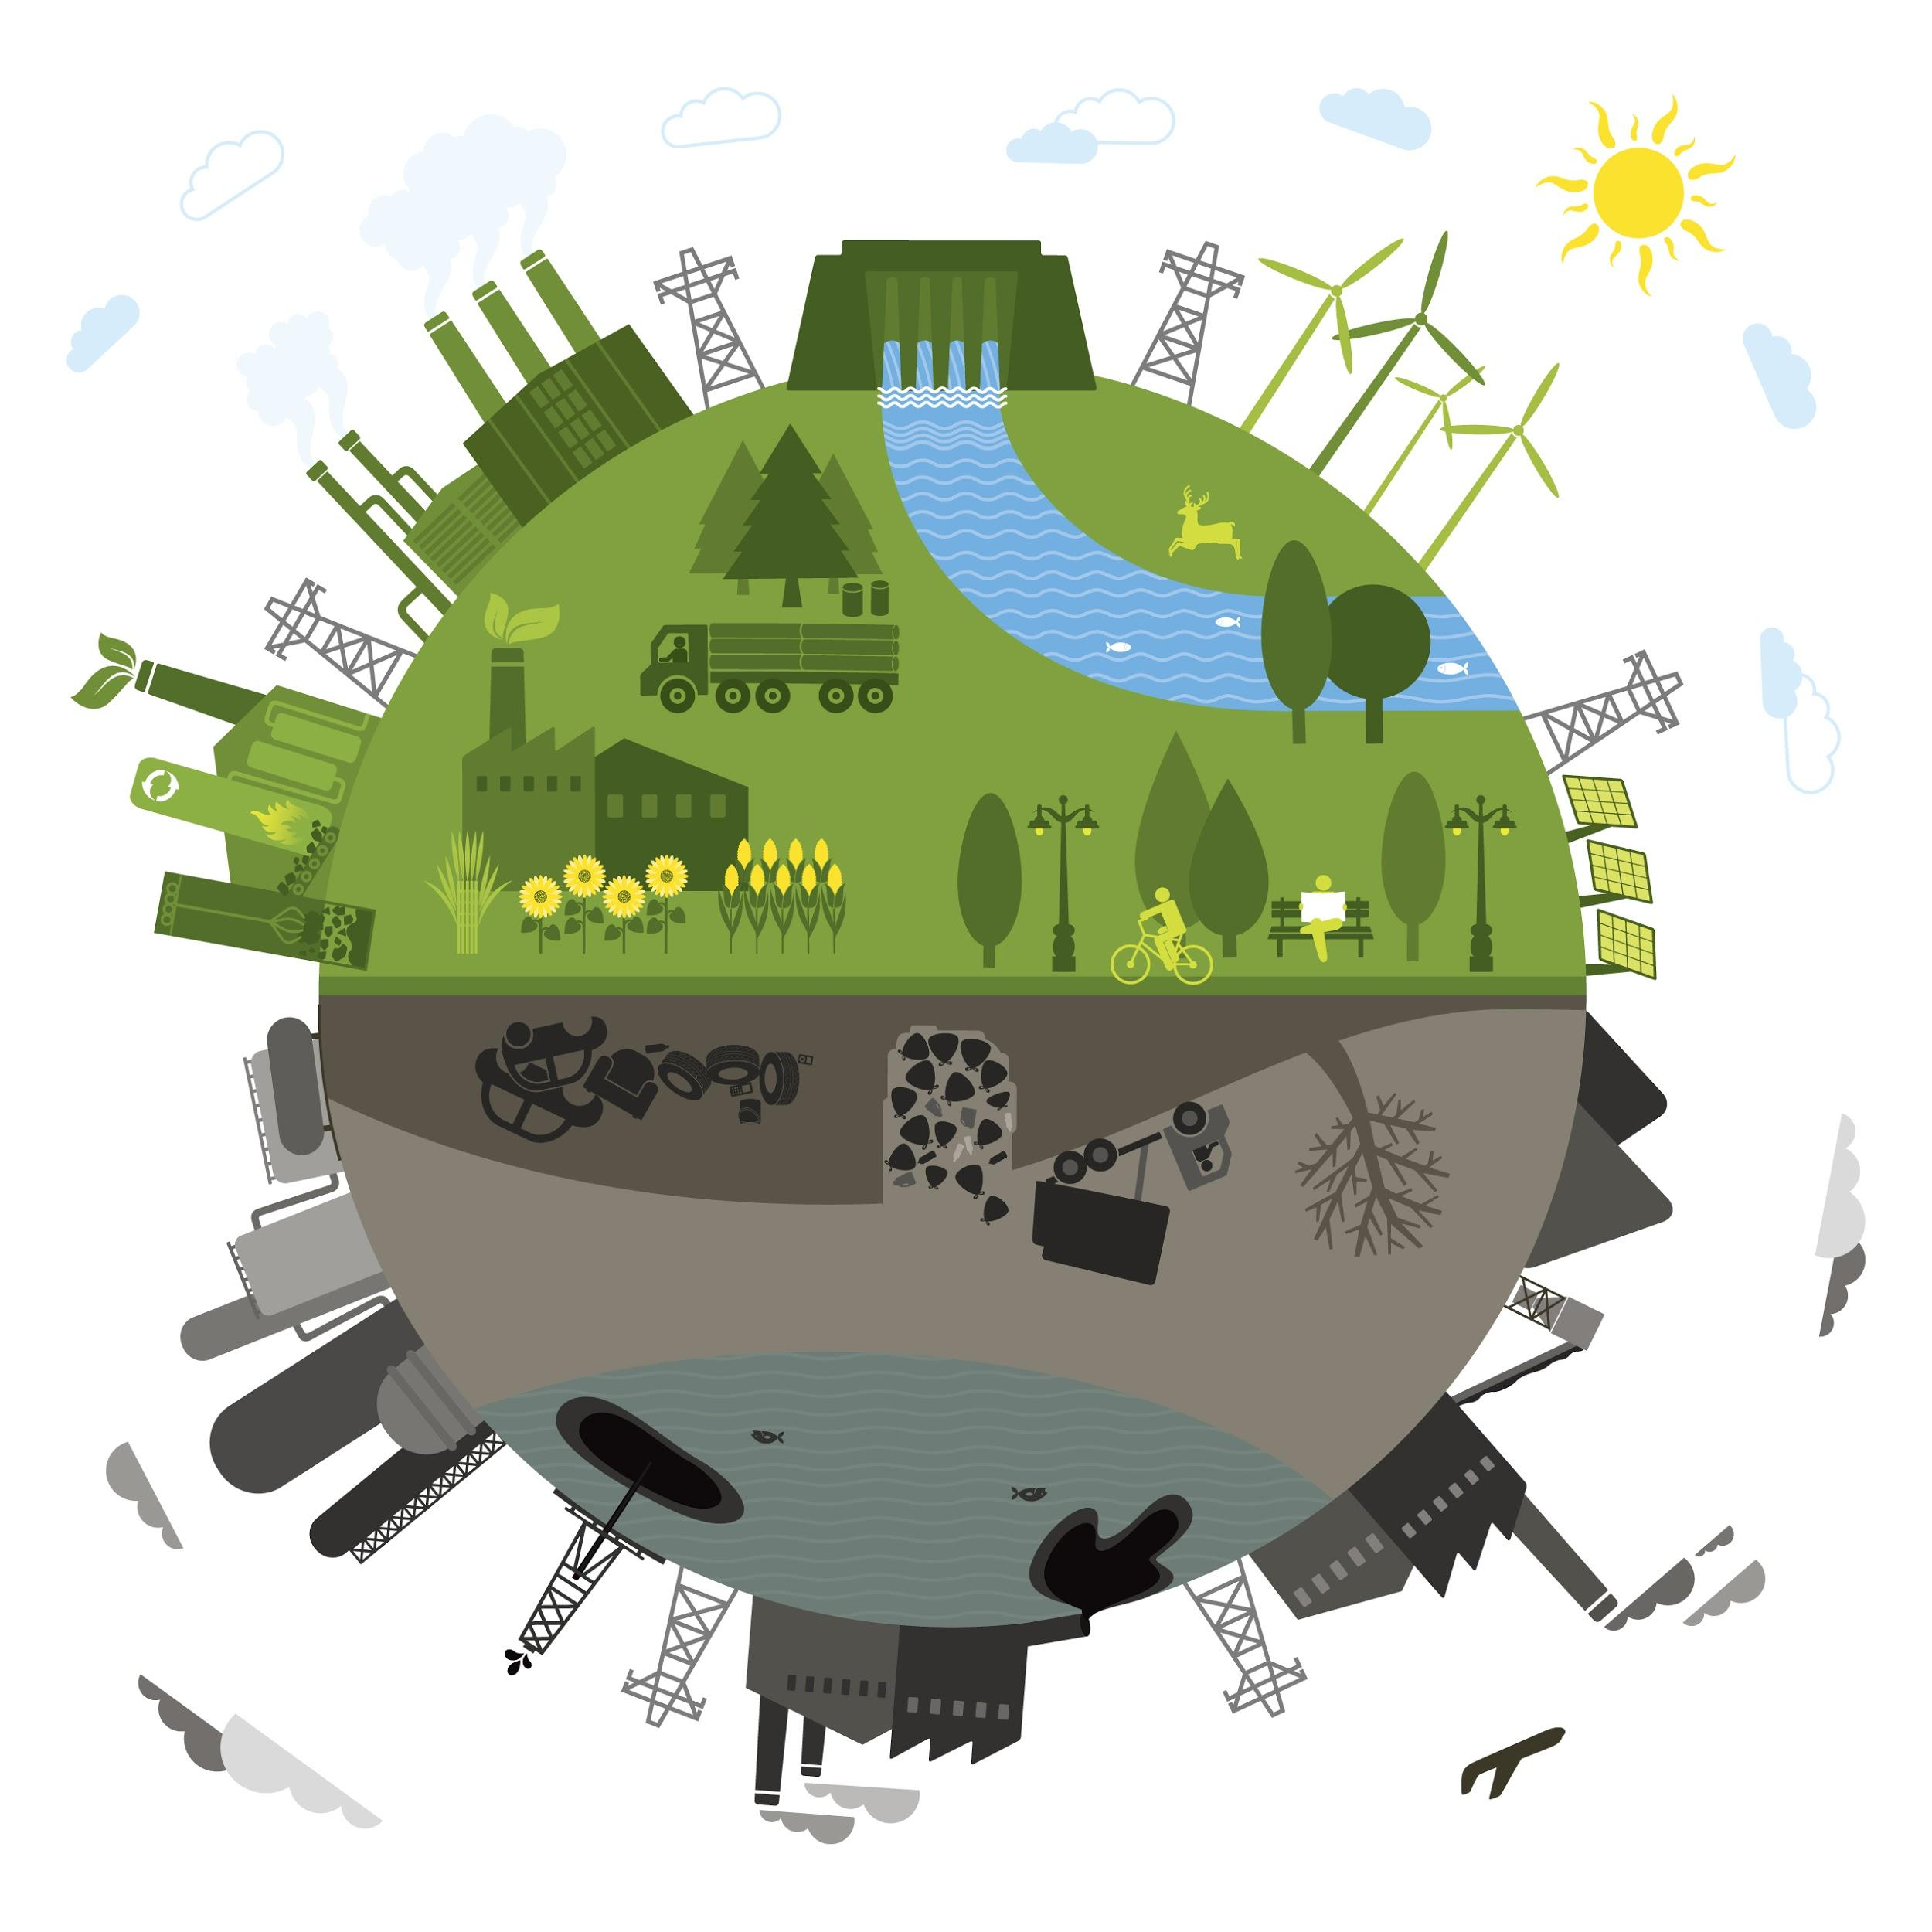

What makes something a Renewable energy resource?

- generated from a natural resource

- can be replenished in OUR LIFETIME

Concept 3: Generating Electrical Energy from Other Energy Sources

Electrical energy from Wind - https://youtu.be/0Kx3qj_oRCc
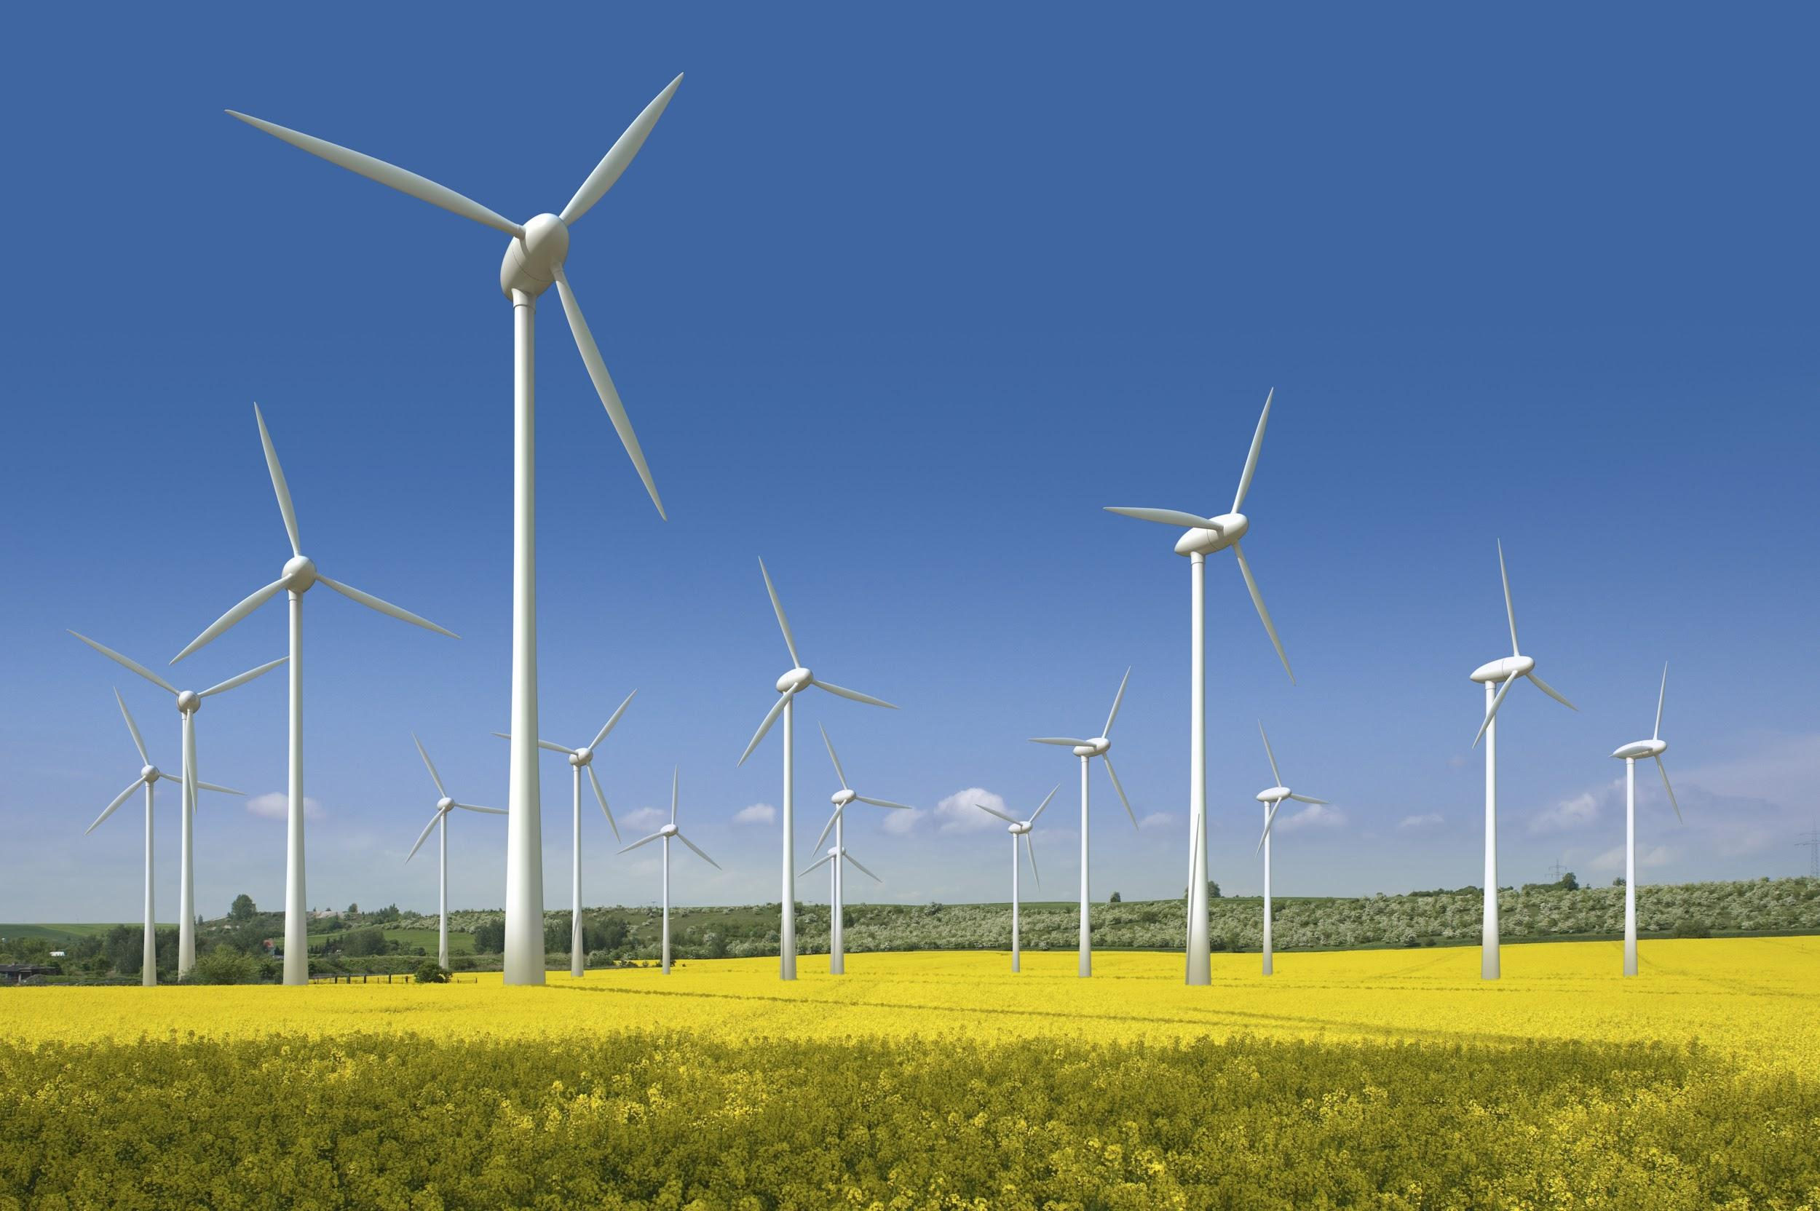
The kinetic energy of wind is transformed into electrical energy as moving air turns the turbine of a generator system.

A wind turbine starts to produce electrical energy when wind speed is about 13 km/hr.

An anemometer is used to measure wind speed.

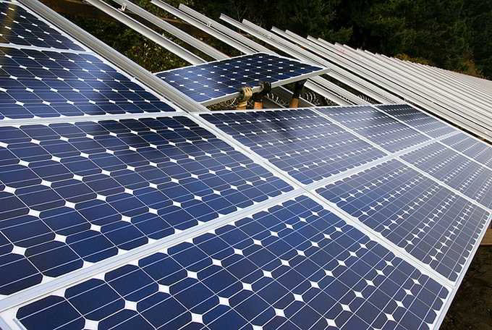
Electrical Energy from Sunlight

Photovoltaic cells generate electrical energy when visible light (solar energy) strikes their surface.

The cells are made up of silicon crystals. When visible light comes in contact with the surface electrons trapped in the in the cells absorb just enough energy to flow freely and generate electrical energy.

Electrical Energy from Geothermal Sources - https://youtu.be/mCRDf7QxjDk
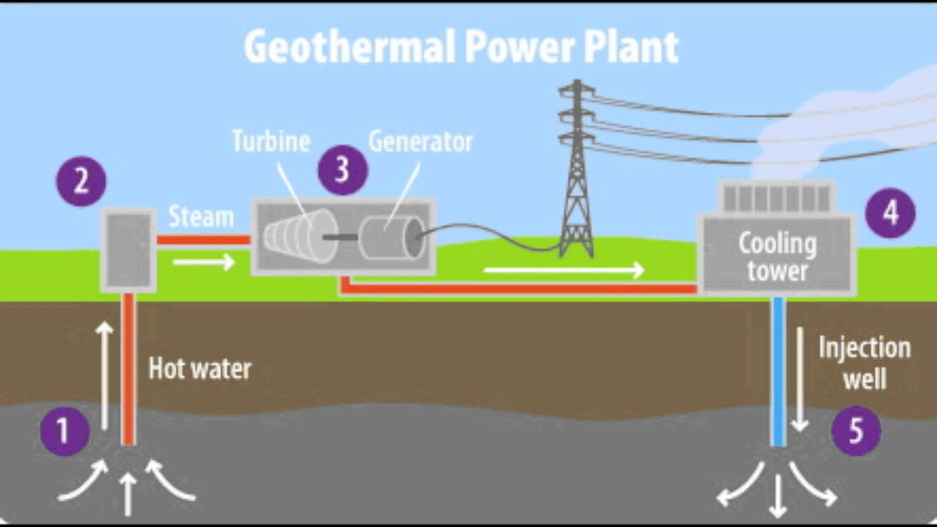
Where Earth’s crust is thin and molten rock comes close to the surface, hot steam (thermal energy) can be used to turn turbines to generate electrical energy.

Iceland generates 25% of its electrical energy from geothermal sources.

Electrical Energy from Waves and Tides - Watch the video: https://youtu.be/VkTRcTyDSyk

The vertical rise and fall of waves can either turn a turbine or compress air, which will then turn a turbine

Tidal energy is only effective when there is a difference of 5 m from high tide to low tide.

Tidal energy stations only generate electrical energy for about 10 hours a day

The three methods of producing electrical energy from the potential energy of tides are:
- Tidal barrage
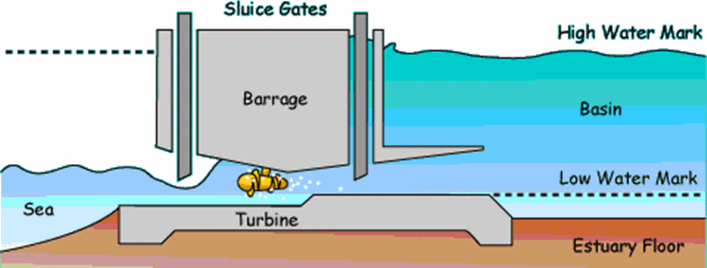
- Tidal fences
- Tidal turbines

