Renewable Energy Sources

List some examples and qualities of a renewable and nonrenewable energy resource

Renewable
Nonrenewable
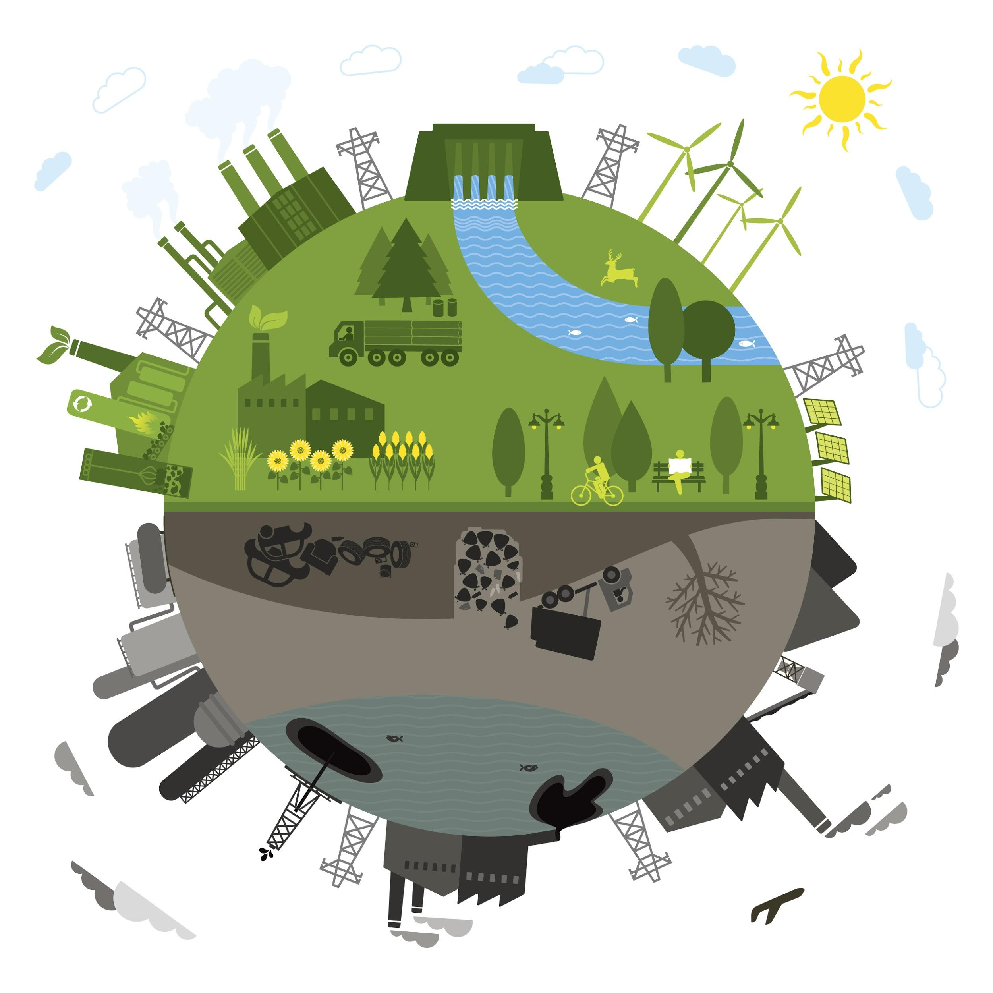

What makes something a Renewable energy resource?

_______________________________________________________
_______________________________________________________
_______________________________________________________

Concept 3: Generating Electrical Energy from Other Energy Sources

Electrical energy from Wind - https://youtu.be/0Kx3qj_oRCc
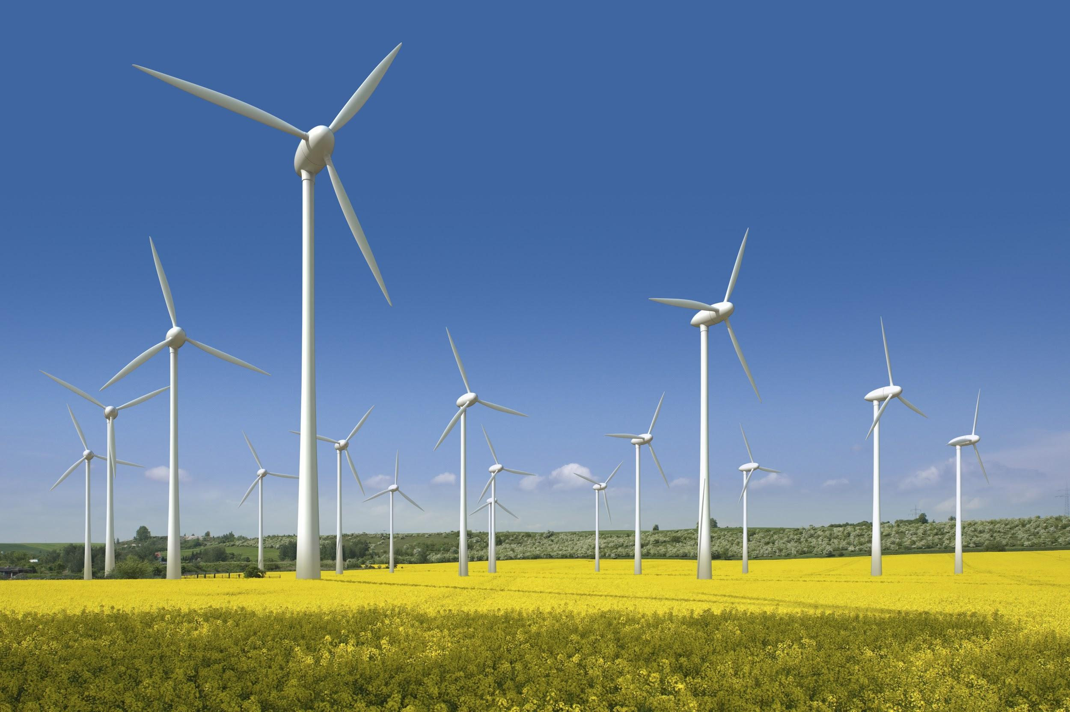
The __________________________ of wind is transformed into _______________________________ as moving air turns the turbine of a generator system.

A wind turbine starts to produce electrical energy when wind speed is about ______________________________

An _____________________________ is used to measure wind speed.

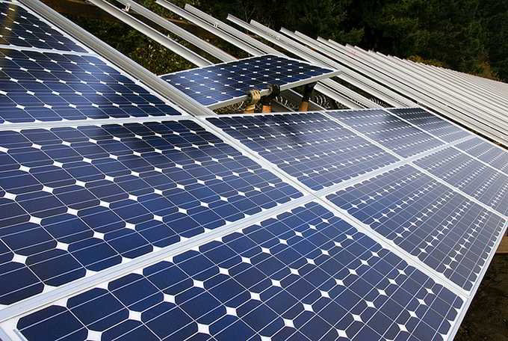
Electrical Energy from Sunlight

_____________________________generate electrical energy when visible light (___________________) strikes their surface.

The cells are made up of _____________________. When visible light comes in contact with the surface __________________ trapped in the in the cells absorb just enough energy to ________________________ and generate ________________________________.

Electrical Energy from Geothermal Sources - https://youtu.be/mCRDf7QxjDk
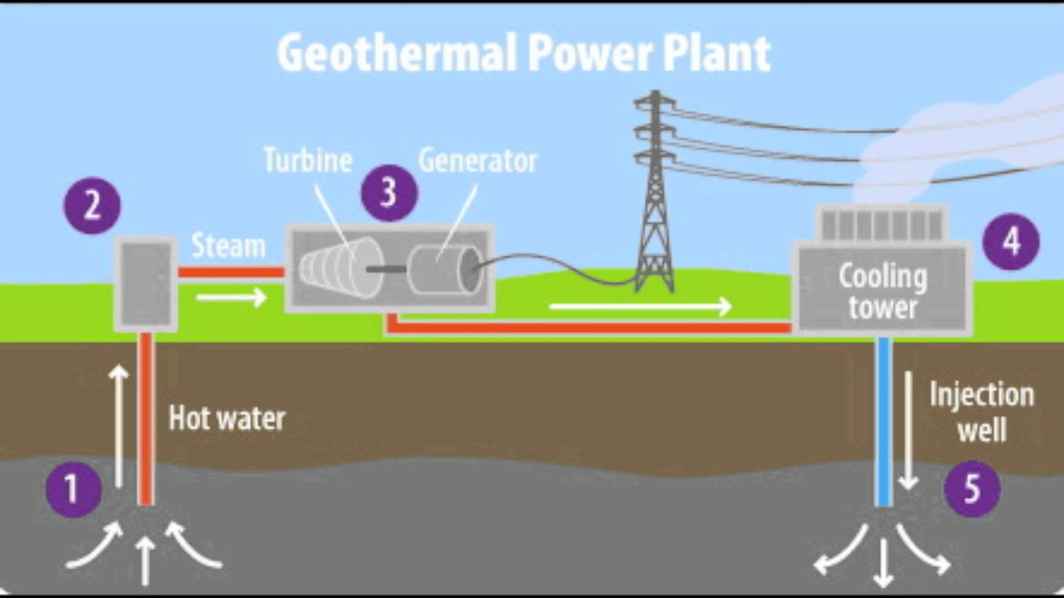
Where Earth’s crust is thin and molten rock comes close to the surface, hot _____________________ can be used to turn turbines to generate ____________________.

Iceland generates ___________ of its electrical energy from geothermal sources.

Electrical Energy from Waves and Tides - Watch the video: https://youtu.be/VkTRcTyDSyk

The vertical rise and fall of waves can either ____________________ or ___________________, which will then turn a turbine

Tidal energy is only effective when there is a difference of __________ from high tide to low tide.

Tidal energy stations only generate electrical energy for about __________________ a day

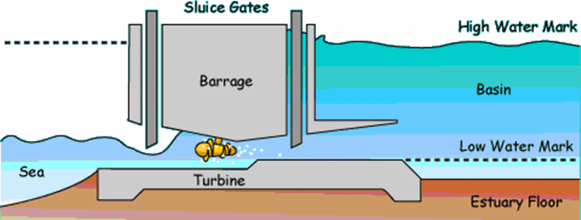
The three methods of producing electrical energy from the potential energy of tides are:

____________________________
____________________________
____________________________

