Lesson 1: Introduction to Matter and the Atom
In what contexts have we discussed matter so far this year?

The Atom
Matter is defined as anything with mass and volume. All matter is made up of atoms, which are considered the smallest unit of matter. Atoms are composed of a nucleus which contains protons and neutrons, orbited by electrons organized in shells. The outermost shell is referred to as the valence shell.
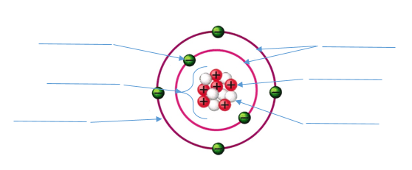

Atomic Particle | Location | Charge | Significance
Proton
Neutron
Electron

Categorizing Matter
The number, type and organization of the atoms within matter can vary. Therefore, we have created subcategories to differentiate between these categories.
Pure substances: In a pure substance, every particle is identical and cannot be separated by physical means.
- Elements
  - The number of protons in an atom determines the identity of the atom
  - For example: all hydrogen atoms will have one proton, all carbon atoms will have six protons
- Compounds
  - When two or more atoms bond together it is called a compound
  - For example: in a sample containing pure water, every particle will contain two hydrogen atoms and one oxygen atom
Mixtures: A mixture is defined as a blend of two or more pure substances, meaning there will always be at least two different types of particles. Mixtures can be separated through physical means.
- Homogeneous mixtures
  - Homogeneous mixtures are not obviously mixtures
  - In a homogeneous mixture, the two or more substances are mixed uniformly
  - For example: salt water is a type of homogeneous mixture
- Heterogeneous mixtures
  - Heterogeneous mixtures are obviously mixtures
  - In a heterogeneous mixture, the substances are not mixed uniformly
  - For example: oil and water is a type of heterogeneous mixture

