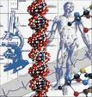
DNA Extraction Lab Name:

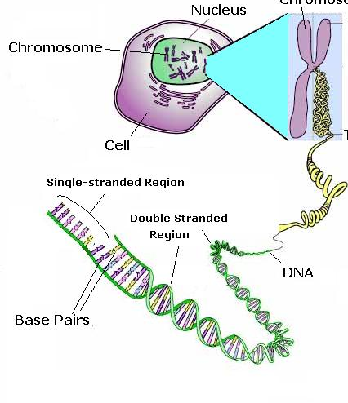
Materials and Equipment:
- A quarter of a banana
- 50ml water
- 1 tablespoon detergent
- ¾ tablespoon of salt
- ethanol
- zip loc bag
- measuring cylinder
- 55°C water bath
- ice
- funnel and filter paper to fit
- glass rod
Procedure
- Store ethanol on ice.
- Mash banana in the zip loc bag.
- Add salt and 10 ml of water to the bag, mash until liquid turns white.
- Add detergent and 40ml of water to the solution, mix well.
- Filter the solution through the filter paper in the funnel and allow it to collect in a measuring cylinder.
- Pour 5ml of the collected solution into a test tube and place in a 55°C water bath for 10 minutes.
- Remove test tube from water bath and place in ice water for 10 minutes.
- Pour 5 ml cold ethanol into the experiment test tube.
- Swirl the liquid.
- Observe a change in the solution.
- Use the glass rod to remove the transparent ‘blob’ of DNA

Purpose: _______________________________________________________________
Materials: As per page 1
Procedure: As per page 1
Observations:
Title:______________________________________________________
Banana mixed with salt and water and soap
DNA blob

Analysis of the procedure
- Why is it necessary to mash the banana?
__________________________________________________________________________________________________________________________________________
Apply
- What is an organelle?
____________________________________________________________________________________________________________________________________
- What is the function of the nucleus? What is the function nucleolus?
____________________________________________________________________________________________________________________________________
- Describe how bases pair up in the DNA molecule.
____________________________________________________________________________________________________________________________________
- What is the difference between a chromosome and chromatin?
____________________________________________________________________________________________________________________________________
- How many chromosomes does a human body cell contain?
__________________________________________________________________
- Your retina cells and muscle cells contain identical DNA. How are these cells able to function differently?
________________________________________________________________________________________________________________________________________________

