Applications of Electrical energy/How is electricity generated?

Concept 1: Electrical Energy has many applications

Brainstorming activities:
- List all of the ways electricity has had a role in your life since you woke up this morning:

- Imagine that the power failed in Vancouver for one full week. Brainstorm with a partner to think of at least 10 impactful changes this would have on our live:

Applications of energy:

For each of the images, write down brief explanations for how there is an application of electrical energy (how is electricity involved in these processes?). Use pages 190-191 in the Connections Textbook :

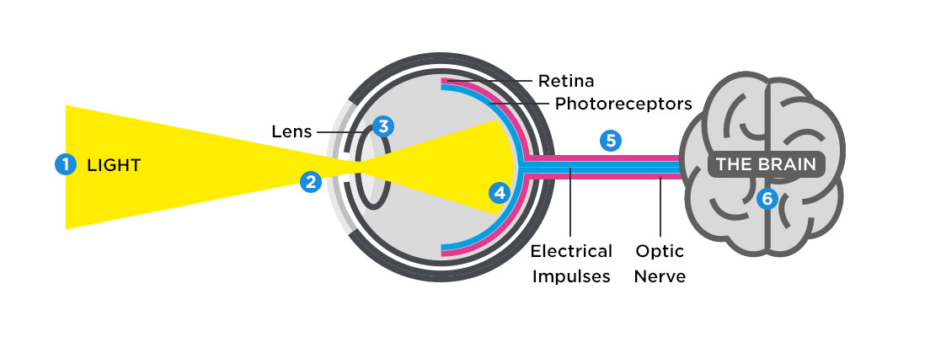

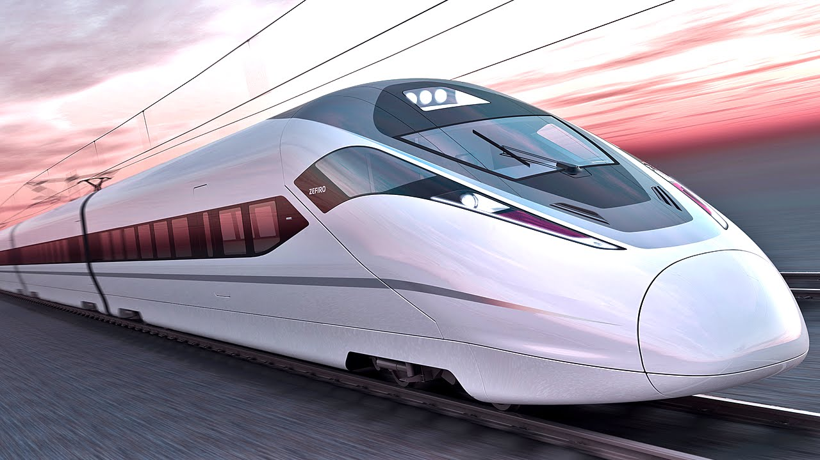

Concept 2 - Many different types of energy can be transformed into electrical energy.

- The Law of Conservation of Energy states that energy is neither created nor destroyed. Use the image below to help you come up with an explanation of what that statement means. Also, look at the image and come up with at least one specific example of how energy goes from one type to the other. (We will do this as a class)
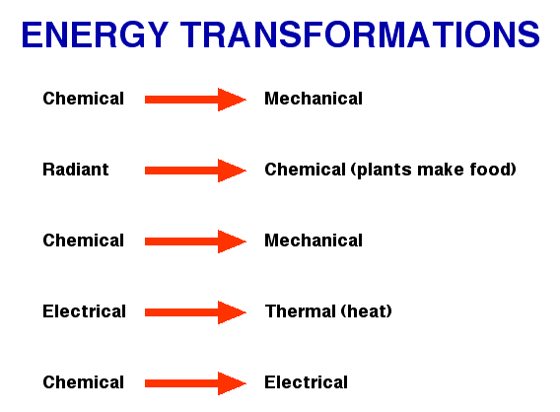
Energy is not created nor destroyed but
Is transformed into other types of energy.

A toaster transforms electrical energy into
heat energy.

Our bodies convert chemical energy from food into mechanical energy to help us move.

b) Many types of energy can be converted into electrical energy. Go to pg. 192-193 of the textbook to write down some notes on each of the different types of energy listed.

 | Type of energy | Description of energy/Sources
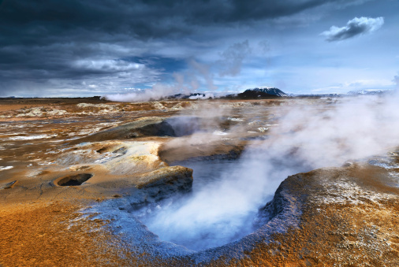 | Thermal | Energy due to rapid motion of particles that make up an object - we detect it as heat.  Sources include: geothermal energy (geysers, volcanoes, hot springs), nuclear reactions
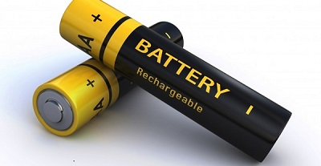 | Chemical | Energy stored in chemical bonds - released when chemical reactions occur.  Sources include: batteries, plants/animals, fossil fuels
 | Mechanical | Sum of kinetic and potential energy  Kinetic - energy of motion  Potential - stored energy
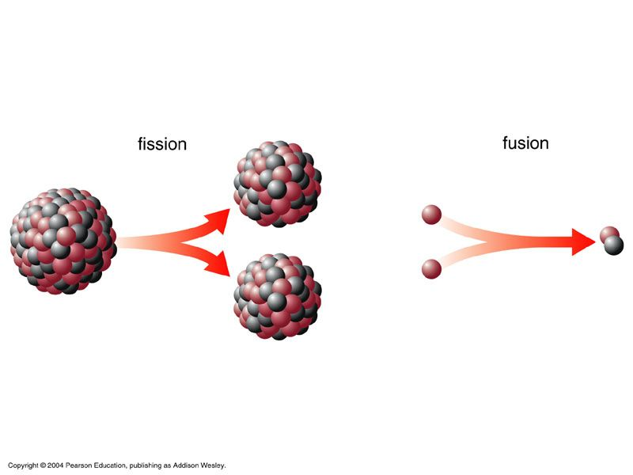 | Nuclear | Generated by forming new atoms.  Examples are fusion (sun and stars) and fission where larger atoms split (nuclear reactors).
 | Solar | Energy carried by electromagnetic radiation given off by Sun.

Concept 3: Electrical Energy is generated in different ways from different sources

- With the people at your table, take a few minutes to discuss the questions listed below.
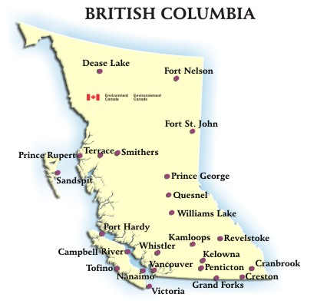

How do you think most of the electrical energy in British Columbia generated?

Think of some pros and cons for the primary way in which energy is produced here in British Columbia.

Are there other ways used that you know of?

Is this the same for all of Canada? For the World?
b) KINETIC TO ELECTRICAL ENERGY Watch the video: https://goo.gl/3PBP04
- Most electrical energy in Canada is generated by transforming mechanical
energy into electrical energy.
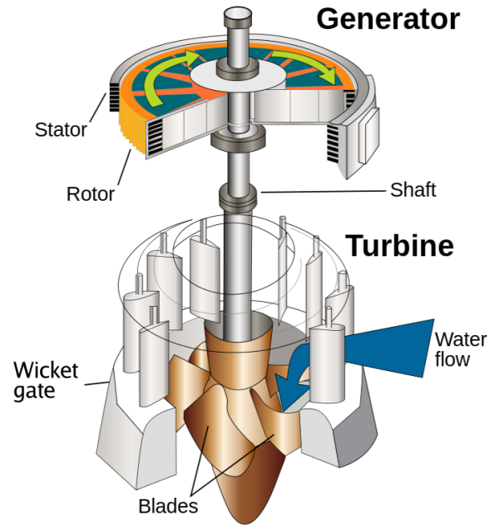
- Sources of kinetic energy may be moving water or ______________. It may also be moving steam produced by thermal energy generated in nuclear reactions, or by burning fossil fuels.
- In each case, electrical energy is generated using a generator system
- A generator system consists of three parts: turbine, shaft and a generator.
c) GENERATING ELECTRICAL ENERGY IN CANADA
- Most of the electrical energy in Canada comes from water flow, fossil fuels, and nuclear reactions.
- In BC, water flow is the main source and fossil fuels are also used to generate electrical energy. BC has no nuclear reactors.
- Watch this video on how energy is produced by river flow: https://goo.gl/JA3Eyh

TASK
Choose one of the energy sources that are explained on pages 195-197 of the textbook (River Flow, Fossil Fuels, Nuclear Reactions, Wind, Sunlight, Geothermal Sources, Waves and Tides). On a separate google document, complete the following questions on your chosen energy source. You can use the textbook as well as any other additional sources of info to complete the questions. When completed, submit the document to your teacher.

- In 4-5 sentences, describe your chosen energy source. Is this a common energy source or is it a ‘small player?’ In what parts of the World is this energy source utilized? Is it a growing industry? Etc. (3 marks)

- List some pros and cons of this particular energy source (at least two for each) (2 marks)

- Draw a detailed diagram that explains how your energy source is able to be converted to electrical energy. Use the textbook or other resources to help you produce this diagram. Take a picture of your diagram and paste it into your document (5 marks).

