Unit 2: Ecology
(Eco – house or environment) & (Logy – study of)
Date:
What is meant by Ecology?
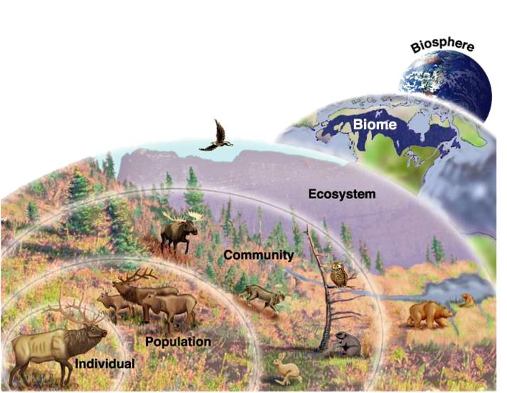
____________________________________________________________________________________.

What is meant by an ecosystem?
_______________________________________________
_______________________________________________
We will begin this unit with the idea of how humans influence our ecosystems. It is important to understand the connection between biotic and abiotic interactions within a system.
https://www.youtube.com/watch?v=GlnFylwdYH4

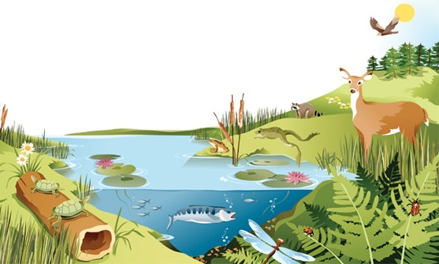
Looking at the image below, can you identify three biotic factors and three abiotic factors?
Biotic | Abiotic

What is the difference between biotic factors and abiotic factors?
Abiotic = ________________________
Biotic = _______________________

What is a Biome?
- largest division of our biosphere which contain large regions of similar abiotic and biotic components
Looking at the image to the right, can you identify the eight terrestrial Biomes here on this planet?
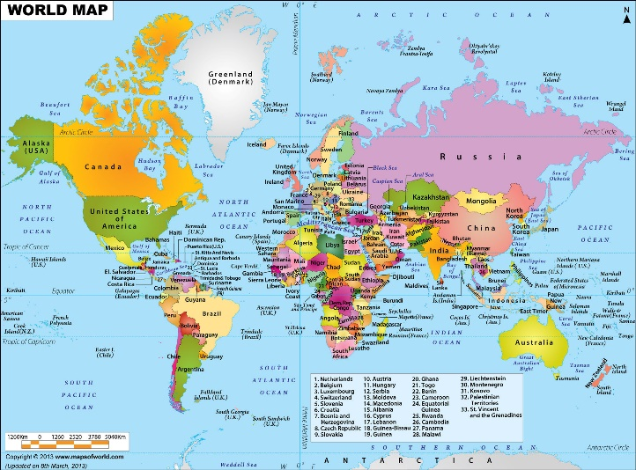

What are the two main factors that determine the characteristics of each Biome on our earth?
_____________________________________________
How do humans influence our ecosystems?
https://www.youtube.com/watch?v=2RC3Hsk90t8 (watch 0 mins – 5:30 mins)
What is meant the carrying capacity of our biosphere?
__________________________________________________________________________________________________________________________________________________________________________
What have we done as humans to increase our carrying capacity for our Earth?
_____________________________________________________________________________________
In class Activity: In the space below, brainstorm how humans have influenced our ecosystems…

