Unit 2: Ecology
(Eco – house or environment) & (Logy – study of)
Date:
What is meant by Ecology?
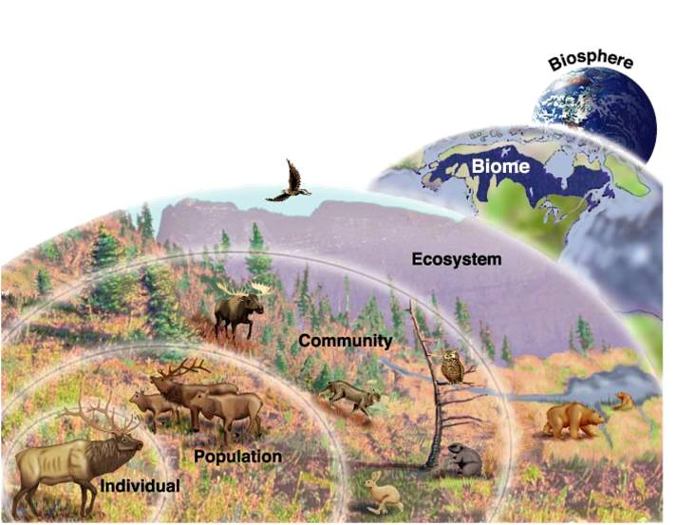
Ecology is the study of interactions among organisms and their environment.

What is meant by an ecosystem?
An ecosystem is part of a Biome that includes biotic and abiotic factors.
We will begin this unit with the study of how human influence our ecosystems. It is important to understand the connection between biotic and abiotic interactions within a system
https://www.youtube.com/watch?v=GlnFylwdYH4

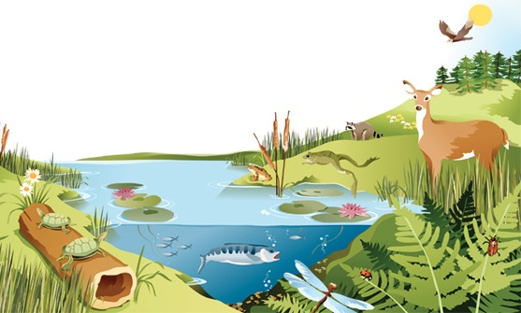
Looking at the image below, can you identify three biotic factors and three abiotic factors?
Biotic | Abiotic

What is the difference between biotic factors and abiotic factors?
Abiotic = non-living
Biotic = living

What is a Biome?
- largest division of our biosphere which contain large regions of similar abiotic and biotic components
Looking at the image to the right, can you identify the eight terrestrial Biomes here on this planet?
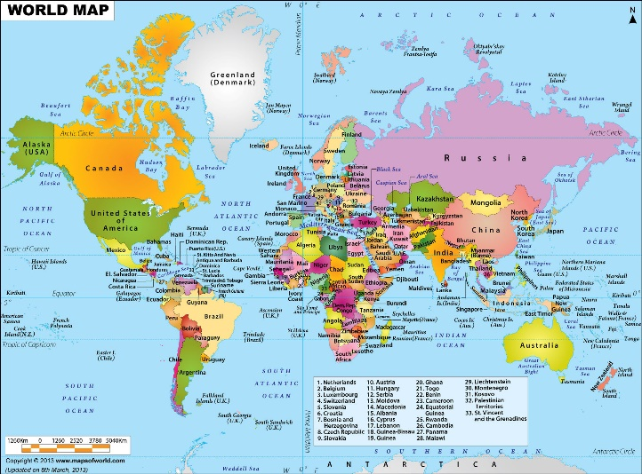
- Tundra
- Permeant Ice
- Temperate Rainforest
- Tropical Rainforest
- Grassland
- Desert
- Temperate Deciduous Forest
- Boreal Forest
What are the two main factors that determine the characteristics of each Biome on our earth?
- Temperature
- Precipitation
How do humans influence our ecosystems?
https://www.youtube.com/watch?v=2RC3Hsk90t8 (watch 0 mins – 5:30 mins)
What is meant the carrying capacity of our biosphere?
- The earth cannot indefinitely support the ever increasingly population
- We would exceed to carrying capacity for our biosphere
What have we done as humans to increase our carrying capacity for our Earth?
- Technology and science to increase food production
In class Activity: In the space below, brainstorm how humans have influenced our ecosystems…

Topics to be covered for our next assignment:
- Air pollution
- Agriculture
- Urbanization
- Water Pollution
- Overexploitation

