Atmosphere Unit
Heating the Earth’s Atmosphere
Chapter 11 (pg. 328 – 357)

11.1: Focus on the Atmosphere: Weather and Climate
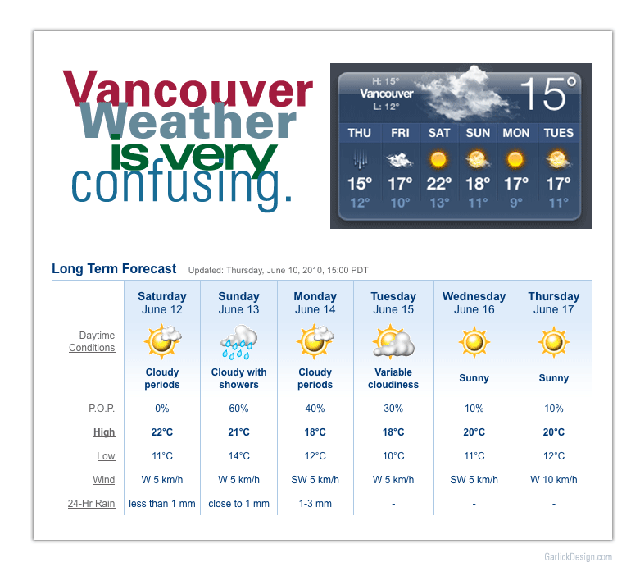
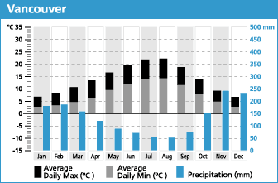

What is the difference between the weather and climate in Vancouver?
Weather | Climate

Weather and Climate are described using the same elements:
- Air Temperature
- Humidity
All of these elements are interconnected and have an effect on each other
- Type and amount of cloudiness
- Type and amount of precipitation
- Air pressure
- Speed and direction of the wind

11.2: Composition of the Atmosphere

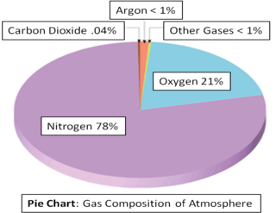
______________________________: Envelope of air between Earth’s surface and Space
What can you tell about the Earth’s atmosphere based on the pie chart?

What is the importance of the components that make up air?
Nitrogen | Building block of proteins, atmosphere is the major source
Oxygen | Necessary for cellular respiration
Carbon Dioxide | Absorbs energy emitted by earth (infrared radiation) = plays a role in heating the atmosphere.
Water Vapour | Humidity varies by location/season. Source for all clouds, precipitation, absorbs heat from Earth/Sun, energy source driving storm
Aerosols | Particles kept in the atmosphere by air movement. Condensation surfaces, absorb/reflect incoming solar radiation.
Ozone | Concentrated in the stratosphere and absorbs UV radiation
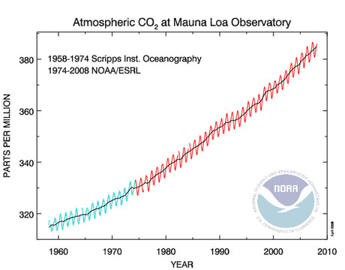
- Oxygen and Nitrogen are the most abundant but have little or no importance in affecting weather phenomena
Explain the graph to the right.

*Origins of the Atmosphere video http://channel.nationalgeographic.com/videos/origins-of-the-atmosphere/
11.3: Structure of the Atmosphere

- The atmosphere is divided into layers based on fluctuating:
  - Temperature
  - Pressure
  - Gas composition
Using the information from the atmosphere layers lab and the diagram below. Complete the table on the following page.
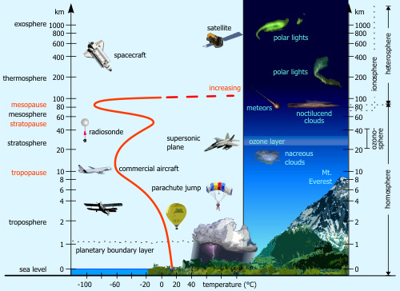

- Earth’s Atmosphere Animation https://svs.gsfc.nasa.gov/20014

Layer | Height Above Earth | Temperature Conditions | Pressure Conditions | Other Notes
Exosphere

Thermosphere

Mesophere

Stratosphere

Trophosphere

*View Power of the Planet: Atmosphere, 0 to 24:31 minutes.
What are two important roles of the atmosphere?

11.4: Earth-Sun Relationships

- Earth’s weather patterns, climates and ocean currents are the products of the unequal distribution of energy from the Sun.
- The angle of insolation effects how much solar energy is being transferred. The more direct (ie. Closer to 90°, the more energy that is transferred)
  - Angle of insolation: the angle of the sun’s rays when they meet Earth’s surface.
What is the difference between a solstice and an equinox?

- Exploring this idea will draw on many ideas from our Solar System Unit, such as the Earth’s rotation, revolution and the creation of seasons.
- You will use Exercise 12 in your workbook to explore these ideas. This is testable material. Make sure you complete Activity 12.1 and 12.2.

11.5 and 11.6: Heating the Atmosphere

What is the difference between temperature and heat?

Mechanisms of Heat Transfer
- In all scenarios heat is always transferred from warmer to colder objects.
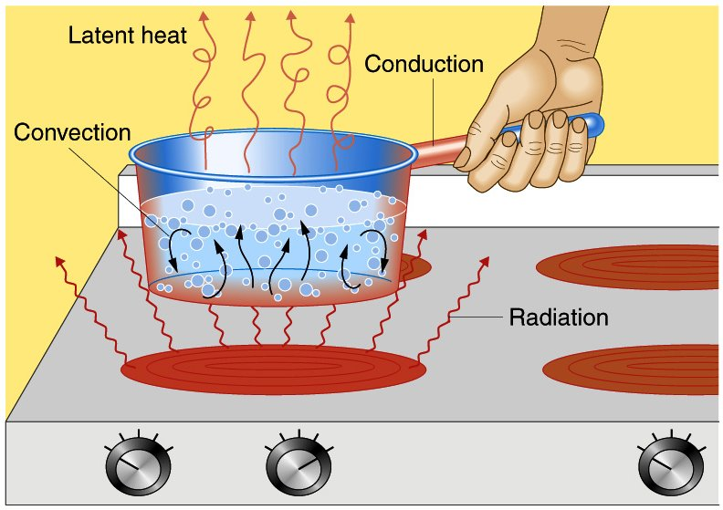

 | Conduction | Convection | Radiation
General Definition
Earth Examples | Transfer of heat between particles in Earth’s surface and lowest layer of the atmosphere | Air at surface is heated, becomes_____________ and rises  Air expands, cools and begins to ___________. | How solar energy (visible light, UV radiation, infrared radiation) reaches us through space.  Incoming solar radiation is ___________ wavelength and more difficult for atmosphere to absorb  Gets absorbed by the Earth’s surface and radiated back towards space in ____________ wavelengths, easier for atmosphere to absorb

Incoming Solar Radiation

Incoming solar energy can be:
What is Earth’s average planetary albedo?

__________________ | Radiation is bounced off a surface without any energy being absorbed or transmitted.  30% of the solar radiation entering Earth’s atmosphere is returned directly back to space.  Albedo: the amount of solar radiation reflected by a surface  High albedo = highly reflective
__________________ | Radiation can pass through substances transparent to  certain wavelengths (water, air). The substance does not absorb any  energy.
_________________ | Gases selectively absorb specific radiation wavelengths,  primarily longwave infrared radiation (energy re-radiated from Earth).
What are some factors that affect albedo? Use the diagram to the right

*Complete Activity 13.1 and 13.2 in your workbook

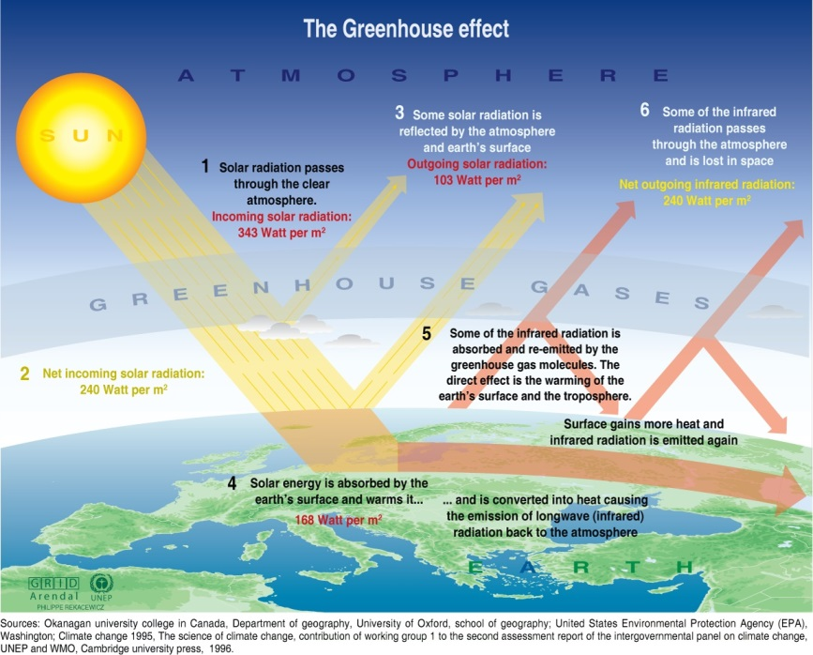

*Check out Smartfigure 11.23!
Is the Greenhouse Effect a useful or harmful process?

*View Power of the Planet: Atmosphere, 47 minutes to End
*Complete activity 13.3 in your workbook
Which two components of the atmosphere absorb the most energy emitted from Earth?

11.7: Human Impact on the Atmosphere’s Composition

CO₂ Emissions
What are the potential consequences of increasing the CO₂ concentration in the atmosphere be?

What natural and human activities add CO₂ to the atmosphere?

- One of the most significant ways humans are impacting the atmosphere is through the addition of CO₂.
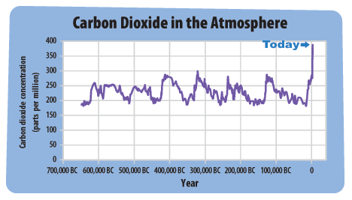

11.8 and 11.9: Air Temperatures and Why do They Vary?

- Air temperatures vary by location and season because of the influence of temperature control variables.
- In a previous section we mentioned that the largest cause of air temperature variations was differences in solar radiation received (e.g. Due to latitude, angle of insolation), but there are also other important factors:

Land vs. Water | Explore this idea by conducting Experiment: Differential Heating of Land and Water in Activity 13B.
Altitude | Air temp cools by 6.5 C/km in the troposphere (due to presence of gases and distance from Earth’s surface)
Geographic Position | _____________________________: have a climate moderated by oceans (cool summers, mild winters)  _____________________________: have a continental climate (warm summers, cold winters).
Cloud Cover and Albedo | Watch Smartfigure 11.36 to examine the effect of these variables on air temperature.

Outline one possible reason for the differences in temperature between Concepcion and La Paz

Outline one possible explanation for the differences in temperatures between Seattle and Spokane

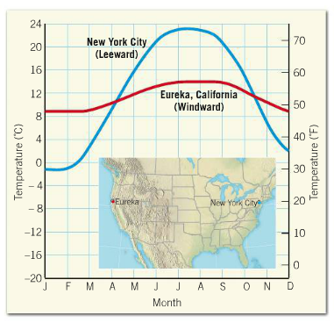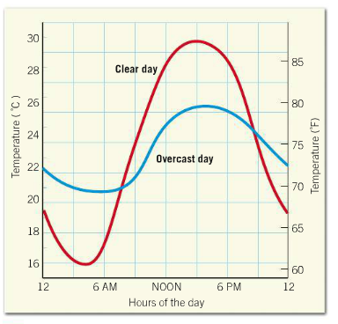
Outline one explanation for the difference in temperature between a clear day and an overcast day

Outline one explanation for the differences in temperature between New York City and Eureka

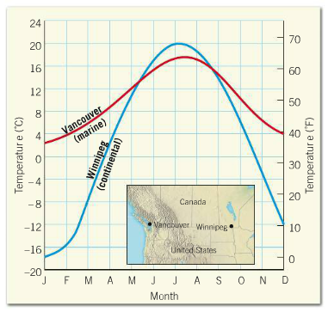
Outline one explanation for the difference in temperature between Vancouver and Winnipeg

