Healthy Oceans Lesson 3: Oceans & the Climate
Please read pages 428-432 to answer the following questions
Oceans are like Earth’s thermostat, keeping the planet comfortable for life. The currents of ocean water move and mix waters of different temperatures around the globe. This movement of water affect climates and weather patterns everywhere

Heat Capacity: a measure of how long it takes for a material to heat up or cool down
Describe water’s heat capacity: Water has a high heat capacity because it takes a long time to heat up or cool down
Compare weather and climate: weather: the condition of the atmosphere at a specific time ie. Temperature, wind speed, air pressure and precipitation. Climate: weather for a particular region is averaged over a long period of time and its main characteristics
According to the textbook (2006), what is the average temperature on Earth? 15 ºC

Examples of The Ocean & The Atmosphere Interacting with Each Other
What is an El Nino? Warm ocean waters off the coast of Ecuador and Peru that appear every year around Christmas time. These warmer than usual waters can be responsible for changing rainfall patterns.
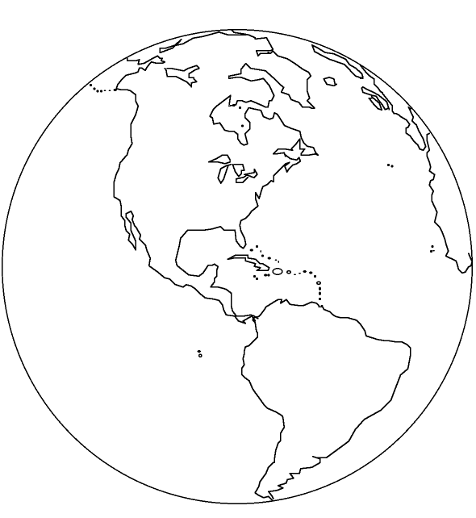
Using Figure 11.26 in textbook (pg. 430), colour in the image of Earth below to demonstrate an el Nino effect. Be sure to state what colour represents warmest water and what colour represents the coolest water.
The El Nino effect causes:
- Droughts in Australia, Africa and Central America
- Smaller ocean organisms move deeper into the waters changing miogration patterns and commercial fishing operations
- Wetter and warmer winter for North America

Describe La Nina effect: A period of upwelling that causes colder than normal water to come to the surface off the coast of South America
Compare El Nino and La Nina effects: ____________________________________________________ ___________________________________________________________________________________ ____________________________________________________________________________________
Video links about El Nino: https://goo.gl/MS47wR or https://goo.gl/ddsu7J
Moderating Effect of Oceans on Climate: The effect on different areas in BC (pg 431-432)
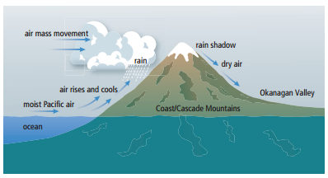
Ocean temperatures can noticeably affect the climate of coastal areas. Look at the climatic zones in British Columbia on page 433. Compare the climatic zone of where we live (Coast Mountains and the Islands) to another climatic zone of your choice in BC:
Climatic zone (where we live): Coast Mountains and the Islands
Description: areas of heavy precipitation, mild temperatures, short periods of freezing cold
Average Temperature:
July: 22 ºC January: 6 ºC

Climatic zone (other): ____________________ ______________________________________
Description: ___________________________________ ______________________________________________ ______________________________________________
Average Temperature:
July: _____ ºC January: ______ºC

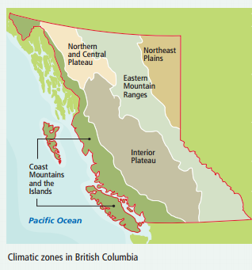
Healthy Oceans Lesson 4: The Ocean Supports a Great Diversity of Life & Ecosystems (12.2)
Activity #1: Deep Breaths
Count the number of breaths you take in one minute and record it here: _______
The oxygen from 7 out of 10 breaths that we take comes from the ocean. So, how many breaths per minute comes from the ocean for you? ____________
$$\# breaths from ocean=\# of breaths per minute ×\frac{7}{10}$$
Almost 90 % of all sea creatures live near the surface of the ocean, while almost 10 % of all sea creatures live in total darkness deep in the ocean. In this next activity, you will pick an ocean animal to study and make a card about it. Below is your brainstorming area.
Activity #2: Create an Animal Card
Animal: ________________________________
- Size: ________________________________________________________________________________
- Habitat: ______________________________________________________________________________
- Diet: _________________________________________________________________________________
- Natural predators: _______________________________________________________________________
_____________________________________________________________________________________
- Human Threat: __________________________________________________________________________
____________________________________________________________________________________
- Conservation status: ______________________________________________________________________
- Interesting fact #1: _____________________________________________________________________
____________________________________________________________________________________
- Interesting fact #2: _____________________________________________________________________
____________________________________________________________________________________

Activity #3: Creating an Ocean Food Web
Explain the activity that was completed in class:
Each student was given an animal card and we stood in a circle. The ball of yarn started at phytoplankton and then went to zooplankton since zooplankton eats phytoplankton. This continued until we reached the top of the food web. By the end all of the students held on to a piece of yarn and there was a web connecting each of them in the middle.

Conclusion: Write a conclusion for the activity by answer the following questions. This can be done on this paper here on in your Science folder in Google Docs (already shared with you):
How might the environment affect the food web? For example, if one part of the food web lost its habitat, what would happen to the other part of the web?
If an animal environment is affected it could die. If smaller fish die then there is not enough food for larger fish therefore their numbers start to decrease. If there are less larger fish then orca’s have less food and this could cause a decrease in their population. All animals in an ecosystem are interconnected.
When we are protecting an animal, why is it also important to protect the animals it depends on? For example, if we are trying to protect whales, why would it be important to also protect salmon?
We need to protect all animals in a food web because one’s population has an affect on others. Similar to the answer to the question above.
Humans are dependent on the ocean as well. Not only for the oxygen we breathe, but also for the food that it produces. Research how you can make sustainable seafood choices as part of your role in the food web.
____________________________________________________________________________________
____________________________________________________________________________________
____________________________________________________________________________________
____________________________________________________________________________________
____________________________________________________________________________________
____________________________________________________________________________________
____________________________________________________________________________________
____________________________________________________________________________________
____________________________________________________________________________________

Healthy Oceans Lesson 5: The Oceans and Humans are Inextricably Linked
Ocean Acidification
Why is this a problem? https://goo.gl/W05AJm

Many ocean plants and animals protect themselves by growing shells of calcium carbonate, one of the main ingredients of chalk. To observe what can happen to this substance as the ocean acidifies, we are going to submerge chalk in water with a pH of _____ and in vinegar, with a pH of ________. While the oceans are not yet at the acidic level of vinegar, but it is important to remember that small changes in pH can affect plants and animals.

Properties of chalk:

Observations of chalk in 2 different liquids with different pH values
Time (min) | Chalk in Water (pH = ) | Chalk in Vinegar (pH = )
1
2

The ocean absorbing carbon from our atmosphere causes ocean acidification. Activities, such as burning fossil fuel, add carbon dioxide to the atmosphere, while deforestation takes away trees that could help remove carbon dioxide from the atmosphere.
What can you (or an individual) do to reduce the amount of carbon that humans produce? (Be creative!)
Lot’s of possibilities! Walk or ride your bike to school. Recycle plastics and glass. Reuse or repurpose clothing. Become an advocate for decreasing carbon usage and try to implement change on school or community level

“Oceans of Plastic”:
Learn about what happens when plastic gets into the ocean at: http://goo.gl/w2X7t2
Watch this video: http://goo.gl/XdSZrs and fill out the boxes below:
Life Cycles of Three Different Plastic Bottles
 | Plastic Bottle ends up: | Problem(s) with this fate:
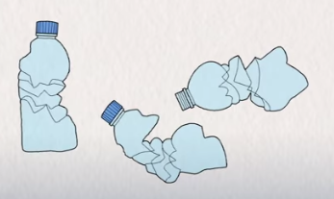
#1:

#2:

#3:

Although the third option is the best option, these three life cycles of bottles all create plastic that exists in our world that never break down completely. What might be an even better solution to reduce the amount of plastic water bottles that are created? (Be creative!)
_____________________________________________________________________________________
_____________________________________________________________________________________
If you could go back in time, would you stop the discovery of plastic? Or do you think this material offers us important benefits that outweigh its negatives?
_____________________________________________________________________________________
_____________________________________________________________________________________
_____________________________________________________________________________________
_____________________________________________________________________________________
_____________________________________________________________________________________
_____________________________________________________________________________________

