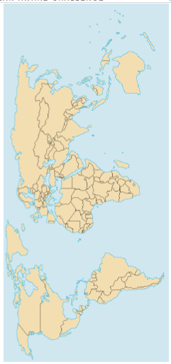
Healthy Oceans Lesson 1: The Earth’s Oceans
Activity #1: Draw lines where you think the world’s oceans start and end

The five major oceans which cover 2/3 of the Earth’s surface (from largest to smallest) are: (Sxn 11.1)
- ______________________
- ______________________
- ______________________
- _______________________
- _______________________

List 3-4 reasons why oceans are important: (Section 11.1)
__________________________________________________________________________________ __________________________________________________________________________________ __________________________________________________________________________________ __________________________________________________________________________________

Layers of the Ocean (Section 12.2)
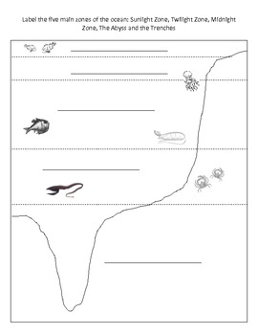
Ocean water can be divided into two different environments: the open water, or the _________________ zone; and the bottom of the ocean, or _________________ zone.
Zone | Subzone | Depth (m) | Interesting Facts about subzone
Pelagic
Benthic

Graphing Ocean Temperatures (11-4 – pg. 425)
What happens to the temperature of the ocean water the deeper you go?

Healthy Oceans Lesson 2: Oceans have Surface and Deep Currents (Section 11.2)
An ocean current is a ___________________________________________________________________, almost like a river, in a particular and unchanging direction.
What do these ocean currents transport with them? _________________________________________ _____________________________________________________________________________________

Activity #1: Draw some of the many different surface ocean currents (Section 11.2, pg 414)
What factors are involved in creating the surface ocean currents?
- _______________
- _______________
- _______________________ ______________

Activity #2: Draw the great ocean conveyer belt that shows the deep currents move enormous amounts of water around the globe. (pg. 419)

What factors are involved in creating the deep ocean currents? Briefly explain them.
- _______________________: _____________________________________________________ ______________________________________________________________________________
- ________________ ___________________________: __________________________________ ______________________________________________________________________________
These two factors above help create a ________________ _____________: the sinking and movement of dense water beneath the surface water.
The saltiest, coldest and densest water are found at _______________________________. They will sink and flow along the ocean floor until they are warmed by the surrounding water by the ______________________. It may take _____-_______ years for water to make it back up to the ocean’s surface.

Upwelling (pg. 420)
What is upwelling? _____________________________________________________________________ _____________________________________________________________________________________
Why is it important, particularly to the BC coast? _____________________________________________ _____________________________________________________________________________________
_____________________________________________________________________________________
We are going to observe plankton under the microscope. Using a pencil, draw what you observe under the microscope. Below, write a description of what is being viewed and record the magnification that was used.
https://goo.gl/dlM28d
https://goo.gl/c4OLFd

Healthy Oceans Lesson 3: Oceans & the Climate
Please read pages 428-432 to answer the following questions
Oceans are like Earth’s thermostat, keeping the planet comfortable for life. The currents of ocean water ______________ and _______ waters of different temperatures around the ________________. This movement of water affect climates and weather patterns everywhere

Heat Capacity: ________________________________________________________________________ _____________________________________________________________________________________
Describe water’s heat capacity: ___________________________________________________________ _____________________________________________________________________________________

Compare weather and climate: ___________________________________________________________ _____________________________________________________________________________________ _____________________________________________________________________________________
According to the textbook (2006), what is the average temperature on Earth? ______ºC

Examples of The Ocean & The Atmosphere Interacting with Each Other
What is an El Nino? ___________________________________________________________ _________________________________________________________________________________
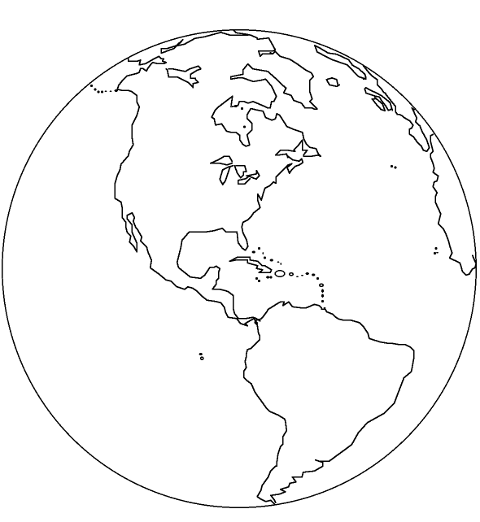
Using Figure 11.26 in textbook (pg. 430), colour in the image of Earth below to demonstrate an el Nino effect. Be sure to state what colour represents warmest water and what colour represents the coolest water.
The El Nino effect causes:

Describe La Nina effect: _____________________________________________________________ __________________________________________________________________________________
Compare El Nino and La Nina effects: ____________________________________________________ ___________________________________________________________________________________ ____________________________________________________________________________________
Video links about El Nino: https://goo.gl/MS47wR or https://goo.gl/ddsu7J
Moderating Effect of Oceans on Climate: The effect on different areas in BC (pg 431-432)
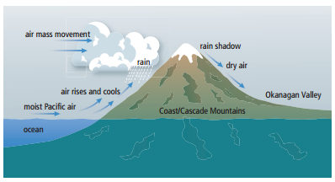
Ocean temperatures can noticeably affect the climate of ________________ areas. Look at the climatic zones in British Columbia on page 433. Compare the climatic zone of where we live (___________ ______________________ and the _________________) to another climatic zone of your choice in BC:
Climatic zone (where we live): _______________ _______________________________________
Description: ___________________________________ ______________________________________________ ______________________________________________
Average Temperature:
July: _____ ºC January: ______ºC

Climatic zone (other): ____________________ ______________________________________
Description: ___________________________________ ______________________________________________ ______________________________________________
Average Temperature:
July: _____ ºC January: ______ºC

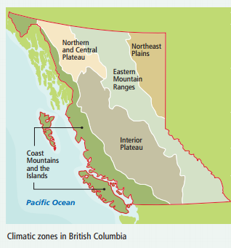
Healthy Oceans Lesson 4: The Ocean Supports a Great Diversity of Life & Ecosystems (12.2)
Activity #1: Deep Breaths
Count the number of breaths you take in one minute and record it here: _______
The oxygen from 7 out of 10 breaths that we take comes from the ocean. So, how many breaths per minute comes from the ocean for you? ____________
$$\# breaths from ocean=\# of breaths per minute ×\frac{7}{10}$$
Almost _____% of all sea creatures live near the ________________ of the ocean, while almost _____% of all sea creatures live in ______________ _____________________ deep in the ocean. In this next activity, you will pick on ocean animal to study and make a card about it. Below is your brainstorming area.
Activity #2: Create an Animal Card
Animal: ________________________________
- Size: ________________________________________________________________________________
- Habitat: ______________________________________________________________________________
- Diet: _________________________________________________________________________________
- Natural predators: _______________________________________________________________________
_____________________________________________________________________________________
- Human Threat: __________________________________________________________________________
____________________________________________________________________________________
- Conservation status: ______________________________________________________________________
- Interesting fact #1: _____________________________________________________________________
____________________________________________________________________________________
- Interesting fact #2: _____________________________________________________________________
____________________________________________________________________________________

Activity #3: Creating an Ocean Food Web
Explain the activity that was completed in class: _____________________________________________ ____________________________________________________________________________________
____________________________________________________________________________________
____________________________________________________________________________________
____________________________________________________________________________________
____________________________________________________________________________________
____________________________________________________________________________________
Conclusion: Write a conclusion for the activity by answer the following questions. This can be done on this paper here on in your Science folder in Google Docs (already shared with you):
How might the environment affect the food web? For example, if one part of the food web lost its habitat, what would happen to the other part of the web?
____________________________________________________________________________________
____________________________________________________________________________________
____________________________________________________________________________________
____________________________________________________________________________________
____________________________________________________________________________________

When we are protecting an animal, why is it also important to protect the animals it depends on? For example, if we are trying to protect whales, why would it be important to also protect salmon?
____________________________________________________________________________________
____________________________________________________________________________________
____________________________________________________________________________________
____________________________________________________________________________________
____________________________________________________________________________________

Humans are dependent on the ocean as well. Not only for the oxygen we breathe, but also for the food that it produces. Research how you can make sustainable seafood choices as part of your role in the food web.
____________________________________________________________________________________
____________________________________________________________________________________
____________________________________________________________________________________
____________________________________________________________________________________
____________________________________________________________________________________
____________________________________________________________________________________
____________________________________________________________________________________
____________________________________________________________________________________
____________________________________________________________________________________
Healthy Oceans Lesson 5: The Oceans and Humans are Inextricably Linked
Ocean Acidification
Why is this a problem? https://goo.gl/W05AJm

Many ocean plants and animals protect themselves by growing shells of calcium carbonate, one of the main ingredients of chalk. To observe what can happen to this substance as the ocean acidifies, we are going to submerge chalk in water with a pH of _____ and in vinegar, with a pH of ________. While the oceans are not yet at the acidic level of vinegar, but it is important to remember that small changes in pH can affect plants and animals.

Properties of chalk:

Observations of chalk in 2 different liquids with different pH values
Time (min) | Chalk in Water (pH = ) | Chalk in Vinegar (pH = )
1
2

The ocean absorbing carbon from our atmosphere causes ocean acidification. Activities, such as burning fossil fuel, add carbon dioxide to the atmosphere, while deforestation takes away trees that could help remove carbon dioxide from the atmosphere.
What can you (or an individual) do to reduce the amount of carbon that humans produce? (Be creative!)
_____________________________________________________________________________________
_____________________________________________________________________________________
_____________________________________________________________________________________
_____________________________________________________________________________________
_____________________________________________________________________________________
_____________________________________________________________________________________
_____________________________________________________________________________________
_____________________________________________________________________________________
_____________________________________________________________________________________
_____________________________________________________________________________________
“Oceans of Plastic”:
Learn about what happens when plastic gets into the ocean at: http://goo.gl/w2X7t2
Watch this video: http://goo.gl/XdSZrs and fill out the boxes below:
Life Cycles of Three Different Plastic Bottles
 | Plastic Bottle ends up: | Problem(s) with this fate:
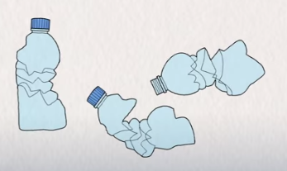
#1:

#2:

#3:

Although the third option is the best option, these three life cycles of bottles all create plastic that exists in our world that never break down completely. What might be an even better solution to reduce the amount of plastic water bottles that are created? (Be creative!)
_____________________________________________________________________________________
_____________________________________________________________________________________
If you could go back in time, would you stop the discovery of plastic? Or do you think this material offers us important benefits that outweigh its negatives?
_____________________________________________________________________________________
_____________________________________________________________________________________
_____________________________________________________________________________________
_____________________________________________________________________________________
_____________________________________________________________________________________
_____________________________________________________________________________________

