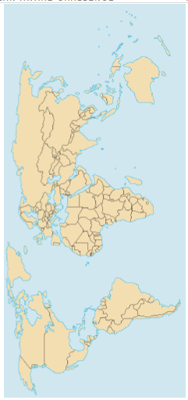 **Healthy Oceans Lesson 1: The Earth’s Oceans**

Activity #1: Draw lines where you think the world’s oceans start and end

The five major oceans which cover 2/3 of the Earth’s surface (from largest to smallest) are: (Section 10.1)



1. ______________________



1. ______________________



1. ______________________



1. _______________________



1. _______________________



List 3-4 reasons why oceans are important: (Section 10.1)



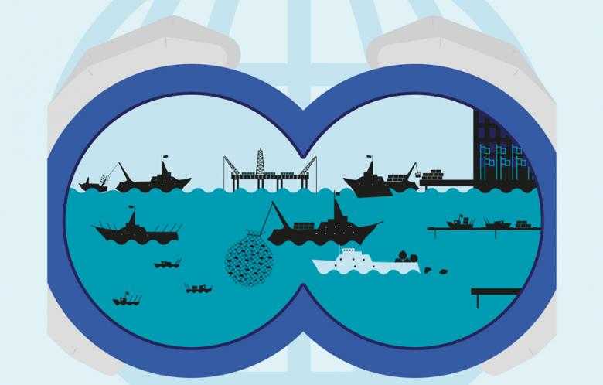_________________________________________________



__________________________________________________



__________________________________________________



__________________________________________________



__________________________________________________



**Layers of the Ocean (Section 12.2)**

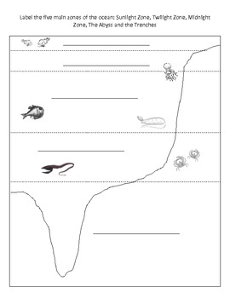Ocean water can be divided into two different environments: the open water, or the _________________ zone; and the bottom of the ocean, or _________________ zone.



|  |  |  |  |
| --- | --- | --- | --- |
| Zone | Subzone | Depth | Interesting Facts about subzone |
| Pelagic |  |  |  |
|  |  |  |
|  |  |  |
| Benthic |  |  |  |
|  |  |  |



**Graphing Ocean Temperatures (11-4 – pg. 425)**

What happens to the temperature of the ocean water the deeper you go?



**Healthy Oceans Lesson 2: Oceans have Surface and Deep Currents**

An ocean current is a **large amount of ocean water that moves**, almost like a river, in a particular and unchanging direction.

What do these ocean currents transport with them? **Dissolved minerals, solar energy, oxygen, carbon dioxide**

Activity #1: Draw some of the many different **surface ocean currents** (Section 11.2, pg 414)

What factors are involved in creating the surface ocean currents?

1. **Uneven heating of the atmosphere (Wind)**
2. **Spinning of Earth on it’s axis**
3. **Continent Shape**

Activity #2: Draw the great ocean conveyer belt that shows the **deep currents** move enormous amounts of water around the globe.

What factors are involved in creating the deep ocean currents? Briefly explain them.

1. **Water Temperature**: **Temperature affects the density of water. The colder the water the greater the density.**
2. **Water Salinity**: **water with high salinity is denser that water with low salinity**

These two factors above help create a **density current**: the sinking and movement of dense water beneath the surface water.

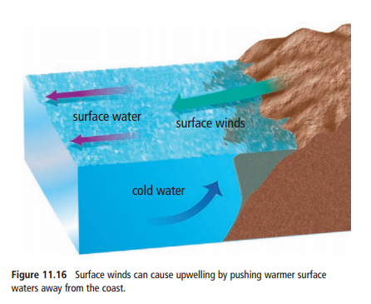The saltiest, coldest and densest water are found at **the North and South Poles**. They will sink and flow along the ocean floor until they are warmed by the surrounding water by the **equator**. It may take **500**-**2000** years for water to make it back up to the ocean’s surface.

**Upwelling**

What is upwelling? **Rising of water due to it being warmed or**

**being pushed up by colder denser water**

Why is it important, particularly to the BC coast? **Contributes to a**

**large variety of fish populations, keeps a constant supply of**

**nutrients coming to the surface**

We are going to observe plankton under the microscope. Using a pencil, draw what you observe under the microscope. Below, write a description of what is being viewed and record the magnification that was used.

___________________________________________________________________________ ___________________________________________________________________________