‘How Humans Influence Ecosystems’
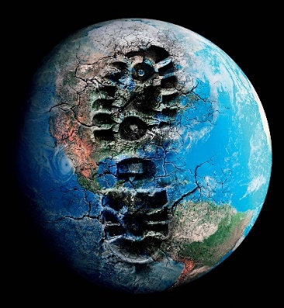
This is a research assignment that will have you investigate a current example of how humans are having a negative influence on a particular ecosystem. You will first choose a BIOME in which you will be researching your particular Human Impact. The biomes to choose from are below:
BIOMES
- Permanent Ice
- Tundra
- Boreal Forest
- Temperate Rainforest
- Tropical Rainforest
- Grasslands
- Desert
- Temperate Deciduous Forest

Next, you will choose one factor (from the table below) that influences an ecosystem. You will be researching this factor through the library database to find a relevant article from a magazine, newspaper, internet source etc.
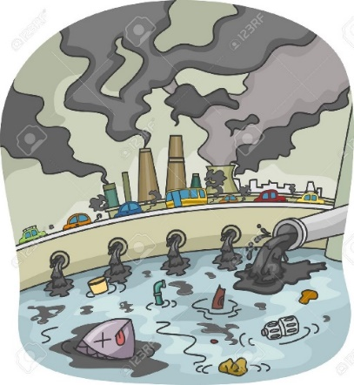
The following are the topics that you can choose from within your Biome.
FACTORS
- Overexploitation
- Urbanization
- Agriculture
- Water pollution
- Air pollution

**EXAMPLE**
You may choose to look at 5. Tropical Rainforest (BIOME) and choose c) Agriculture. This may lead you to investigate an article discussing the negative impacts of farming on the biodiversity of the Amazon Rainforest**
What to do:
PART 1 – Researching and Summarizing
- Once the biome and human impact are decided on, you will search for a relevant article using the Library Database (your teacher will show you how to access this database).

News and Media database
http://www.morvenlibrary.org/news-media-search.html

Science Specific database
http://www.morvenlibrary.org/science-and-some-geography.html

- Once you have selected the article that interests you, read through it and complete the Google Form (How Humans Influence Ecosystems Part 1) your teacher will provide you.

Once everyone has completed the article summary form, your teacher will use this information to create a Google Map that includes all of the information you and your classmates have provided.

PART 2 – Google Map Task

- Explore this map and find an article/topic from one of your classmates that interests you.

- You are then going to search the database for a sustainable solution to this particular problem. (ex. If someone has looked at ocean acidification, you will be looking for an article that looks at either how we can prevent this, or what can be done to combat it.

- Complete the second Google Form (How Humans Influence Ecosystems Part 2) that your teacher will provide to you.

PART 1 RUBRIC
Name: _______________________
ARTICLE CHOICE: Did you find a relevant article (from your biome) for your human impact topic? Does the article fit under the ‘factor’ category that you chose?’ | 1 2 3 4
Did you complete the Google Form provided by your teacher?  (How Humans Influence Ecosystems Part 1) | 1 2 3
Article summary: Did your article summary (using minimum of 150 words) capture the important points of the article and explain clearly to the reader the human impact you chose. | 1 2 3 4 5 6 7 8 9 10
Use of class time, Submitted on time | 1 2 3 3
TOTAL | / 20

PART 2 RUBRIC
Name: _______________________
ARTICLE CHOICE: Did you find a relevant article that addresses a sustainable solution to the summary your classmate provided? | 1 2 3 4
Did you complete the Google Form provided by your teacher?  (How Humans Influence Ecosystems Part 2) | 1 2 3
Article summary: Did your article summary (using minimum of 150 words) capture the important points of the article and explain clearly to the reader a sustainable solution. | 1 2 3 4 5 6 7 8 9 10
Use of class time, Submitted on time | 1 2 3 3
TOTAL | / 20

Total: /40

