Earth Science 11: Geologic Time Unit

Text: Chapters 8
Lab: Exercise 6

Name________________________________

Geology 12: Geologic Time

8.1: The Geologic Time Scale
Today, we know that Earth is approximately 4.6 billion years old. How do we know this?

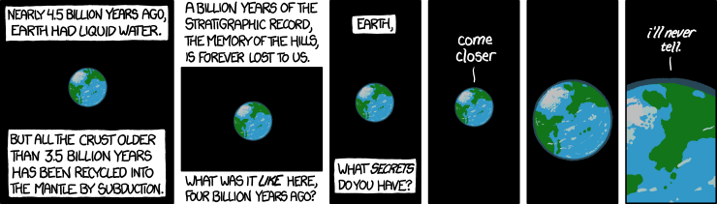
In this unit we will look at the scientific principles developed to make sense of the clues Earth provides us with to its origins and transformations.

8.2: Relative Dating Principles
Relative Dating relates the age of one object to another. It can’t provide an actual age for a geologic feature, only a relative one (older or younger than another feature).
Although relative dating techniques were developed in the 1800s, they are still widely used today as they allow for rocks to be placed in their sequence of formation.

1. Uniformitarianism
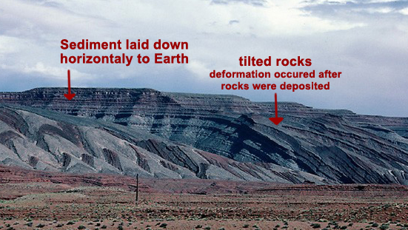
- ________________________________________________________________________
*The key to understanding the past is the present!
2. Principle of Original Horizontality
- Strata are deposited in a ______________________ position.
- Folded or tilted strata have been altered from their original ___________________________

3. Law of Superposition
- In an unaltered sequence each strata is _______________________ than the one above it.
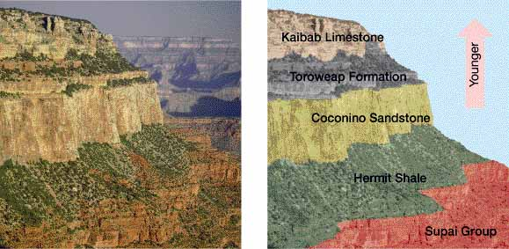
- Can also be applied to igneous rocks deposited on Earth’s surface.

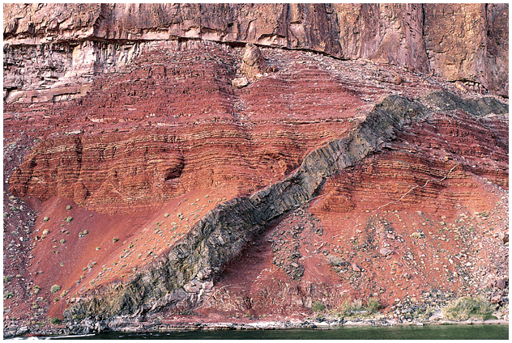
4. Principle of Cross Cutting Relations
- A fault or intrusion is _____________________ than the rocks it affects.

5. Inclusions
- Inclusions are fragments of a rock that have been incorporated into another rock.
- Rock containing inclusions must be ___________________________ than the rock beside it (which provided the rock fragments).

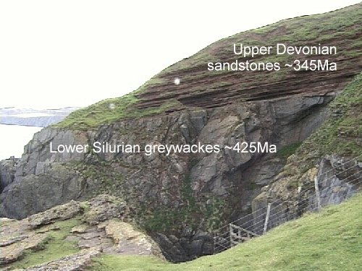
6. Unconformities
Siccar Point, Scotland. This unconformity was used to support the idea of Uniformitarianism.
- Rock layers deposited without interruption in the sequence are called _______________________.
- However, no sedimentary strata is complete as erosion can occur and there are several ways for the deposition of strata to be interrupted.
- The resulting gaps in the rock sequence are called ____________________________________.

There are three types of unconformities:
Type of Unconformity | Description | Picture
Angular Unconfornity | Tilted or folded sedimentary rocks covered by younger, horizontal strata.  Indicates that deformation and erosion occurred while deposition was interrupted. | 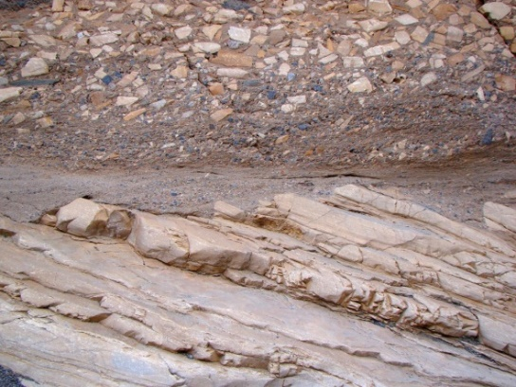  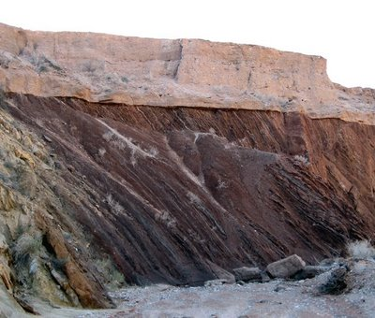
Disconformity | Parallel strata are separated by an unknown length of time.  Difficult to spot as strata are horizontal, often of the same rock type and little evidence of erosion is visible. | 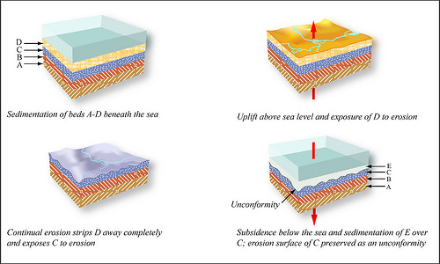
Nonconformity | Break in strata separates older metamorphic or intrusive igneous rock from younger sedimentary strata.  Uplifting and erosion are necessary to expose the metamorphic or intrusive igneous rocks. | 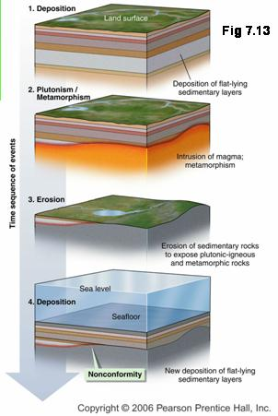

Process of how angular unconformities form
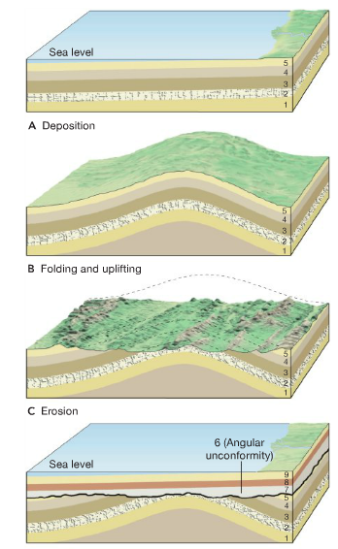

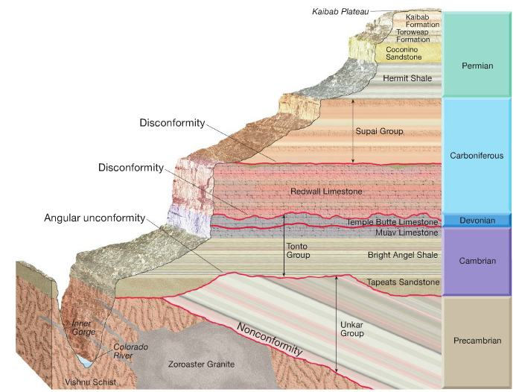

Rock Layer Correlation
- To fill in gaps in the geologic time scale, rocks of similar ages in different regions on Earth can be correlated.
- This can be done on a small scale by simply walking around outcrops and noting the position of a bed in a sequence of strata. However, on a larger scale other tools must be used:
1. Index Fossils
Fossils can be used to estimate the age of strata in which they are found due to the Principle of Fossil Succession: _______________________________________________________________
____________________________________________________________________________________________________________________________________________________________
This idea is based on three assumptions:
a) Life has varied over time.
b) Successive forms of life can be distinguished from one another
c) The relative ages of life forms can be determined.

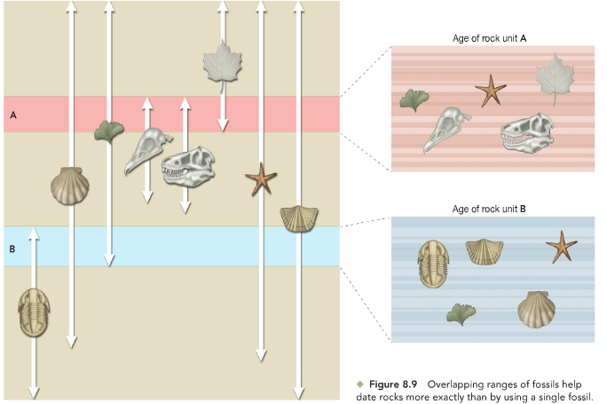
In this process, Index Fossils are very useful as they have characteristics that allow strata to be more easily dated. In particular, these fossilized organisms were:
a) ________________________: Useful over large distances
b) _________________________: Greater chance of being fossilized, surviving and being found.
c) _________________________: Can be distinguished from other species.
d) ____________________________: Allow strata to be dated to a narrow age range.
How else could fossils be useful in reconstructing the history of Earth?
____________________________________________________________________________________________________________________________________________________________
2. Index Strata
Perform the same function as index fossils and generally have the same characteristics.
8.5: Absolute Age Dating
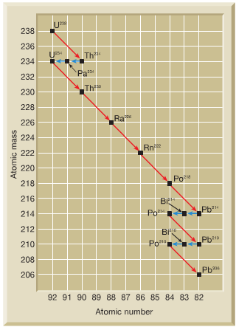
Absolute dating techniques discover the numerical age of geologic events.
1. Radioactive Decay
_____________________________________________: atoms of an element with the same number of protons and electrons, but a different number of neutrons that are not stable, but decay at a regular rate over time.
- Decay from a parent isotope into a stable daughter isotope. Together, both are called a decay pair.
- The decay of radioactive isotopes occurs at a known rate that is not affected by _____________________________ factors.

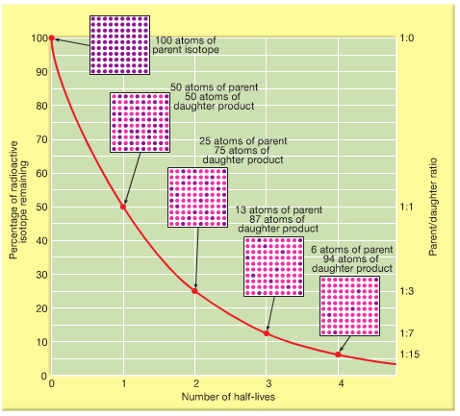
2. Half-Life
- the time it takes for half of the nuclei in a sample to decay.
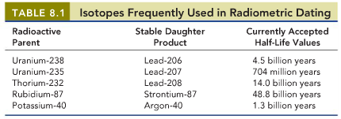
- If the half-life if known and the parent/daughter ratio can be determined, the age of a sample can be calculated.

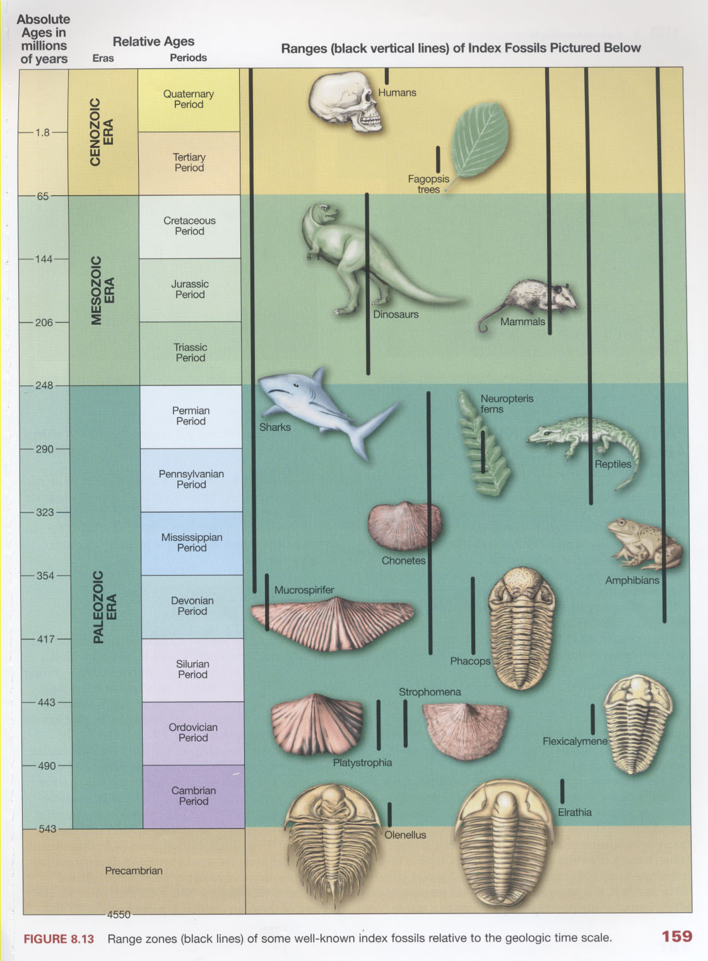
Part E: The Geologic Time Scale
Through combining the relative and absolute dating techniques above scientists have been able to divide the history of Earth into distinct units, which are collectively known as the Geological Time Scale.

