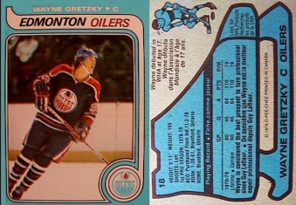
Elements ‘Hockey Card’
You will be working individually.
- The common elements are: Hydrogen, Iron, Oxygen, Sodium, Chlorine, Mercury, Silver, Carbon, Nitrogen and Silicon. You may choose one of these or another element of your choice. Record your choice on the master sheet with the teacher to ensure we do not have any doubles.

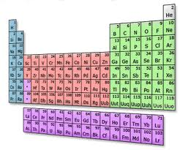
- You need to gather the information listed in the tables provided. There are plenty of resources available. You will create a ‘hockey card’ to display your information. The hockey card must be ¼ of a regular piece of paper, or 10cm x 14 cm. The information that should be displayed on your card is listed in the information tables below. Your cards can be hand-drawn or done on the computer (they must be printed off and be double sided).

- The general layout of the card will include the following information
Front of card:the front of the card has the general information.  Name – what is the name of the element (can include a nickname as well)  Symbol – the element’s symbol  Jersey Number – this should be the element’s atomic number.  Picture - this can either be the element by itself (such as a bar of gold) or the element within another substance (potassium within a banana)  Team – Is it a metal or a non-metal. If the element belongs to a particular family you can include that as well. | Back of card:the back of the card has the statistics and other information for the element.  What year was the element discovered?  Who discovered the element?  What is the atomic mass of the element?  What common items contain this element?  At least one interesting fact.

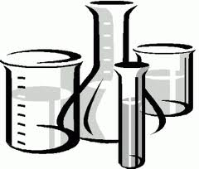
Name:_______________________
Block: ____ Date: __________

Element Name:
Element Symbol:
What is the atomic number? (# of protons) :

What is the atomic mass

Metal or Non-metal?:

Does the element belong in a certain family (ex. Halogens? Noble Gases?) :

How would the Earth be different if your element didn’t exist? (Be specific!)

What year was the element discovered and by who?

Any other interesting facts (at least one).

Handing in your hockey card physically:
After you complete creating a virtual hockey card (see instructions below) you must still hand in the completed hockey card.
Name:
Use of class time/Link sent | Student not using class time productively. (1-2) | Student is on task most of the time. (3-4) | Student in always on task. (5) | 5
Information | Most of the information provided is inaccurate or missing. (1-3) | Most of the information is included and accurate. There are at least two ‘common items’ listed for both elements. (4-7) | All of the information selected is included and accurate. There are at least two ‘common items’ listed for your elements (8-10) | 10
Interesting Facts | None provided or else fact is irrelevant or already listed. (1) | One fact provided that is interesting and relevant. Description of fact may not be detailed. (1-4) | More than one fact provided that is interesting and relevant. Description of this fact is detailed. (5) | 5
Hockey Card Layout and Creativity | Hockey was incomplete or shows minimal information. No picture is included and card lacks creativity (1-4) | Hockey card descriptive, including picture(s) of elements, Card is generally creative (5-7) | Hockey Card is visually attractive, informative and includes picture(s) of the elements. Lots of creativity is shown. (8-10 | 10
 |  |  |  | 30
Elements Hockey Card Rubric: STUDENTS NEED TO FILL THIS OUT (in pencil)

