Topic 3.3: How do charges flow through the components of a circuit
Concept 1: Chemical energy separates electrical charges in cells
Electrochemical cell
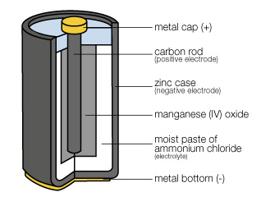
Using page 214 to define the following terms:
Electrode
Electrolyte
Terminals
What is the difference between a wet cell and a dry cell?

Battery: a connection of two or more cells
Source: Anything that supplies electrical energy
How a cell works
In the space below, draw the ladder analogy from the textbook and provide a brief description of how an electrochemical cell work. Use pg. 215 in your textbook.
Description
Drawing
Electrical Potential Difference
Use page 214 - ***** in the textbook to help fill in the blanks
- a unit of charge, called a coloumb, gains electrical potential energy when it passes through a source
Electrical potential difference (voltage): measure of the electrical potential energy that is gained by a unit of charge. Measured in volts (V)
  - represents the amount of energy it took to carry the last unit of charge up the ladder
  - Electrical potential difference is determined by the nature of the chemical reaction in the cell
If it took 1.5 units of energy to carry the last unit of charge up the ladder, then what is the electrical potential difference?
1.5 V
If you link together three 1.5 V cells what is the voltage?
4.5 V

Concept 3: Moving electrical charges form an electric current
- Charges can flow from a source through a conducting material to an appliance or electrical device
  - The moving charges are called electrical current. The symbol is I and the unit is amperes (A).
Concept 4: A load resists the flow of current
Load: a device that converts electrical energy into another type of energy
  - Ex. Lightbulb, radio

- A load resists or hinders the flow of current
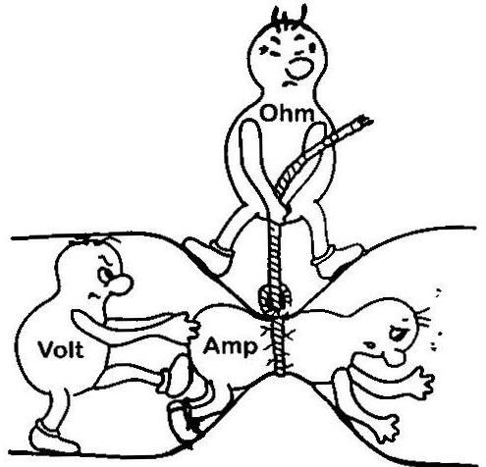
- The degree to which the flow is hindered is called resistance. The symbol for resistance is R and the unit is ohms (Ω).
Explain the cartoon using the vocabulary you just learned.

