2.2 THE DIGESTIVE System (PART 2) Name:

(Refer to pp. 70 – 76 of BC Science 8)

The Four Stages of Digestion
What is digestion? ________________________________________________________________________________________________________________________________________________________________________
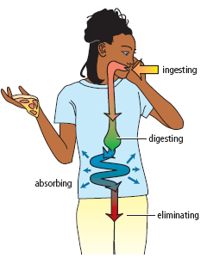
- The four stages of digestion are:
  - _________________________
  - _________________________
  - _________________________
  - _________________________

Digestion occurs along a big tube
- Your digestive system is basically one big tube that starts at your ___________ and ends at your ___________.
- Digestion breaks down your food so that the nutrients can get _________________.
- Anything not absorbed is __________________ in the feces.

Stage of Digestion | Location | Key Features of Stage
- Ingesting | 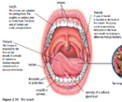  Mouth | “To ingest” means to _________________.  It is the starting point of the digestive process.
- Digesting | 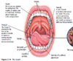  Mouth  Teeth, tongue  Pharynx: 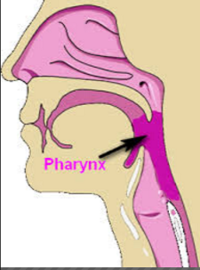  Epiglottis  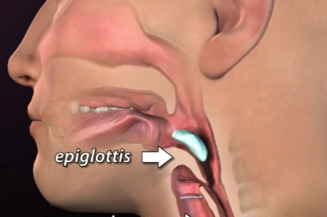  Esophagus  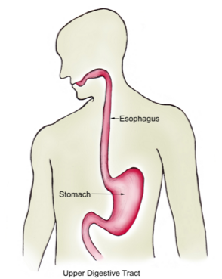  Stomach  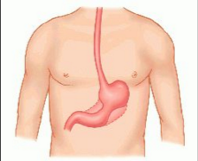  Small Intestine  (Liver, Gall Bladder) | You start digesting food the moment you start ______________.  When food enters your mouth, it undergoes both mechanical and chemical digestion.  mechanical digestion: It occurs by your teeth and tongue ____________________________________________________________________________________________________________  Each small piece of food is called __________.  chemical digestion: When saliva coats the bolus it begins to break it down ____________________________________________________________________________________________________________  An enzyme called _______________ in your saliva begins to break down complex carbohydrates into simple carbohydrates.  As food moves from your mouth it passes through the pharynx  ____________________________________________________________________________________________  To make sure that food doesn’t enter your airway tube, a small flap of flesh covers the airway tube. It is called the ____________.  When you swallow, the epiglottis covers your airway tube and your food enters the esophagus.  The bolus is pushed through the esophagus in a process called __________________, in which muscles in the esophagus push boli down to the stomach.  Inside the stomach is _________________, which is very acidic.  It is made from hydrochloric acid, mucus and enzymes.  The stomach walls are lined with _________ to protect the tissue from being damaged by the acid.  An enzyme called ___________, present in gastric juice, breaks down protein.  The bolus that enters your stomach breaks down into a liquid called ______________.  The first metre of the small intestine is called the ___________.  The pancreas adds _____________ that help break down the carbohydrates, protein, and fat in the chyme.  The liver produces ______ which is stored in the gall bladder.  Bile breaks the globs of ______ into smaller droplets.
- Absorbing | Small intestine  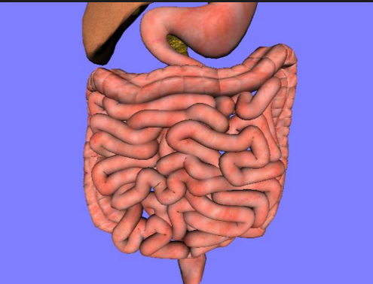  Large Intestine  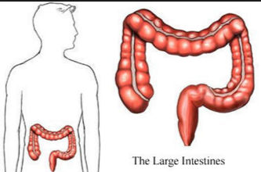 | Absorption: ___________________________________  __________________________________________________________________________________________  The small intestine is covered with _______ to help increase the rate at which nutrients are absorbed.  villi: fold-like structures lining the wall of the small intestine, which increase the _________________ available to absorb nutrients.  The large intestine reabsorbs ________ and some ___________.  _________ moves the undigested food along the digestive system.  The role of bacteria in digestion  Beneficial bacteria aid in the breakdown and absorption of ______ and use undigested material to make _____________.  Ex. Vitamin K, which helps your blood clot.
- eliminating | Rectum & Anus  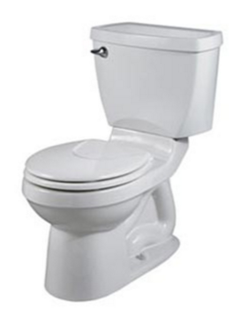 | Any solid material, undigested by the end of the large intestine is called _________.  Feces are stored in the _______ until they are eliminated through the _____.  _____________ is the end of the digestion process.

