The Salmon: The Pasquit salmon run is a world renowned salmon run that has been going on for ages – long before humans were even on the planet! Millions of us (including Chinook, Coho, Pink, Sockeye & Chum) were born in the Pasquit and will be returning there to spawn. We,as the salmon, are concerned how the new dam might affect our ability to return to our spawning grounds.

BC Hydro: We are excited to begin new construction on the large Pasquit Hydro Dam. As you know, British Columbia relies heavily on hydro power to generate electricity. As we move forward in the 21st century, our current systems are aging and our energy needs are growing – this dam will ensure that all people of British Columbia will have their energy needs met.

First Nations: The land that Pasquit sits on, including the river, has been our home for centuries. Our ancestors grew up here and thrived on this land for generations. The river has always been a source of life for us – not only does it offer us water and food, but also is a spiritual lifeline. This land is a big part of who we are: anything that happens to it will hurt our people.
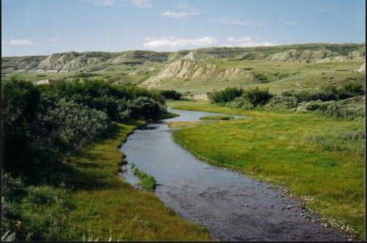

Pasquit Labour Association: Ensuring that the people of Pasquit are working is our main priority. Once the logging industry began to suffer in the 1990’s, we saw a huge impact here in Pasquit, as many of our labourers were laid off. Any opportunity to create jobs and get these people back to work will be a vital if we want to see this town get back to its old prosperous ways.

GoGreen Enviro Group: Our chief mission is to protect the environment from the many threats that we, as humans, impose. For too long we have been living in ignorance of our environmental impact on the many species that live in this region. It is not good enough to continue our ways. We must find a way to make positive changes so that our environment, including all of the species that reside here, are able to thrive.
Sport & Leisure Society – Pasquit has always been an active community. The river has been a source of recreation for the residents of Pasquit for years: the fishing, kayaking and canoeing are world-class. Not only do the residents of Pasquit enjoy these activities, but also people from all around the world that come here to enjoy the river.
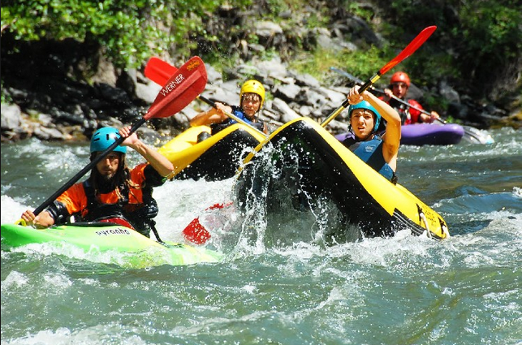

BC Government – As you know, BC relies on hydroelectric dams to provide power to its residents. Not only does this dam have potential to provide more power to the people of BC, but also to those across the border in the USA. The Province forecasts that the financial benefits of this dam will benefit all people in BC, both through the money we will generate by selling our power to the USA, and the jobs that will be created in Pasquit.

