**Celestial Bodies**

**Chapter 10.2 Galaxies** *(Refer to pp. 356 - 365 of BC Science 9)*

What is a galaxy and how many are estimated to exist in the universe?

* A collection of gas, stars and dust held together by gravity. About 125 billion galaxies are estimated to exist in the universe

What galaxy do we live in?

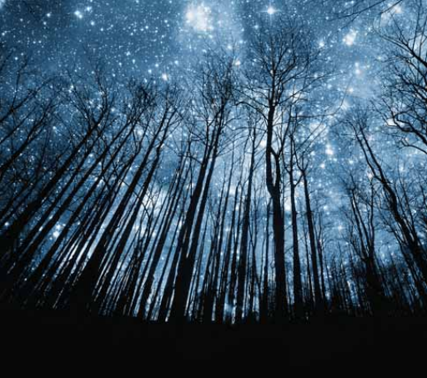The Milky Way

**The number of galaxies in the universe**

According to the textbook, the number of sand grains that would fill a toothpaste cap represents?

# of stars we can see

The number of sand grains that would fill a dump truck represents?

# of stars in Milky Way



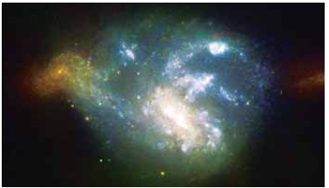In 1925, Edwin Hubble identified another galaxy besides the Milky Way, which is now called Andromeda

Images of thousands of galaxies are transmitted to Earth by the Hubble Space Telescope

What is the difference between a nebula and a galaxy?

A nebula is just a cloud of gas and dust; No stars. Stars are born in nebulas.

**Celestial Bodies in the Universe**

*This is a brief introduction to all the different objects that are in our universe.*

*We will be learning some of the in more detail.*

**11.1 Stars** *(Refer to pp. 368-381 of BC Science 9)*

* Define “star”: a spherical object in space made up of hot gases, with a core like a thermonuclear reactor
* Astronomers estimate that 9000 billion billion stars have formed in the observable universe over its 13.7 billion year history.
* How long a star lives depends on its mass (next class!)

**Star Sizes**

* Many stars visible from Earth are much larger than our Sun.
* The largest star discovered so far might be VY Canis Majoris. Astronomers are still debating its full size, but some observations suggest it could have a diameter 3000 times larger than that of the Sun.

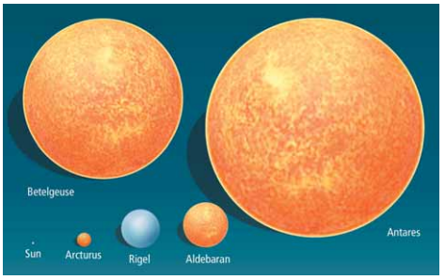

**11.2 The Sun and Its Planetary System** *(Refer to pp. 382 - 389 of BC Science 9)*

* Our Sun, an average star in the universe, is the centre of our solar system.
  + Our solar system is full of planets, moons, asteroids and comets, all of which revolve around the Sun at the center.
  + When a star forms from a nebula, gravity pulls most of the material into the new star, but some may also clump together to form objects in a solar system.

**PLANETS**

* **Planet**: a celestial body that orbits one or more stars
  + Each planet may also spin on its axis (rotation) while it orbits the Sun (revolution).
  + **rotation**: the motion of Earth as it spins on its axis (an imaginary line from N to S) at a speed of 0.5km/s or 1670 km/h ONE DAY
  + **revolution**: the motion of Earth as it orbits the sun at a speed of 30km/s ONE YEAR

**THE FORMATION OF THE SOLAR SYSTEM**

* **solar system**: a group of planets circling one or more stars
  + quite common - more than 200 planets have been discovered orbiting distant stars.
* Our solar system formed approximately 4.5 billion years ago.
* The 4 inner planets or **terrestrial** (Earth-like) planets:
  + Mercury, Venus, Earth, Mars
  + Formed first, in the first 100 million years of the Sun’s existence.
  + Relatively small, have solid cores and rocky crusts.
* The 4 outer or **Jovian** planets formed out of gas, dust and ice:
  + Jupiter, Saturn, Uranus, Neptune
  + Formed later form leftovers from the Sun’s original nebula.
  + Have large gaseous bands and cold temperatures.

**THE PLANETS**

* To be considered a planet, a body must:

1. Orbit one or more stars
2. Be large enough that its own gravity holds it as a sphere.
3. Be the only body occupying the orbital path.

**OTHER SOLAR SYSTEM BODIES**

There are also numerous celestial bodies smaller than planets in our solar system.

**Moons**: orbit planets

* aka “satellites” (natural satellites)
* Found around all planets except Mercury and Venus

**Asteroids**: small rocky bodies in our solar system

* + Found mostly between Mars and Jupiter in the asteroid belt
  + It is thought these are ‘leftovers’ from the formation of the solar system.
  + Range in size from a grain of sand up to 1000 km wide (Ceres).

**Comets**: small bodies made of rock and ice that occur far outside the planets, in the Kuiper belt and Oort cloud

* + Sometimes called “dirty snowballs”
  + When a comet is bumped into the inner solar system, the Sun's light may make the comet's tail of gas and dust visible from Earth, point away from the Sun.

**Trans-Neptunian Objects**: circles the Sun outside Neptune’s orbit

* + Ex. Pluto (now referred to as a dwarf planet)
  + Ex. the Kuiper belt
    - a region beyond the planets, from 30 AU to 55 AU from the Sun
    - composed of flat disks of millions of small bodies and made of leftover material from the formation of the solar system.

**Oort Cloud**: spherical cloud of small, icy fragments

* + 50 000 - 100 000 AU from the Sun.
  + 1/4 of the distance to the next star nearest to us, Proxima Centauri (next closest star to us after the Sun)