**Celestial Bodies**

**Chapter 10.2 Galaxies** *(Refer to pp. 356 - 365 of BC Science 9)*

What is a galaxy and how many are estimated to exist in the universe?

* ____________________________________________________________________________________________________________________________________________________________

What galaxy do we live in?

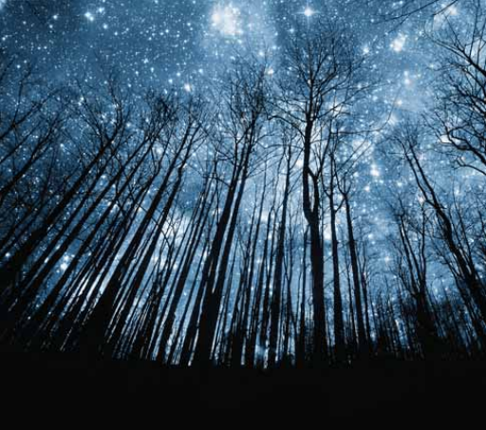___________________________________

**The number of galaxies in the universe**

According to the textbook, the number of sand grains that would fill a toothpaste cap represents?

______________________________________

The number of sand grains that would fill a dump truck represents?

_______________________________________



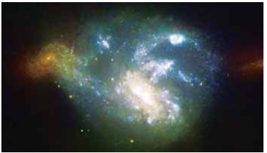In 1925, Edwin Hubble identified another galaxy besides the Milky Way, which is now called ________________.

Images of thousands of galaxies are transmitted to Earth by the _____________________________________.

What is the difference between a nebula and a galaxy?

____________________________________________________________________________________________________________________________________________________________

**Celestial Bodies in the Universe**

*This is a brief introduction to all the different objects that are in our universe.*

*We will be learning some of the in more detail.*

**11.1 Stars** *(Refer to pp. 368-381 of BC Science 9)*

* Define “star”: ___________________________________________________________________ ______________________________________________________________________________
* Astronomers estimate that _________ billion billion stars have formed in the observable universe over its 13.7 billion year history.
* How long a star lives depends on its mass (next class!)

**Star Sizes**

* Many stars visible from Earth are much larger than our Sun.
* The largest star discovered so far might be VY Canis Majoris. Astronomers are still debating its full size, but some observations suggest it could have a diameter 3000 times larger than that of the Sun.

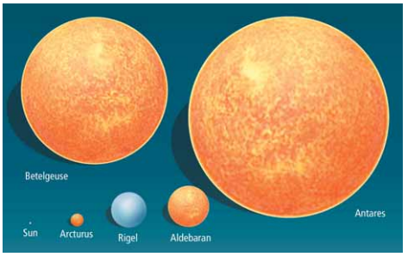

**11.2 The Sun and Its Planetary System** *(Refer to pp. 382 - 389 of BC Science 9)*

* Our Sun, an average star in the universe, is the ___________ of our solar system.
  + Our solar system is full of planets, moons, asteroids and comets, all of which ______________ around the Sun at the center.
  + When a star forms from a ____________, gravity pulls most of the material into the new star, but some may also clump together to form objects in a solar system.

**PLANETS**

* **Planet**: ___________________________________________________

**___________________________________________________**

* + Each planet may also spin on its axis (_____________) while it orbits the Sun (________________).
  + **rotation**: ___________________________________________ ___________________________________________________
  + **revolution**: _________________________________________ ___________________________________________________

**THE FORMATION OF THE SOLAR SYSTEM**

* **solar system**: ______________________________________________

**_________________________________________________________**

* + quite common - more than 200 planets have been discovered orbiting distant stars.
* Our solar system formed approximately _______________ years ago.
* The 4 inner planets or **terrestrial** (Earth-like) planets:
  + ______________,_________,___________,________
  + Formed __________, in the first 100 million years of the Sun’s existence.
  + Relatively ___________, have ___________ cores and ___________ crusts.
* The 4 outer or **Jovian** planets formed out of gas, dust and ice:
  + ____________,__________,____________,________
  + Formed _________ form leftovers from the Sun’s original nebula.
  + Have large _________ bands and _______ temperatures.

**THE PLANETS**

* To be considered a planet, a body must:

1. ____________one or more stars
2. Be ______________ enough that its own gravity holds it as a sphere.
3. Be the only __________ occupying the orbital path.

**OTHER SOLAR SYSTEM BODIES**

There are also numerous celestial bodies smaller than planets in our solar system.

**Moons**: ____________________________________________

* aka "__________________________"
* Found around all planets except _____________ and _______.

**Asteroids**: _________________________________________

* + Found mostly between _______ and ______________ in the ___________________________.
  + It is thought these are ‘leftovers’ from the formation of the solar system.
  + Range in size from a grain of sand up to 1000 km wide (Ceres).

**Comets**: _________________________________________

**____________________________________________**

* + Sometimes called “dirty snowballs”
  + When a comet is bumped into the inner solar system, the Sun's light may make the comet's tail of gas and dust visible from Earth, point ____________ from the Sun.

**Trans-Neptunian Objects**: _______________**___________________________________________**

* + Ex. _____________ (now referred to as a dwarf planet)
  + Ex. the ____________________________.
    - a region beyond the planets, from 30 AU to 55 AU from the Sun
    - composed of flat disks of millions of small bodies and made of leftover material from the formation of the solar system.

**Oort Cloud**: _______________________________________

* + 50 000 - 100 000 AU from the Sun.
  + 1/4 of the distance to the next star nearest to us, ___________________________.