**Atmosphere Movement**

**Chapter 13**

**Workbook Activity 14**

|  |
| --- |
| **13.1: Air Pressure** |

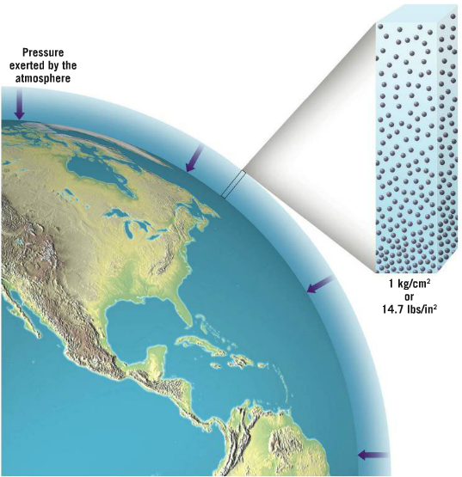

Does air have weight?

**Yes, 1 kg/cm3. This is called air pressure.**

Air pressure is not constant everywhere on Earth: there are areas of high and low pressure. Why?

**-Air pressure depends on the weight of air above a point.**

**-High pressure at sea level, low pressure at higher elevations. (Air pressure decreases by 50%/km).**

**Air pressure can also be affected by:**

a) **Temperature**

* When air is warm, molecules are **farther** apart. As a result, a given volume of air will have **less** air molecules and a lower air pressure. The opposite is true of cold air.

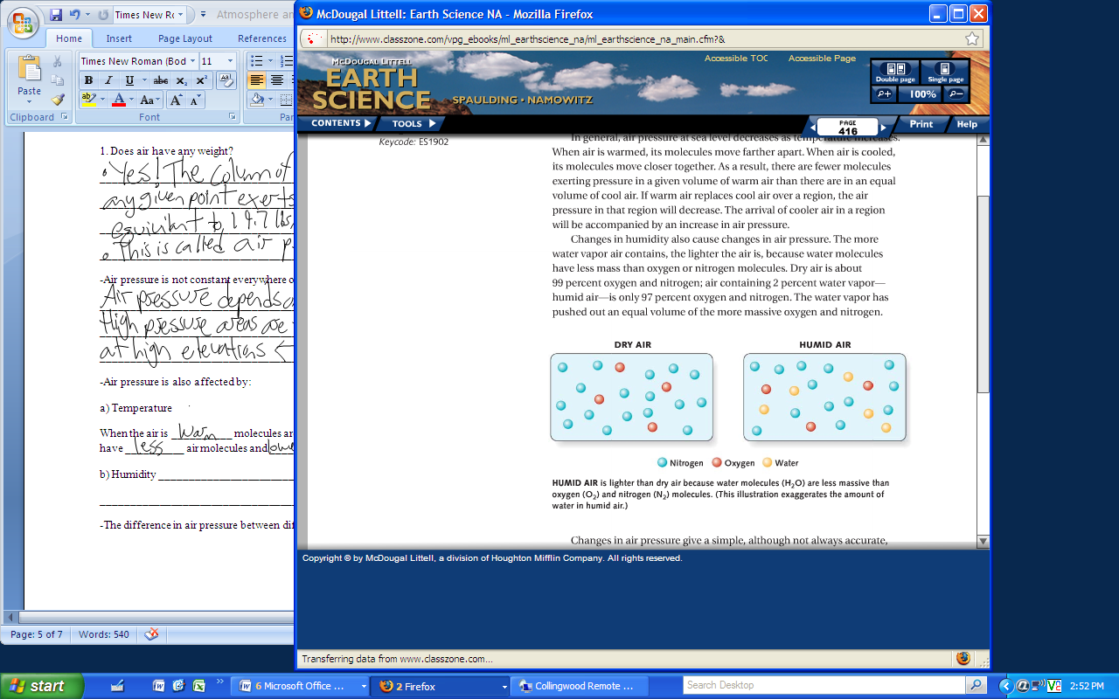b) **Humidity**

* Water molecules push out an equal volume of oxygen and nitrogen (heavier than water) in humid air conditions, creating less dense air and a lower air pressure.

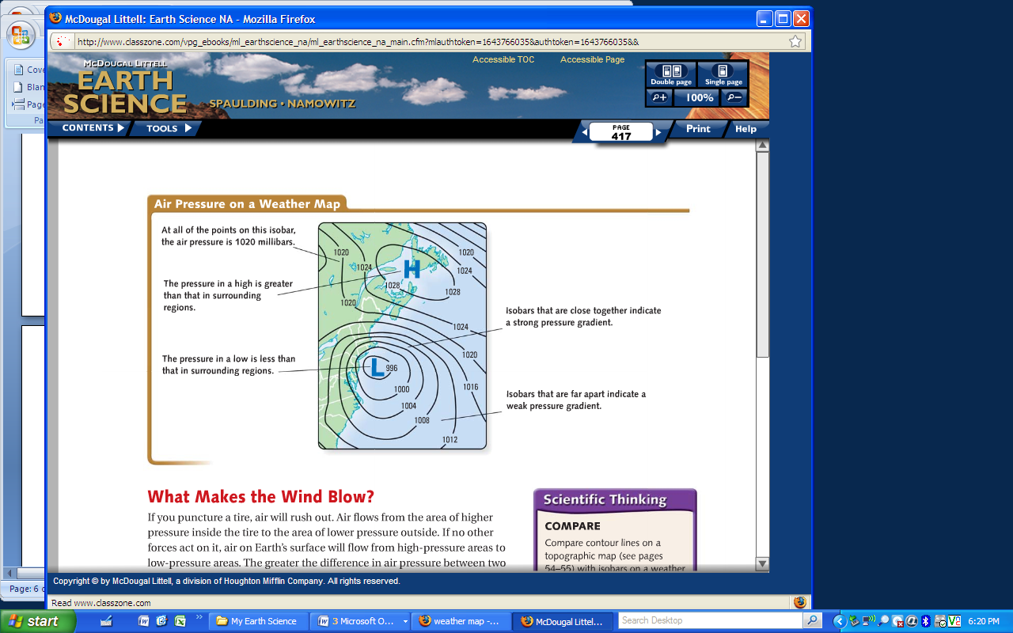**The differences in air pressure can be plotted on a weather map:**

**Pressure Gradient** = Pressure change ÷ Distance Covered

Line joining points with the same atmospheric pressure.

= stronger winds



|  |  |
| --- | --- |
| **High Pressure Area (Anticyclones)** | **Low Pressure Area (Cyclones)** |
| Associated with **fair weather** as **compression** of air results in higher temperatures and evaporation of water droplets (no cooling/condensation) | Associated with high winds and warm air rising to produce **clouds, precipitation, storms**, etc. |

|  |
| --- |
| **13.2: Factors Affecting Wind Movement** |

* Air will always move from **high** to **low** pressure areas.
  + differences in pressure are caused by the unequal heating of Earth by solar radiation.
  + 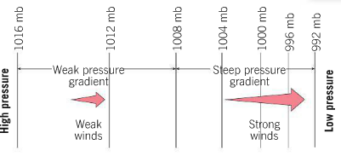Earth’s winds do not travel in a straight line because the planet’s rotation and the force of friction.

**Three forces to act on its direction and speed:**

a) **Pressure Gradient**

* An inbalance in pressure produces a force driving the air from high to low pressure areas.
* The greater the pressure difference, the greater the wind speed.

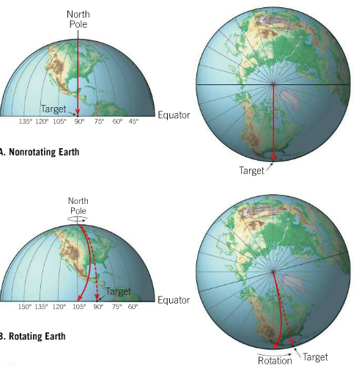b) **Coriolis Effect**

* Earth turns under moving objects, making them appear to deflect away from their target.
* Moving objects deflect to the right in the Northern Hemisphere and the left in the Southern hemisphere.

**Four basic rules of the Coriolis Effect are:**

1. Deflection is always at 90 degree angles to the direction of airflow.

2. Deflection affects only wind **direction, not speed**.

3. Deflection is affected by wind speed (stronger winds produce greater deflection).

4. Deflection is strongest at the poles and non-existant at the equator.

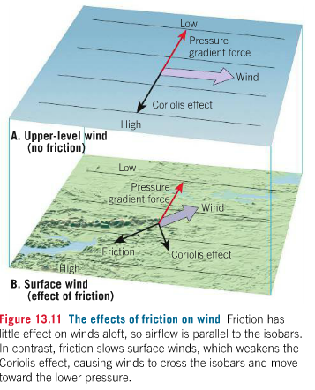c) **Friction**

* Friction slows wind speeds at Earth’s surface, but plays little role in the upper atmosphere.

-Will friction have a greater effect on land or over the ocean?

**Land, as ocean is very smooth = less friction, creating faster winds.**

|  |
| --- |
| **13.3: Highs and Lows** |

|  |  |  |
| --- | --- | --- |
| **High Pressure** | Winds flow out of pressure centre (diverging surface winds)  Rotate clockwise due to Coriolis Effect |  |
| **Low Pressure** | Wind flows into pressure centre (converging surface winds)  Rotate counterclockwise due to Coriolis Effect |

There are two types of pressure centres and both provide important information about future weather conditions:

|  |  |
| --- | --- |
| Is air rising of falling and what does this mean for weather patterns in affected areas? | |
| High Pressure | Low Pressure |
| Air is falling  As it fails it is compressed, warmed producing fair weather | Air is rising as it is piling up on itself  As it rises it cools and clouds/precipitation will occur |

If air is stacking up on itself above a low pressure centre is the air pressure increasing or decreasing?

**Air pressure would be increasing and the low would disappear unless divergence higher in the atmosphere occurred at the same rate.**

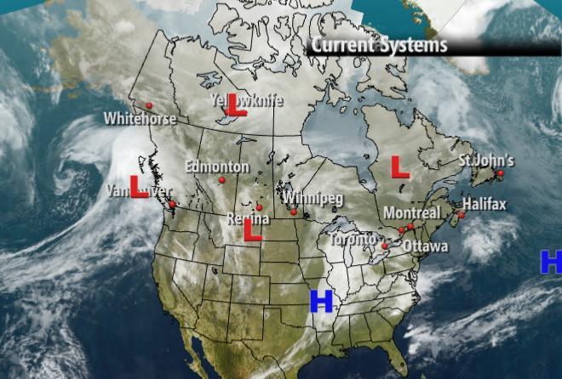

The weather map to the right was for January 2nd, 2014. What weather conditions was Vancouver experiencing then?

**Clouds with precipitation. Product of the Low.**

|  |
| --- |
| **13.4 : Global Atmosphere Circulation** |

* the primary cause of wind is the unequal heating of Earth’s surface!
  + [](http://media.pearsoncmg.com/bc/bc_0media_geo/smartfigure/sf-global-circulation.html)The atmosphere attempts to balance these differences through transferring heat by the movement of air.

*Watch the video on Idealized Global Atmosphere Circulation.

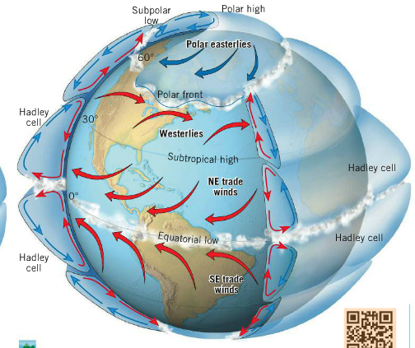

**There are 4 main pressure zones:**

**Polar High:** Cold, dry air sinks and spreads south.

**Subpolar low**: upward airflow that creates clouds and precipitation

**Subtropical High:** 30° N or S, air sinks as it cools and produces hot, dry conditions.

**Intertropical convergence zone (ITCZ):** Low pressure zone at the equator, product of high solar intensity causing air to rise.

**The following help move warm air from the equator:**

**Hadley Cell:** convection cell where air rises at the equator and sinks at 30°

**These zones help create 3 main wind systems:**

|  |  |
| --- | --- |
| **Polar Easterlies** | Cold wind that blows east to west from 90° to 60° |
| **Westerlies** | Warm wind the blows west to east from 30° to 60° |
| **Trade winds** | Warm wind that blows east to west from 30° to 0° |

**The interaction between these wind systems create:**

Polar Front: **_______________________________________________________________________________________________________________________________________________________________________________________________________________________________________________________________**

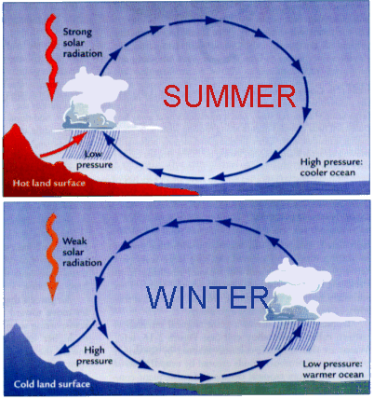**The above pattern is a generalization and there are exceptions to it. Below is one example:**

**1. _______________________________________________**

Large seasonal fluctuations in temperatures on continents generate monsoons (seasonal changes in wind direction):

a) High pressure systems are created in the winter as the air above continents is cool, causing air to flow out to sea.

b) Low pressure systems are created in summer as the air above continents warm, causing air to flow inland.

Why do these seasonal fluctuations exist at the subpolar low (Northern Hemisphere)?

[](http://media.pearsoncmg.com/bc/bc_0media_geo/smartfigure/sf-local-winds.html)a) Land and Sea Breezes

*Watch the video on Land and Sea Breezes and Mountain and Valley Breezes.

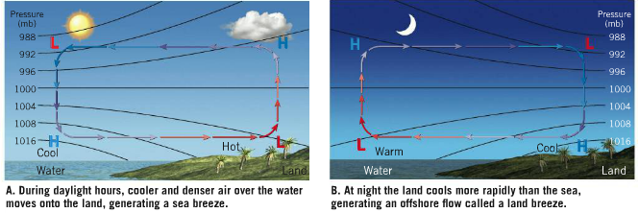

b) Mountain and Valley Breezes

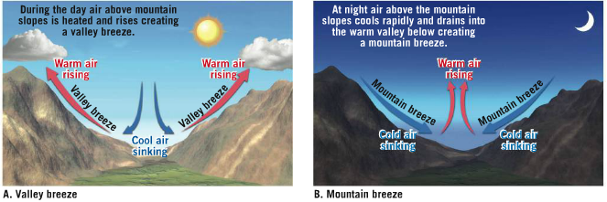

**Air Masses**

**Chapter 14**

**Workbook Activity 15**

|  |
| --- |
| **14.1: Air Masses** |

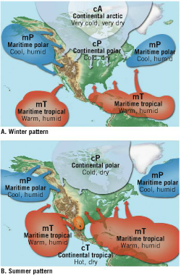

**What is an air mass?**

**-Large (160+km wide and several km thick) bodies of air with a uniform temperature and moisture content**

**- Think about balloon analogy**

**Why do we care?**

**-Most severe weather conditions occur where air masses meet.**

These basic air mass types can be combined to describe the source region and characteristics of air masses.

|  |  |
| --- | --- |
| **Name (symbol)** | **Conditions** |
| **Polar (P)** | Cold air |
| **Arctic (A)** | Cold air |
| **Tropical (T)** | Hot air |

|  |  |
| --- | --- |
| **Name (symbol)** | **Conditions** |
| **Continental (c)** | Dry air |
| **Maritime (m)** | Humid air |

**What type of air mass would south from the north pole in the winter?**

**What type of air mass would travel east from Hawaii?**

**Type of air mass**

**=**

**+**

***\*Complete Activity 15.1 in workbook (pg. 258)***

|  |
| --- |
| **14.2: Weather Fronts** |

What is a weather front?

**A boundary that seperates two different air masses**

Use the following website to draw and describe the 4 main types of weather fronts: <https://goo.gl/mr2Mu>

|  |  |  |
| --- | --- | --- |
| **Type of Front** | **Description** | **Diagram** |
|  |  |  |
|  |  |  |
|  |  |  |
|  |  |  |

[](http://media.pearsoncmg.com/bc/bc_0media_geo/smartfigure/sf-fronts.html)*Here is another video on the 4 types of fronts

The weather map to the right was for January 12, 2014.

What front was Vancouver experiencing then?

**-Warm front**

What type of weather did Vancouver have?

**-Rain, followed (hopefully) by warmer temperatures and clearer skies.**

What are the properties of the air mass that remains near Earth’s surface?

**-Cooler, more dense. Acts as a wedge (Frontal Wedging)**

What are the characteristics of the air mass forced upwards?

**Warmer, less dense and higher moisture content.**

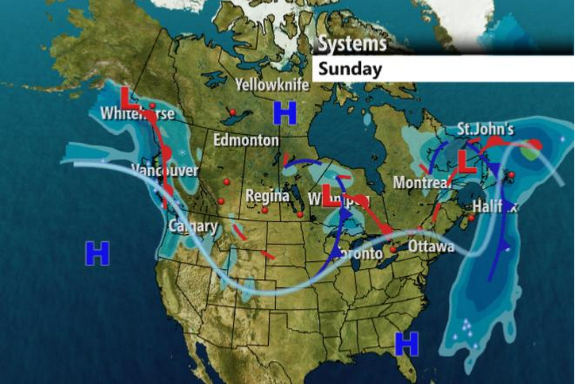

***\*Complete Exercise 15.2 Fronts (pg. 259 – 261)***

**Upper Air Flow**

* 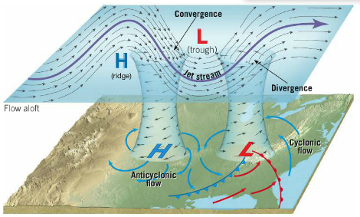The life span and intensity of a cyclone and anticyclone is controlled by airflow in the middle to upper troposphere (jet stream)
* The jet stream moves west to east between 120-210 km/hr and separates the cP and mT air masses.
* The amount of air that sinks into anticyclones and rises out of cyclones depends on how sharp the jet stream’s trough is and how fast it is moving.

*Watch this video on the jet stream: <https://goo.gl/sW2c7V>