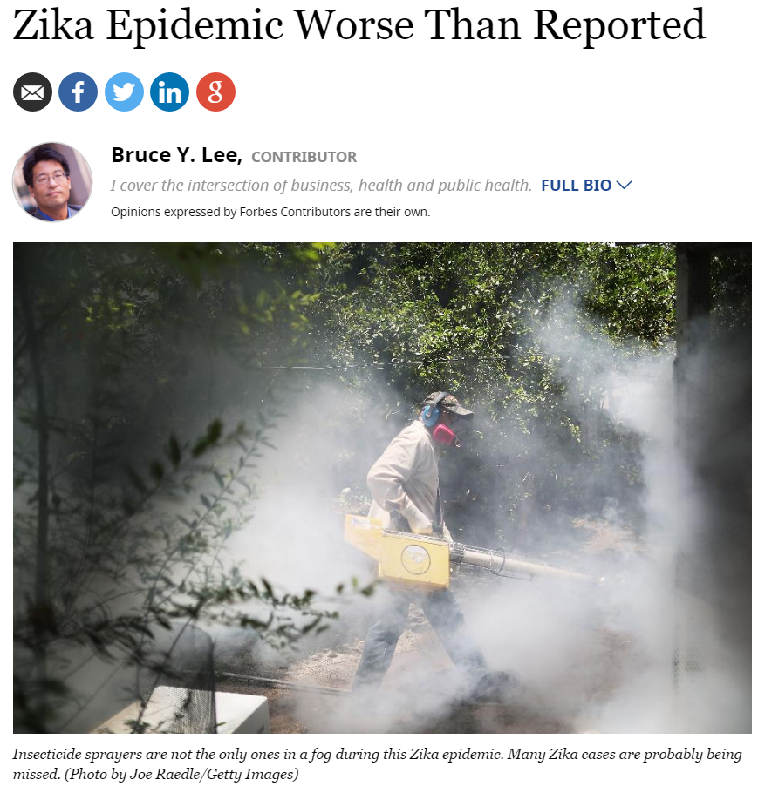
Here are several things that are probably being underestimated: the number Taylor Swift fans who are men, the number of times someone you are attracted to passes gas and the number of Zika cases. The problem in all of these cases is reporting…or, actually, under-reporting.

Many people do not realize that they are infected with Zika. Only approximately 20% of people infected with Zika even have symptoms. Those who do have symptoms may mistake Zika infection for a case of the flu or standard “pink eye.” Many may not even go see a doctor. Even when Zika is suspected, a doctor may not check laboratory tests to confirm. Even if the doctor finds a positive test, the doctor has to report the case to local, state or federal public health officials.
Therefore, when you hear of reported Zika cases in the news, you may be seeing just the tip of the iceberg (or just the male fans photographed attending a Taylor Swift concert or just that one time when you are present and the fart noise is loud enough for you to hear…well, you get the picture). This is an inherent problem with passive disease surveillance. Passive surveillance means that you wait for people to tell you when they find newly identified disease cases. The analogy would be passive flatulence surveillance in which you rely on people to tell you, “I farted.” You can see how this would result in missing many, many cases.

By contrast, active disease surveillance involves making efforts to search for cases. Now, there are different degrees of active surveillance. Active flatulence surveillance could range from regularly asking people if they farted to using some type of pants monitoring device…well, use your imagination. Active Zika surveillance can range from more aggressively telling to doctors to be on the lookout for Zika and then requiring that they report all possible cases to searching medical records for cases that may be suspicious for Zika to routinely testing people for Zika even if they don’t have any symptoms. The more aggressive active surveillance is, the more accurate the tracking of Zika is, but also the more expensive and time-intensive. For instance, regularly testing all people for Zika every week would give us a much better idea of where Zika is spreading but would probably cost far too much and be very inconvenient.

Disease surveillance can vary based on when and where you look for cases. For instance, looking for cases can be easier in larger cities where there are more people, facilities, testing equipment and laboratories, and communications channels. In more remote or poorer areas (even in large cities), the lack of such resources can lead to less or even no reporting of disease cases. This is why diseases can “hide out” and continue to spread to the point that the diseases are uncontrollable even in less remote and richer areas.

Without good disease surveillance, it can be difficult to know how best to respond to a disease in the most efficient manner. For instance, Miami, Florida, is now spraying insecticide in an attempt to control the mosquito population because now well over a dozen cases of Zika (caught from mosquitoes) have been reported. But where else do we need aggressive spraying? Waiting until you hear about cases in your neighborhood may be too late. For the Zika epidemic, tracking the following in a more active manner would be helpful:
- Zika cases: where, when and who
- Zika disease outcomes such as birth defects and Gullain-Barré syndrome
- Mosquito population: what types of mosquitoes are where, where are they breeding and which may be carrying the Zika virus
- Zika prevention and control measures: where and when are mosquito control, Zika testing and other measures occurring

The challenge is that surveillance, especially active surveillance, costs money, and to date, Zika funding is still under debate in Congress and the Senate. Building and running the infrastructure and information systems that can gather, store, analyze and communicate the appropriate information is no small task. Despite the stalling in funding decisions, the Centers for Disease Control and Prevention (CDC) recently awarded over $16 million to 40 different states and territories to build and run surveillance systems that track birth defects from the Zika virus. The awards range from $200,000 to $720,000.

Different organizations have already made efforts to provide some form of Zika surveillance. For example, athenahealth, which develops and provides electronic services and applications that work with electronic health record systems, has been incorporating algorithms to help doctors identify patients at risk for Zika infection and electronic and phone messages that inform doctors and patients about how to identify potential Zika symptoms. The company indicated that as of August 3, its system has helped identify more than 1,800 patients in the Miami area who may be at risk for Zika infection and, in turn, whom to urge testing and additional precautions. The company aims to publish detected Zika patterns its website. In another example, the state of Wisconsin is making efforts to determine the locations and potential breeding sites of the two mosquito species most likely to transmit the Zika virus.

Ultimately, surveillance plays a key role in preventing and controlling nearly any disease that may affect many people, especially Zika. Zika is especially problematic because it spreads very quietly through different means (via mosquito and sexual transmission) but can have devastating consequences. With both infectious disease and flatulence, the silent ones can cause the most problems.

Follow me on Twitter @bruce_y_lee and visit our Global Obesity Prevention Center (GOPC) at the Johns Hopkins Bloomberg School of Public Health. Read my other Forbes pieces here.

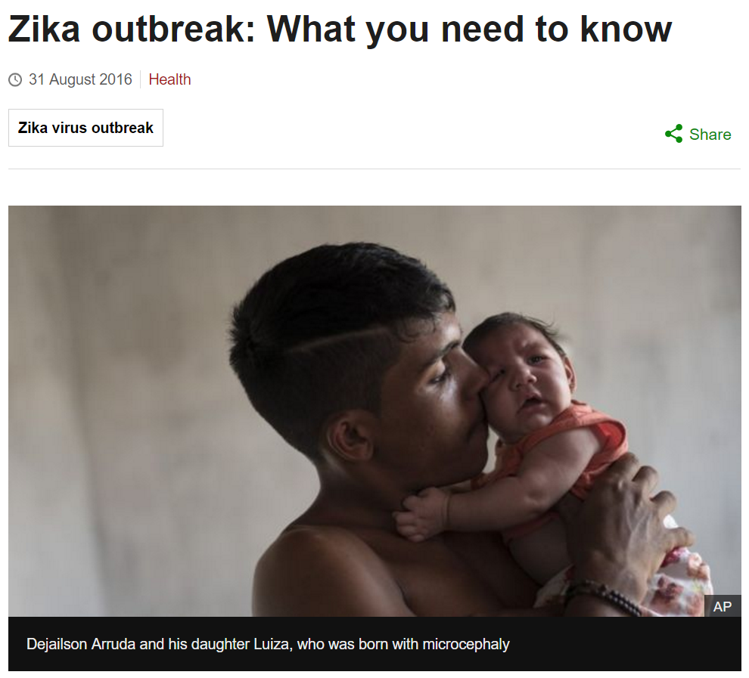
The World Health Organization has declared the Zika virus a global public health emergency.

The infection has been linked to thousands of babies being born with underdeveloped brains.
Some areas have declared a state of emergency, doctors have described it as "a pandemic in progress" and some are even advising women in affected countries to delay getting pregnant.
But there is much we do not know.

What are the symptoms of Zika?
Deaths are rare and only one-in-five people infected is thought to develop symptoms.
These include:
- mild fever
- conjunctivitis (red, sore eyes)
- headache
- joint pain
- a rash
A rare nervous system disorder, Guillain-Barré syndrome, that can cause temporary paralysis has been linked to the infection. There is no vaccine or drug treatment so patients are advised to rest and drink plenty of fluids. But the biggest concern is the impact it could have on babies developing in the womb and the surge in microcephaly.

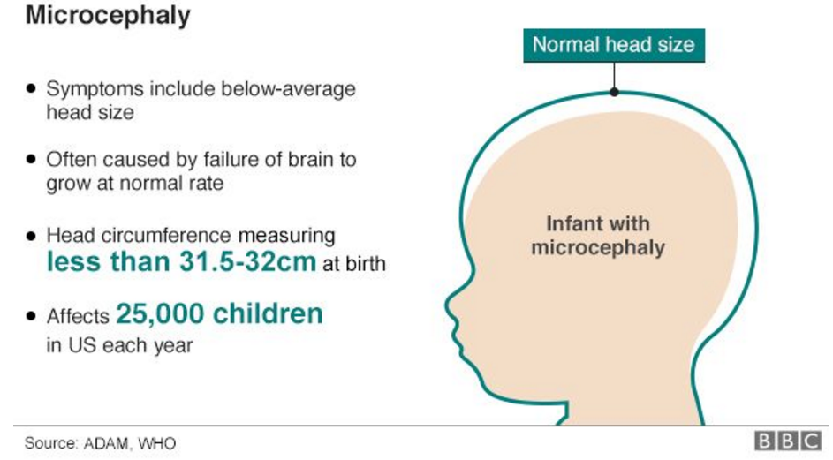
It is when a baby is born with an abnormally small head, as their brain has not developed properly. The severity varies, but it can be deadly if the brain is so underdeveloped that it cannot regulate the functions vital to life. Children that do survive face intellectual disability and development delays. It can be caused by infections such as rubella, substance abuse during pregnancy or genetic abnormalities. The WHO says there is "scientific consensus" that Zika causes microcephaly as well as Guillain-Barre syndrome. Some babies who died had the virus in their brain and it has been detected in placenta and amniotic fluid too.

Is it safe to try for a baby?
Some governments have advised women to delay getting pregnant until more is known. Experts now believe Zika is linked to a broader set of complications in pregnancy, including miscarriage, stillbirth, premature birth and eye problems. The US Centres for Disease Control says Zika lingers in the blood for about a week and can be spread by sexual intercourse. "The virus will not cause infections in a baby that is conceived after the virus is cleared from the blood," it says.
"There is currently no evidence that Zika-virus infection poses a risk of birth defects in future pregnancies." The WHO advises couples practice safer sex or abstain for at least eight weeks if they are returning from Zika-affected areas. If the man in the couple planning a pregnancy develops Zika symptoms, then this period of abstinence or safe sex should be extended to six months.

Why is it a public health emergency?
The WHO is worried that Zika is spreading far and fast, with devastating consequences. Declaring Zika as a "public health emergency of international concern" singles the disease out as a serious global threat. It puts it in the same category of importance as Ebola. Unlike Ebola, where the focus was on boots on the ground, with Zika the attention will be on understanding the link with microcephaly. The WHO will co-ordinate countries' health agencies to conduct trials to determine the risk. It will also encourage efforts to stop the mosquito that spreads the disease as well as finding a treatment or a vaccine to stop the virus. The work will depend on money donated by countries.

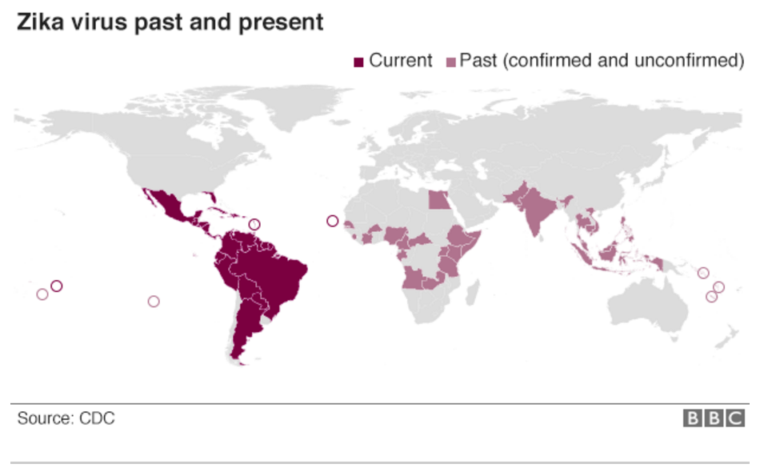

Where did Zika come from?
It was first identified in monkeys in Uganda in 1947.
The first human case was detected in Nigeria in 1954 and there have been further outbreaks in Africa, South East Asia and the Pacific Islands.

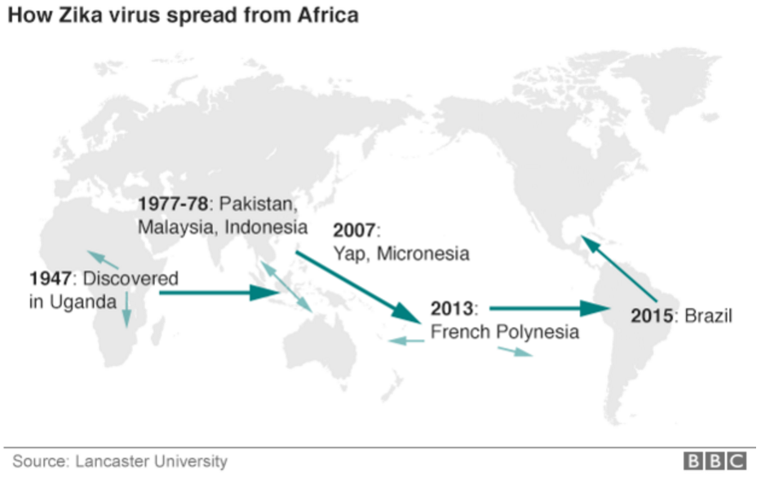
Most were small and Zika has not previously been considered a major threat to human health. But in May 2015 it was reported in Brazil and has since spread rapidly. "Its current explosive pandemic re-emergence is, therefore, truly remarkable," the US National Institutes of Health said.

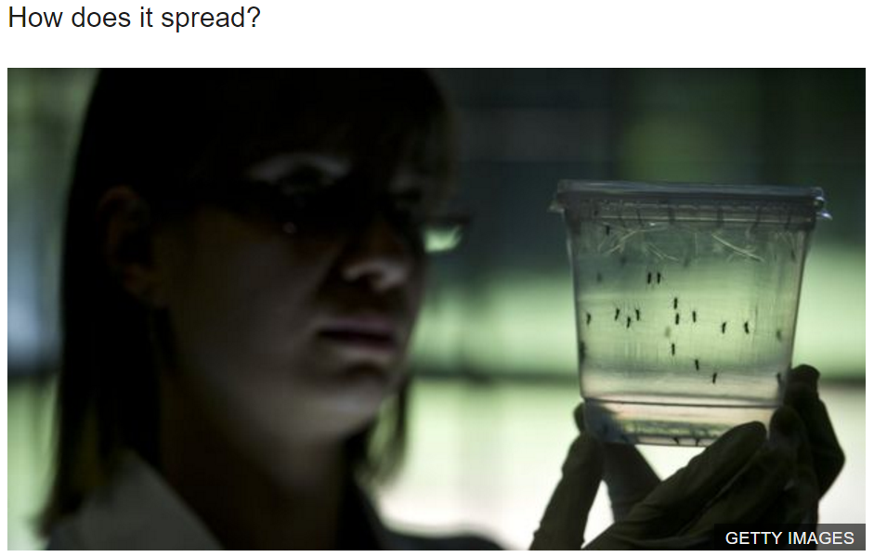
It is spread by Aedes mosquitoes. They are the same insects that spread dengue and chikungunya virus. They are found throughout the Americas except for Canada and Chile where it is too cold for them to survive, and across Asia.
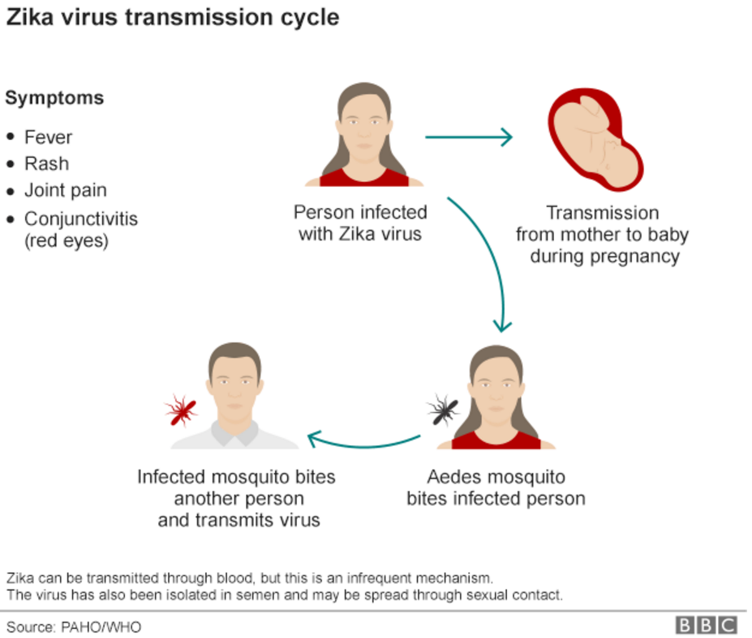

And, unlike the mosquitoes that spread malaria, they are mostly active during the day, so bed nets offer limited protection. If they drink the blood of an infected person they can then infect subsequent people they bite. The WHO says sexual transmission is also possible.

How long are people infectious?
The best evidence so far suggests that people can spread the virus via mosquitoes for a week after being infected. In semen it may persist for two weeks. Countries have advised safe sex and a ban on blood donations for a month after just visiting such countries and for longer if they developed symptoms.

What can people do?
As there is no treatment, the only option is to reduce the risk of being bitten.

Health officials advise people to:
- use insect repellents
- cover up with long-sleeved clothes
- keep windows and doors closed
- avoid vacationing in areas affected with Zika

The mosquitoes lay their eggs in standing water, so people are also being told to empty buckets and flower pots. The US Centers for Disease Control has advised pregnant women not to travel to affected areas.

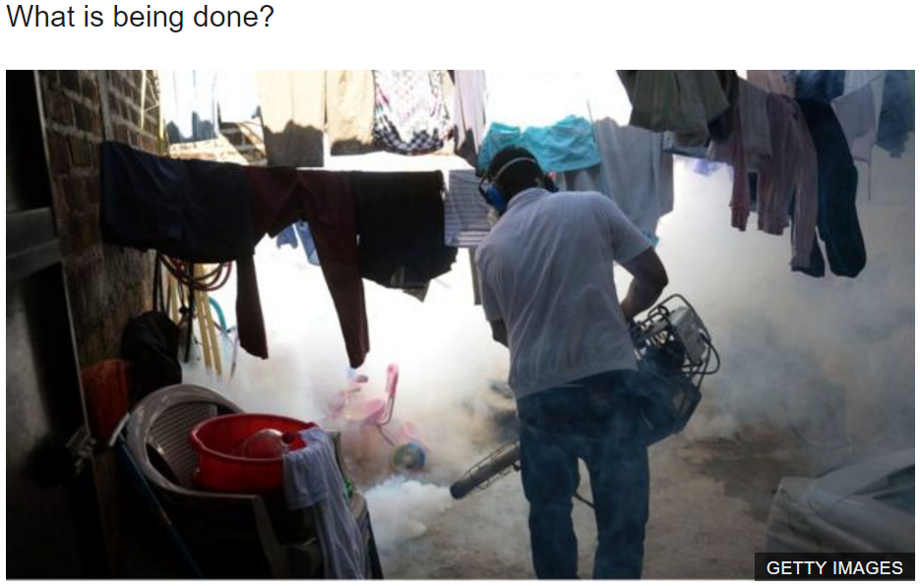

Zika vaccine
US experts from the National Institutes of Health say trials of a Zika vaccine will likely start in September this year. Depending on the results, larger trials could begin at the start of 2017. "The very, very best scenario" would be a vaccine ready for the general public by the beginning of 2018, they say.
Name: ______________________________ Block: _____

Critical Thinking

Epidemics and Pandemics are said to have both social and economic impacts on human populations. From reading the two articles, describe five social and five economic impacts the Zika virus has had on the world.

What is meant by social impacts?  Delete this box before printing  Run discussion for what is social impact? Some ideas for the bullet points:  - How does it affect people’s daily life?  - How does it affect family life?  - How does it affect relationships?  - ____________________________________________________  - ____________________________________________________ | What is meant by economic impacts?  - ____________________________________________________  Delete this box before printing  Run discussion for what is economic impact? Some ideas for the bullet points:  - cost to treat the outbreak  - cost to prevent the outbreak  - cost to develop vaccines  - loss of money from loss of tourism  - ____________________________________________________  - ____________________________________________________

Zika has large socioeconomic impacts. What does socioeconomic mean?

Why do you suppose diseases break out more frequently in less wealthy countries? Provide at least two explanations.

