When Smallpox Arrived in Canada
Excerpts from the First Nations Health Authority

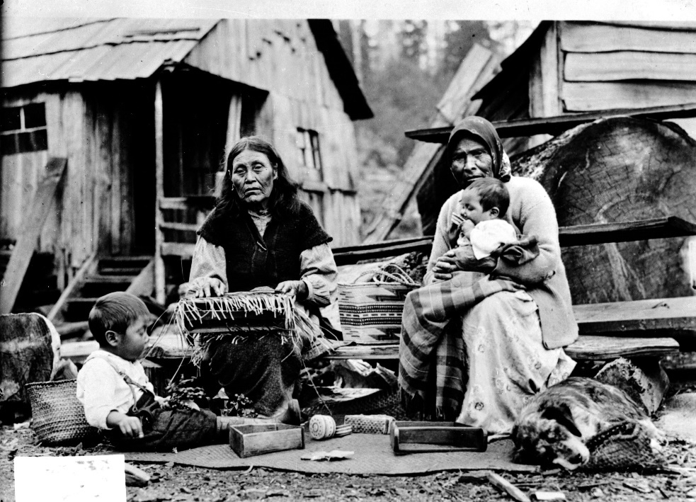

Traditional Healing
Throughout history there have been specialist healers who use plants to heal a wide range of ailments. First Nations throughout BC have developed intimate understandings of their environment and the healing qualities of many plants, some of which are also used during ceremonies and for other spiritual reasons.

Communities and families greatly valued holistic approaches for preventative health care. When a member of a community fell sick, the family and community would provide support and comfort, a practice that is as much in evidence today as it was in the past. A sense of place and belonging was recognized as one of the factors affecting health. Custom and wise leadership ensured that people had roles in their communities that took advantage of their particular skills, everyone contributing to the overall well-being of the group. In terms of child-rearing, it was commonly understood that children were raised and nurtured not only by their parents, but by their extended families too, especially grandparents, uncles and aunts. This ensured that the child’s growth and education was properly addressed by knowledgeable members of the family and community. First Nations communities thrived by working together to ensure their members were cared for so that the Nation remained strong.

Population Estimates
Prior to contact with Europeans, the area now known as British Columbia had one of the densest and most linguistically diverse populations within what is now Canada. It is estimated that one third of the pre-contact population of Canada resided within British Columbia. Pre-contact population estimates for BC vary widely with some estimates ranging from a conservative 200,000 to more than a million.

Contact
​Contact between First Nations and non-Aboriginal people occurred rather late in BC, some of the earliest recorded contact occurring in the late 1700s with Russian, French, Spanish and British traders and explorers all visiting parts of the coast during this time. Inland contact was primarily through traders (Hudson’s Bay Company) and explorers (Alexander McKenzie and Simon Fraser). It is also possible that other earlier unrecorded contact occurred on the coast.

Population Collapse
Epidemics spread through First Nations communities in advance of explorers. Some researchers have suggested epidemics reached the Northwest Coast as early as the 1500s, believing the well-known epidemics from the Caribbean and Central America may have spread to the Pacific Coast through native trade networks and social contact. Some of the recorded epidemics in the Interior were known to have originated on the prairies in early ​1800s. The introduction of infectious diseases from Europe and Asia into the Northwest Coast and adjacent areas, and an increase in the severity of warfare, had devastating effects on the First Nations people.

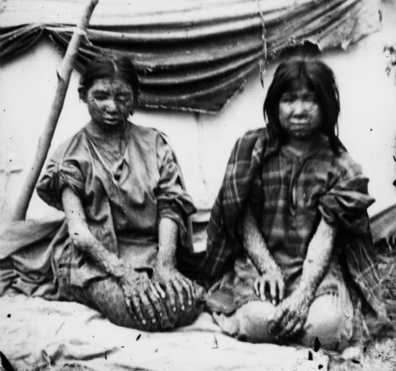 | Two girls from the Ho-Chunk nation afflicted with smallpox. One of them actually survived the disease, which was notable enough to be written on the back of the photograph, even though smallpox didn’t kill off as many Native Americans during later years as when Europeans first arrived, they still had a lower survival rate than either Europeans or those of African descent.

Lacking biological or cultural adaptations to these diseases, First Nations were overwhelmed. Smallpox, influenza, measles, and whooping cough were recorded epidemics, with smallpox particularly recurring with devastating effects in the native population. In some cases, people who were sick may have otherwise survived if provided with basic care. First Nations health systems had never encountered these diseases and were unprepared to deal with them. These epidemics continued throughout the historic period and caused ongoing and dramatic population decline. When these epidemics struck, people died in such mass numbers that it was a common occurrence for bodies to remain unburied.

With so many people affected by these diseases, at times regular food harvest was impossible. The disruption in harvesting during these times made matters worse with a lack of available food for the remaining tribe members and further reduced their immune systems’ resistance to disease due to lack of nutrients. Chronic diseases also entered the population at this time and included Tuberculosis and venereal diseases. It is clear that in some cases entire villages were significantly reduced in single disease events, with mortality rates ranging from 50% to 90% of the population. During this time, there was a vaccine for smallpox, which was discovered in Europe in the late 1700s; however, it was rarely provided to First Nations people.

Without a written culture, First Nations lost large pieces of their oral knowledge when experts died off in large numbers during the epidemics. The population collapse seriously unbalanced traditional health care systems. These new diseases overwhelmed and infected the traditional healers themselves, while simultaneously discrediting their methods when they proved ineffective against new maladies. Healers were nearly powerless in the face of the new diseases. During this time, the smallpox epidemic undermined the power of many coastal First Nations, clearing the way for the colonization and repression that followed. The concept of terra nullius, or settlement of ‘empty land’ was advanced at this time, based on the recently depopulated landscape that resulted from these waves of epidemics.

____________________________________________________________
Reflection on the reading

Why did the First Nation community sustain so many deaths due to smallpox while the traders from Europe did not? Give at least two explanations.

Bouquet's blankets
Excerpts from BBC.
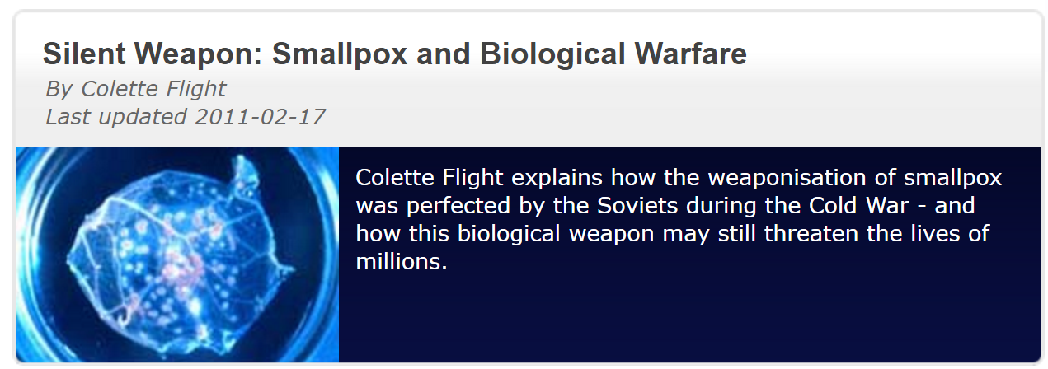

In 1992, a Soviet defector revealed to Western intelligence that he had overseen an extensive, illegal program to develop smallpox into a highly effective biological weapon.

Britain and the United States were shocked by the revelations. Russia's intent to use biological weapons, they claimed, was morally abhorrent. But a closer look at the history of biological weapons shows that Britain and America both played seminal roles in turning lethal diseases into weapons of war. In fact, Britain was probably the first nation to come up with the idea of using smallpox to kill its adversaries.

In the 18th century, the British fought France and its First Nation allies for possession of what was to become Canada during the French and Indian Wars (1754-63). At the time of the Pontiac rebellion in 1763, Sir Jeffrey Amherst, the Commander-in-Chief of the British forces in North America, wrote to Colonel Henry Bouquet: 'Could it not be contrived to send smallpox among these disaffected tribes of Indians? We must use every stratagem in our power to reduce them.' The colonel replied: 'I will try to inoculate the [Native American tribe] with some blankets that may fall in their hands, and take care not to get the disease myself.' Smallpox decimated the Native Americans, who had never been exposed to the disease before and had no immunity.

It has been alleged that smallpox was also used as a weapon during the American Revolutionary War (1775-83). During the winter of 1775-76, American forces were attempting to free Quebec from British control. After capturing Montreal, it looked as if they might succeed. But in December 1775, the British fort commander reportedly had civilians immunized against the disease and then deliberately sent out to infect the American troops. A few weeks later a major smallpox epidemic broke out in the American ranks, affecting about half of the 10,000 soldiers. They retreated in chaos after burying their dead in mass graves.

____________________________________________________________
Reflection on the reading

What are your thoughts on the British’s use of Smallpox as a weapon? Should there be an international law against the use of bioweapons?

What are some dangers of using a biological weapon?

Immune to HIV: How Do They Do It?
Retrieved from livescience.com
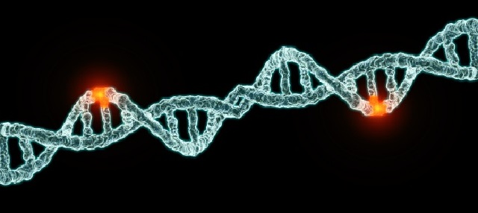

The HIV Individuals with HIV immunity have intrigued scientists for over a decade. How is it that the immune systems of some seem impenetrable to a virus that kills 2 million people around the globe each year?

Researchers have focused on a few proteins – called CCR5, CD4 and human leukocyte antigen – that may hold the key to this puzzle as well as offer the potential for new HIV treatments.

A new study at the University of Southern California shows mice with a mutation in the DNA that encodes CCR5 have immunity to HIV. The CCR5 protein is found on the surface of human immune-system cells. Essentially, CCR5 works as a lock that the HIV virus can pick to gain entry into the immune cells.

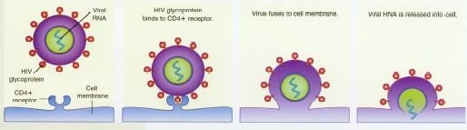

The researchers took mice already infected with HIV and injected them with stem cells containing a specific mutation in the CCR5 DNA. They found the injected cells were able to fight and destroy HIV, and the mice were able to fight off other infections, too.

Because stem cells reproduce indefinitely, these mutant stem cells could provide a permanent supply of HIV-resistant immune cells, according to the researchers.

The procedure is currently being tested in humans in Phase 1 clinical trials. It was inspired by a 2009 New England Journal of Medicine case report that described a patient with both HIV and leukemia. After undergoing a bone marrow transplant from a donor with the CCR5 mutation — known as the CCR5-delta 32 mutation — the patient became HIV-free and no longer required anti-AIDS drugs.

Tracking a mysterious mutation
This mutation in CCR5 is associated with natural immunity to HIV in about 10 percent of Caucasian people. Scientists suspect that its commonness comes from being spared by deadly plagues in the distant past. However, there is disagreement over which disease or diseases influenced the mutation over time.

Much research has shown that the mutation may have given some people immunity to the waves of bubonic plague that swept through Europe during the 12th through 15th centuries.

But University of Berkeley researchers suggest smallpox is a likely cause for the mutation's spread. In a 2003 report in the Proceedings of the National Academies of Science, the scientists explained that smallpox was around far longer than the plague and killed far more people. And smallpox especially affected younger children, who were not yet old enough to reproduce.

In a 2006 study, Johns Hopkins University researchers found that the mutation reduced infection by the hepatitis B virus, as well. They concluded that "a diverse group of infectious disease, rather than a single, deadly pathogen," may have been the driving force behind the mutation's prevalence.
Other factors
Because the CCR5 mutation does not provide HIV immunity in all populations, researchers have looked at other proteins that may bestow a natural advantage in fighting off the virus.

A protein called cystatin may be at work. In 2008, researchers at the University of Manitoba studied Kenyan women who were still HIV-free after working as prostitutes for at least three years. The scientists found increased levels of cystatin, which is known to interfere with the ability of HIV to reproduce.

Studies of Zambians have highlighted the influence of the protein HLA, or human leukocyte antigen. So-called "elite controllers" – people whose cells are able to effectively attack and destroy HIV – often possess certain types of HLA. They may never experience symptoms even though they are infected with the virus.

Another protein that has garnered attention from scientists is called CD4. As with CCR5, HIV must interact with CD4 in order to enter person's immune cells, and some say it may make a better drug target than CCR5.

Recently Peter Kwong, a scientist at the National Institute of Allergy and Infectious Diseases, led a team that investigated a protein produced by people immune to HIV that binds to HIV and to CD4. The researchers concluded that fully understanding how this protein binds to both the virus and the human cells could lead to the creation of an HIV vaccine.

"The CCR5 binding site is only revealed to the virus after it binds to CD4," Kwong said. "So although CCR5 is an extremely good drug target, the CD4 site is much better because it must always be accessible for HIV to get into the cell."

____________________________________________________________
Reflection on the reading

Why are scientists interested in people with natural HIV immunity?

Name: ________________________________ Block: ______

Critical Thinking

- What is meant by immunity? __________________________________________________________________________________________________

- Compare and contrast developed immunity with natural immunity.

Developed Immunity  As discussed in the Smallpox articles | Natural Immunity  As discussed in the HIV article
What is developed immunity?  Can any group of people get developed immunity or only certain individuals? | What is natural immunity?  Can any group of people get natural immunity or only certain individuals?

