**8.2 PRESSURE Name:**

**Date:**

**Block:**

**(Refer to pp.290 – 299 of BC Science 8)**

* 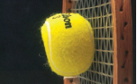_________________ is the amount of force applied over a given area on an object.
* When pressure is applied to matter, _______________ can result.
* 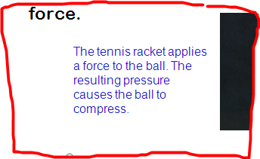**Compression** is a _____________ in volume produced by a force.

**Gases Are Compressible**

* A gas can ________ be compressed because there is a large amount of __________ between its particles.
  + Gas that is trapped in a container and heated will _______________ in pressure.
  + 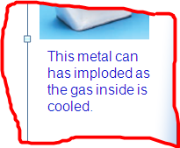Heat causes the particles to move ___________. These fast moving particles _____________ ______ the sides of the container.
  + The increased pressure could cause the container to _______.
* Gas that is trapped in a container and cooled will ______________ in pressure.
  + The decreased pressure could cause the container to ______.

**Liquids and Solids Are Very Difficult to Compress**

* The particles of liquids and solids are already so tightly packed together that squeezing them together is almost ______________.
* 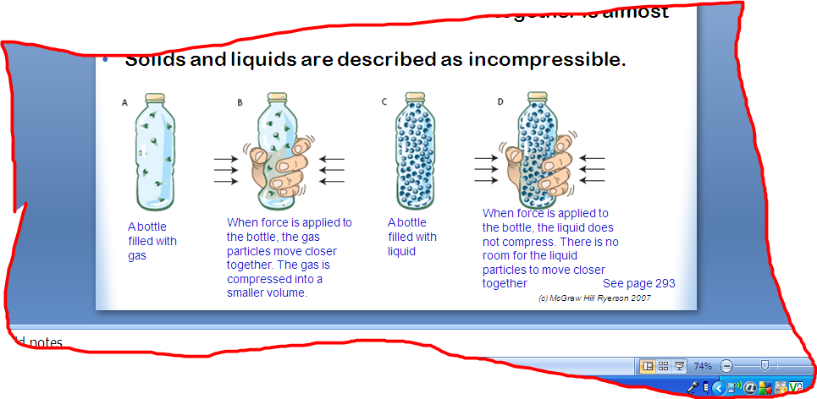Solids and liquids are described as ______________________.

**Compression and Deformation**

* 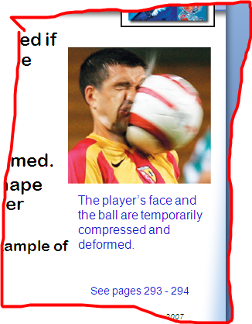Solids can appear to be compressed if the “_____ ____________” in the material are compressed.
  + An example would be squishing (compressing) a marshmallow.
* Solids can also appear to be compressed when they are __________.
* **___________________** means to change shape without being forced into a smaller volume.
  + 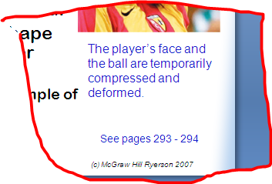A ball hitting a solid surface is an example of deformation.

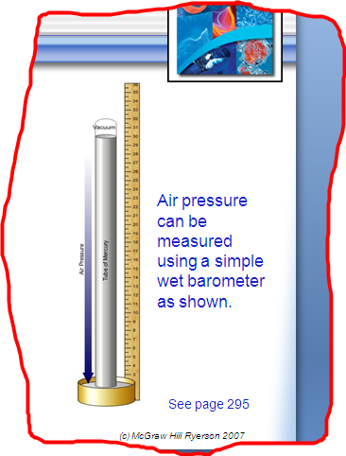**Comparing Pressure**

* Pressure depends on both the amount of __________ and also the _________ the force acts upon.
* Formula for pressure:

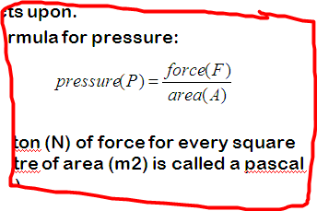

* 1 newton (N) of force for every square metre of area (m2) is called a ___________ (Pa).
  + _________ Pa = 1 kPa

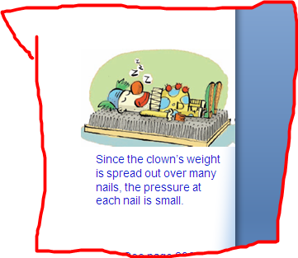**Calculating Pressure**

Use the formula to calculate the pressure involved in the following questions. Show your work!!!

1. An 880 N person stands on a 0.80 m by 1.2 m board. **(920 Pa)**
2. A 52 000 N car rests on a 3.0 m by 6.0 m platform. **(2900 Pa)**

**SUMMARY:**